|  |  |
| --- | --- |
| logo ngan.png | **MINISTRY OF EDUCATION AND TRAINING** |

|  |
| --- |
| **FPT UNIVERSITY** |
| Capstone Project Document |
| Office Rental Service |
|  |
| |  |  | | --- | --- | | **Group 6** | | | **Group Members** | Lê Xuân Tiến – Team Leader – SE60897  Nguyễn Vũ Hoàng Quốc – Team Member – SE61112  Trương Tiến Thành – Team Member – SE61052  Trần Lê Tuấn – Team Member – 60350 | | **Supervisor** | Mr. Nguyễn Trọng Tài | | **Ext Supervisor** | N/A | | **Capstone Project Code** | ORS | |
| - Hồ Chí Minh City, May 2015 - |

*This page is intentionally left blank*

Table of Contents

1. Introduction 15

1.1 Project Information 15

1.2 Introduction 15

1.3 Current Comparison websites in Vietnam 15

1.3.1 Limitations of the existing system 15

1.3.2 Benefits of expected system 15

1.4 Problem Definition 16

1.5 Proposed Solution 16

1.5.1 Feature functions 16

1.5.2 Advantage and disadvantage 17

1.6 Role and Responsibility 17

2. Project Management Plan (PMP) 17

2.1 Problem Definition 17

2.1.1 Name of this Capstone Project 17

2.1.2 Problem Abstract 18

2.1.3 Project Overview 18

2.2 Project organization 20

2.2.1 Software Process Model 20

2.2.2 Roles and Responsibilities 21

2.2.3 Tools and Techniques 22

2.3 Project management plan 22

2.3.1 Tasks 22

2.3.2 Task sheet 25

2.3.3 All Meeting Minutes 25

2.4 Coding Convention 25

3. System Requirements Specifications (SRS) 25

3.1 User Requirement Specification 25

3.1.1 Guest requirement 25

3.1.2 General user requirement 26

3.1.3 Customer requirement 26

3.1.4 System requirement 26

3.1.5 Admin requirement 26

3.1.6 Staff requirement 27

3.2 System Requirement Specification 27

3.2.1 External Interface Requirements 27

3.2.2 Functional Requirements: 27

3.2.3 Non-Functional Requirements 148

3.3 Entity Relationship Diagram or Data Structures 148

3.4 Other material (if any) 150

4. Software Design Description 150

4.1 Design Overview 150

4.2 System Architectural Design 152

4.2.1 Choice of System Architecture 152

4.2.2 Discussion of Alternative Designs 153

4.2.3 Description of System Interface 153

4.3 Component Diagram 154

4.4 Detailed Description of Components 154

4.4.1 Class Diagram 154

4.4.2 Class Diagram Explanation 156

4.5 Sequence Diagram 167

4.5.1 Add Exchangeable Toy 167

4.5.2 Remove Exchangeable Toy 168

4.5.3 View All Exchangeable Toys 168

4.5.4 Send Exchange Request 169

4.5.5 View Exchange Request 170

4.5.6 Respond Exchange Request 170

4.5.7 Finish Exchange 171

4.5.8 Cancel Exchange 171

4.5.9 Assign Shipper For Exchange 172

4.5.10 Add To Cart 172

4.5.11 Update Cart 173

4.5.12 Remove Cart 173

4.5.13 View Cart 174

4.5.14 View Order History 175

4.5.15 Cancel Order 176

4.5.16 Cancel Rented Toy 177

4.5.17 Return Toy Soon 178

4.5.18 Login 178

4.5.19 Logout 179

4.5.20 View Toy Details 179

4.5.21 View Toy Categories 180

4.5.22 Checkout Payment Cash On Delivery 181

4.5.23 Checkout Payment Online 182

4.5.24 Return Toy 183

4.5.25 Advanced Search 185

4.5.26 Basic Search 185

4.5.27 Reserve Toy 185

4.5.28 View Suggested Toys 186

4.5.29 Extend Rent Time 187

4.5.30 Edit Customer Profile 190

4.5.31 Mobile Finish Deliver Order 190

4.5.32 Mobile Return Toy 192

4.5.33 Mobile Finish Exchange 193

4.6 User Interface Design 195

4.6.1 Login 195

4.6.2 View suggest toys 196

4.6.3 My Exchangeable List 198

4.6.4 Add exchangeable products 199

4.6.5 Other Customer Exchangeable List 200

4.6.6 Send Exchange Request – Select product 202

4.6.7 Send Exchange Request – Select new return date 203

4.6.8 Send Exchange Request – Confirm and send request 205

4.6.9 My sent exchange request 206

4.6.10 My receive exchange request 208

4.6.11 Exchange Request Details 209

4.6.12 Manage Exchange 212

4.6.13 Product Details 214

4.6.14 View statistic report by year 219

4.6.15 Mobile app menu 221

4.6.16 Mobile Assigned Orders 222

4.6.17 Mobile order details 224

4.6.18 Mobile product details 226

4.6.19 Mobile Assigned Exchange List 228

4.6.20 Mobile Exchange Details 230

4.6.21 Mobile Search Return Product Options 232

4.6.22 Rent Toy 232

4.6.23 View Order History 234

4.6.24 Extend Rent Time 235

4.6.25 View Cart 237

4.6.26 Check Out _ Choose payment way 240

4.6.27 Check Out _ Confirm information delivering 241

4.6.28 Check Out_ Confirm al information 242

4.6.29 View User Profile 245

4.6.30 Update User Profile 246

4.6.31 Information of Child 247

4.6.32 Add Child 248

4.6.33 Update Child 249

4.6.34 Manage Order 251

4.6.35 View Order Detail (staff) 252

4.6.36 View Order Detail (customer) 254

4.6.37 Return Back 256

4.6.38 Assign Shipper 257

4.6.39 Manage Promotion 258

4.6.40 Register 259

4.6.41 View Category 261

4.6.42 Advanced search 263

4.6.43 Manage Members 265

4.6.44 Add New Member 266

4.6.45 Update Member 267

4.6.46 Manage Toys 269

4.6.47 Toy Instance List 271

4.6.48 Add New Toy Instance 272

4.6.49 Update Toy Instance 273

4.6.50 Add New Toy 274

4.6.51 Update Toy 277

4.7 Database Design 279

4.7.1 Physical Database Diagram 279

4.7.2 Data Dictionary 281

4.8 Algorithms 293

4.8.1 Suggest products which rented by customers who rented current product 293

4.8.2 Suggest products appropriate for child 293

4.8.3 Suggest products by customer orders 294

5. System Implementation & Test (SIT) 298

5.1 Introduction 298

5.1.1 System Overview 298

5.1.2 Test Approach 298

5.2 Test Plan 299

5.2.1 Features to be tested 299

5.2.2 Features not to be tested 299

5.3 Test Cases 299

5.3.1 Basic Search 299

5.3.2 Advanced Search 300

5.3.3 View product details 303

5.3.4 View My Exchange List 304

5.3.5 Add Toy to Exchange List 304

5.3.6 Remove Toy out of Exchange List 306

5.3.7 View Exchange List of Other Customer 307

5.3.8 Send Exchange Request 308

5.3.9 View Detail of Exchange Request 311

5.3.10 Respond Exchange Request 313

5.3.11 Cancel Exchange Request (customer) 314

5.3.12 Staff Assign Shipper For Exchange 315

5.3.13 Cancel Exchange Request (staff) 317

5.3.14 Finish Exchange 318

5.3.15 View Statistic Report 319

5.3.16 Add To Cart 321

5.3.17 Edit Cart 323

5.3.18 Remove Cart 324

5.3.19 Add Promotion Item 325

5.3.20 Checkout And Online Payment 325

5.3.21 View Oder History 328

5.3.22 Cancel Order/Order Detail 328

5.3.23 Extend Rent Time 329

5.4 Checklists 330

5.4.1 Checklist of Validation 330

5.4.2 Submission Checklist 330

5.5 Other material 330

6. System User’s Manual 330

6.1 Installation Guide 330

6.1.1 Setting up environment at server side 330

6.1.2 Deployment at server side 331

6.1.3 Client side environment setting 334

6.2 User’s Guide 335

6.2.1 Admin –Staff Login 335

6.2.2 Staff 335

6.2.3 Customer 338

**List of Figures**

Figure 1: Waterfall Model 22

Figure 2: Use Case Overview 29

Figure 3: <Staff>Overview Use Case 30

Figure 4: <Staff>Manage Exchange 30

Figure 5: <Staff>Cancel Exchange 31

Figure 6: <Staff>Finish Exchange 33

Figure 7: <Staff>Manage Orders 35

Figure 8: <Staff>Cancel Order 35

Figure 9: <Staff>Cancel Order Detail 38

Figure 10: <Staff>Return Rent Toy 40

Figure 11: <Admin>Assign Shipper 42

Figure 12: <Admin>Done Delivering Order 44

Figure 13: <Staff>Manage Toys 46

Figure 14: <Staff>Add Toy 46

Figure 15: <Staff> Update Toy 51

Figure 16: <Staff> Delete Toy 56

Figure 17: <Staff>View Select Next Renter Result 58

Figure 18: <Staff>Process Rent Toy 59

Figure 19: <Staff>Process Return Toy 61

Figure 20: <Staff>Process Exchange 64

Figure 21: <Staff> Manage Promotion 66

Figure 22: <Staff>Add Promotion 66

Figure 23: <Staff>Update Promotion 69

Figure 24: <Staff>Delete Promotion 71

Figure 25: <Staff>Edit Discount Level 73

Figure 26: <Staff> View List Reservation 76

Figure 27: <Staff>Manage Categories 78

Figure 28: <Staff> Add Category 78

Figure 29: <Staff>Update Category 81

Figure 30: <Staff>Delete Category 83

Figure 31: <Customer>Overview Use Case 85

Figure 32: <Customer>View Suggested Toys 86

Figure 33: <Customer>Rent Toys 88

Figure 34: <Customer>Add To Cart 91

Figure 35: <Customer>View Cart 93

Figure 36: <Customer>Update Cart 95

Figure 37: <Customer>Exchange Toys 97

Figure 38: <Customer> View Others Exchangeable Toys List 99

Figure 39: <Customer>Edit Exchangeable Toys List 101

Figure 40: <Customer>Send Exchange Request 103

Figure 41: <Customer> Manage User Profile 105

Figure 42: <Customer>Edit User Profile 105

Figure 43: <Customer>View Order History 108

Figure 44: <Customer>Extend Rent Time 110

Figure 45: <Customer>Cancel Order 112

Figure 46: <Customer> Reserve Toy 114

Figure 47: <System>Overview Use Case 116

Figure 48: <System>Select Next Renter 117

Figure 49: <System> Send Notitication Mail 118

Figure 50: <System>Send Expire Date Remind Mail 119

Figure 51: <System> Send Selected Renter Notification Mail 120

Figure 52: <Admin> Overview Use Case 122

Figure 53: <Admin> View Statistics Reports 122

Figure 54: <Admin> Manage Members 124

Figure 55: <Admin> Add Member 124

Figure 56: <Admin> Update Member 127

Figure 57: <Admin> Ban Member 130

Figure 58: <General User>Overview Use Case 132

Figure 59: <General user>View Toy Details 133

Figure 60: <General User> Search 135

Figure 61: <General User> Basic Search 135

Figure 62: <General User> Advanced Search 137

Figure 63: <General User>View Toys Categories 139

Figure 64: <Customer, Admin, Staff>Logout 141

Figure 65: <Guest>Overview Use Case 143

Figure 66: <Guest>Register 143

Figure 67: <Guest>Login 146

Figure 68: Entity Relationship Diagram 150

Figure 69: MVC Architecture 153

Figure 70: 3 tiers architecture 154

Figure 71: Component Diagram 155

Figure 72: Class Diagram 156

Figure 73: Add Exchangeable Toy Sequence Diagram 168

Figure 74: Remove Exchangeable Toy Sequence Diagram 169

Figure 75: View All Exchangeable Toys 169

Figure 76: Send Exchange Request Sequence Diagram 170

Figure 77: View Exchange Request 171

Figure 78: Respond Exchange Request Sequence Diagram 171

Figure 79: Finish Exchange Sequence Diagram 172

Figure 80: Cancel Exchange Sequence Diagram 172

Figure 81: Assign Shipper For Sequence Diagram 173

Figure 82: Add To Cart Sequence Diagram 173

Figure 83: Update Cart Sequence Diagram 174

Figure 84: Remove Cart Sequence Diagram 174

Figure 85: View Cart Sequence Diagram 175

Figure 86: View Order History Sequence Diagram 176

Figure 87: Cancel Order Sequence Diagram 177

Figure 88: Cancel Rented Toy Sequence Diagram 179

Figure 89: Return Toy Soon Sequence Diagram 179

Figure 90: Login Sequence Diagram 179

Figure 91: Logout Sequence Diagram 180

Figure 92: View Toy Detail Sequence Diagram 180

Figure 93: View Toy Categories Sequence Diagram 181

Figure 94: Checkout Payment Cash On Delivery Sequence Diagram 182

Figure 95: Checkout Payment Online Sequence Diagram 183

Figure 96: Return Toy Sequence Diagram 185

Figure 97: Advanced Search Sequence Diagram 186

Figure 98: Basic Search Sequence Diagram 186

Figure 99: Reserve Toy Sequence Diagram 186

Figure 100: View Suggested Toy Sequence Diagram 187

Figure 101: Extend Rent Time Sequence Diagram 190

Figure 102: Extend Rent Time Sequence Diagram 191

Figure 103: Mobile Finish Deliver Order 192

Figure 104: Mobile Return Toy 193

Figure 105: Mobile Finish Exchange 194

Figure 106: Login 196

Figure 107: View Suggest Toys 197

Figure 108: My Exchangeable List 199

Figure 109: Add Exchangeable Products 200

Figure 110: Other Customer Exchangeable List 201

Figure 111: Send Exchange Request – Select Product 203

Figure 112: Send Exchange Request – Select new return date 204

Figure 113: Send Exchange Request – Confirm and send request 206

Figure 114: My Sent Exchange Request 207

Figure 115: My Receive Exchange Request 209

Figure 116: Exchange Request Details 210

Figure 117: Manage Exchange 214

Figure 118: Product Details 216

Figure 119: View Statistic Report 220

Figure 120: Mobile App Menu 222

Figure 121: Mobile Assigned Orders 223

Figure 122: Mobile Order Details 225

Figure 123: Mobile Product Details 227

Figure 124: Mobile Assigned Exchange List 229

Figure 125: Mobile Exchange Details 231

Figure 126: Mobile Search Return Product Options 233

Figure 127: Rent Toy 234

Figure 128: View Order History 235

Figure 129: Extend Rent Time 237

Figure 130: View Cart 239

Figure 131: Check out_ Choose payment way 241

Figure 132: Check out _ Confirm information delivering 242

Figure 133: Check Out_ Confirm all information 244

Figure 134: View User Profile 246

Figure 135: Update User Profile 247

Figure 136: Information of child 249

Figure 137: Add Child 250

Figure 138: Update Child 251

Figure 139: Manage Order 252

Figure 140: View Order Detail (staff) 254

Figure 141: View Order Detail 256

Figure 142: Return Back 257

Figure 143: Assign shipper 258

Figure 144: Manage Promotion 259

Figure 145: Register 261

Figure 146: View Category 262

Figure 147: Advanced Search 264

Figure 148: Manage Members 266

Figure 149: Add New Member 267

Figure 150: Update Member 269

Figure 151: Manage Toys 270

Figure 152: Toy Instance List 272

Figure 153: Add New Toy Instance 273

Figure 154: Update Toy Instance 274

Figure 155: Add New Toy 275

Figure 156: Update Toy 278

Figure 157: Physical Database Diagram 281

Figure 158: Extract Deployment Package 332

Figure 159: Connect to server 332

Figure 160: Open database script 333

Figure 161: Configure Server 333

Figure 162: Change Web.config connection string 334

Figure 163: Change App.config connection string 334

Figure 164: Deploy web application on server 335

Figure 165: Deploy web application on server 335

Figure 166: Admin - Staff Login Page 336

Figure 167 : View List Of Orders 337

Figure 168 : View Order Detail (Staff) 337

Figure 169 : Assign Shipper 338

Figure 170 : View Exchange Request List 338

Figure 171 : View Detail Of Exchange Request 339

Figure 172 : Cancel Exchange Request 339

Figure 173 : Add To Cart 340

Figure 174 : View Cart 340

Figure 175 : Edit Cart 341

Figure 176 : Check out_ step 1 341

Figure 177 : CheckOut_step 2 342

Figure 178 : CheckOut_step 3 343

Figure 179 : View Order History 344

Figure 180 : View Order Detail (Customer) 344

Figure 181 : Extend Rent Time 345

Figure 182 : Product Detail 346

Figure 183 : View Suggest Toy 347

Figure 184 : View Other Exchangeable Toy List 348

Figure 185 : Exchange Request _ Step 1 349

Figure 186 : Exchange Request_ step 2 350

Figure 187 : Exchange Request – step 3 351

Figure 188 : View Sent Exchange Request Of Customer 352

Figure 189 : View Receive Exchange Request Of Customer 353

Figure 190: View Exchange Request Details 354

**List Of Tables**

Table 1: <Staff>Cancel Exchange 31

Table 2: <Staff>Finish Exchange 33

Table 3: <Staff> Cancel Order 36

Table 4: <Staff>Add Order 39

Table 5: <Staff>Return Rent Toy 40

Table 6: <Staff>Assign Shipper 43

Table 7: <Staff>Done Delivering Order 45

Table 8: <Staff> Add Toy 50

Table 9: <Staff> Update Toy 54

Table 10: <Staff> Delete Toy 56

Table 11: <Staff>View Select Next Renter Result 58

Table 12: <Staff>Process Rent Toy 60

Table 13: <Staff>Process Return Toy 62

Table 14: <Staff>Process Exchange 64

Table 15: <Staff>Add Promotion 68

Table 16: <Staff> Update Promotion 70

Table 17: <Staff>Remove Promotion 72

Table 18: <Staff>Edit Discount Level 75

Table 19: <Staff> View List Reservation 76

Table 20: <Staff>Add Category 79

Table 21: <Staff>Update Category 81

Table 22: <Staff>Delete Category 83

Table 23: <Customer>View Suggested Toys 86

Table 24: <Customer>Rent Toys 89

Table 25: <Customer>Add To Cart 92

Table 26: <Customer>View Cart 94

Table 27: <Customer>Update Cart 95

Table 28: <Customer>Exchange Toys 98

Table 29: <Customer>View Others Exchangeable Toys List 99

Table 30: <Customer>Edit Exchangeable Toys List 102

Table 31: <Customer>Send Exchange Request 104

Table 32: <Customer>Edit User Profile 107

Table 33: <Customer>View Order History 109

Table 34: <Customer>Extend Rent Time 111

Table 35: <Customer>Cancel Order 113

Table 36: <Customer> Reserve Toy 115

Table 37: <Customer>View Suggested Toys 117

Table 38: <System>Send Expire Date Remind Mail 119

Table 39: <System> Send Selected Renter Notification Mail 121

Table 40: <Admin> View Statistics Reports. 123

Table 41: <Admin> Add Member 126

Table 42: <Admin> Update Member 129

Table 43: <Admin> Ban Member 131

Table 44: <Guest> View Toy Details 133

Table 45: <General User>Basic Search 135

Table 46: <General User> Advanced Search 138

Table 47: <General User>View Toys Categories 139

Table 48: <Customer, Admin, Staff>Logout 141

Table 49: <Guest> Register 145

Table 50: <Guest>Login 148

Table 51: Entity Data Dictionary 150

Table 52: Entity Data Dictionary 281

Table 53: Data Dictionary of Role 282

Table 54: Data Dictionary of Account 282

Table 55: Data Dictionary of Child 283

Table 56: Data Dictionary of ChildHobby 283

Table 57: Data Dictionary of Hobby 283

Table 58: Data Dictionary of AccountProfile 284

Table 59: Data Dictionary of Notification 284

Table 60: Data Dictionary of Toy 286

Table 61: Data Dictionary of Image 286

Table 62: Data Dictionary of ToyInstance 287

Table 63: Data Dictionary of Category 287

Table 64: Data Dictionary of AppropriateHobby 287

Table 65: Data Dictionary of WishList 287

Table 66: Data Dictionary of Promotion 288

Table 67: Data Dictionary of DiscountLevel 288

Table 68: Data Dictionary of OrderDetail 289

Table 69: Data Dictionary of Order 290

Table 70: Data Dictionary of PaymetMethod 290

Table 71: Data Dictionary of Reservation 291

Table 72: Data Dictionary of ReservationGroup 291

Table 73: Data Dictionary of ExchangeRequest 292

Table 74: Basic Search Test_Case 300

Table 75: Advanced Search Test_Case 303

Table 76: View Product Details Test_Case 304

Table 77: View My Exchange List Test_Case 304

Table 78: Add Toy To Exchange List Test_Case 306

Table 79: Remove Toy From Exchange List Test_Case 307

Table 80: View Exchange List Of Other Customer Test_Case 307

Table 81: Send Exchange Request Test_Case 311

Table 82: View Details Of Exchange Request Test_Case 313

Table 83: Respond Exchange Request Test_Case 314

Table 84: Cancel Exchange Request (Customer) Test_Case 315

Table 85: Staff Assign Shipper For Exchange Test_Case 317

Table 86: Cancel Exchange Request (Staff) Test_Case 318

Table 87: Finish Exchange Test_Case 318

Table 88: View Statistic Report Test_Case 321

Table 89: Add To Cart Test_Case 322

Table 90: Edit Cart Test_Case 324

Table 91: Remove Cart Test_Case 325

Table 92: Add Promotion Item Test_Case 325

Table 93: Checkout And Online Payment Test_Case 327

Table 94: View Order History Test_Case 328

Table 95: Cancel Order Test_Case 329

Table 96: Extend Rent Time Test_Case 330

Table 97: Login Step 335

Table 98: View List Of Orders 336

Table 99: View Order Detail (Staff) 336

Table 100: Assign Shipper 337

Table 101: View Exchange Request List 337

Table 102: View Detail Of Exchange Request 338

Table 103: Cancel Exchange Request 338

Table 104: Add To Cart 339

Table 105: View Cart 339

Table 106: Edit Cart 340

Table 107: Check out_ step 1 341

Table 108: CheckOut_step 2 341

Table 109: CheckOut_step 3 342

Table 110: View Order History 343

Table 111: View Order Detail (Customer) 343

Table 112: Extend Rent Time 344

Table 113: Product Detail 345

Table 114: View Suggest Toy 346

Table 115: View Other Exchangeable Toy List 347

Table 116: Exchange Request _ Step 1 348

Table 117: Exchange request _ step 2 349

Table 118: Exchange Request – step 3 350

Table 119: View Sent Exchange Request Of Customer 351

Table 120: View Receive Exchange Request Of Customer 352

Table 121: View Exchange Request Details 353

**Definitions, Acronyms, and Abbreviations**

|  |  |
| --- | --- |
| **Name** | **Definition** |
|  |  |

# Introduction

## Project Information

* Project name: **Office Rental Service**
* Project Code: **ORS**
* Product Type: **Website Application**
* Start Date: **September 9th, 2014**
* End Date: **December 17th, 2014**

## Introduction

<Nhập đề: giới thiệu sơ nét về đề tài, có thể ghi các vấn đề cần giải quyết, các

giải pháp, các công nghệ dẫn đến nhu cầu của đề tài ở tầm khái quát, tổng

quan>

## Current Situation

<Mô tả về hệ thống hiện tại trong thực tế hoặc hành vi của người dùng hiện

tại>

## Problem Definition

<Định nghĩa vấn đề: nêu ra các khó khăn, khuyết điểm, hạn chế ở hệ thống hiện

tại>

## Proposed Solution

<Giới thiệu về giải pháp mà nhóm đưa ra để giải quyết vấn đề>

### Feature functions

* <Nêu ra các tính năng cốt lỗi, các vai trò cốt lõi trong giải pháp mà
* nhóm đề xuất, chỉ nên nêu các tính năng chủ chốt giải quyết bài toán,
* không phải liệt kê toàn bộ tính năng>

### Advantage and disadvantage

The advantages and disadvantages of the proposed solution:

* Advantages:
* a
* Disadvantages:
* B

## Functional Requirements

Function requirements of the system are listed as below:

<Liệt kê các tính năng theo gom nhóm cụ thể: tìm kiếm, gợi ý, quản lý tài

khoản>

## Role and Responsibility

|  |  |  |  |  |
| --- | --- | --- | --- | --- |
| **No** | **Full Name** | **Role** | **Position** | **Contact** |
| 1 | Nguyễn Trọng Tài | Project Manager | Instructor | [taint@fpt.edu.vn](mailto:taint@fpt.edu.vn) |
| 2 | Lê Xuân Tiến | Developer | Team Leader | [tienlxse60897@fpt.edu.vn](mailto:tienlxse60897@fpt.edu.vn) |
| 3 | Nguyễn Vũ Hoàng Quốc | Developer | Team Member | [quocnvhse61112@fpt.edu.vn](mailto:quocnvhse61112@fpt.edu.vn) |
| 4 | Trương Tiến Thành | Developer | Team Member | [thanhttse61052@fpt.edu.vn](mailto:thanhttse61052@fpt.edu.vn) |
| 5 | Trần Lê Tuấn | Developer | Team Member | [tuantl60350@fpt.edu.vn](mailto:tuantl60350@fpt.edu.vn) |

Table 1: Roles and Responsibilities

# Project Management Plan (PMP)



## Problem Definition



### Name of this Capstone Project

|  |  |
| --- | --- |
| **Official name** | Children's toy rental service website. |
| **Vietnamese name** | Website dịch vụ cho thuê đồ chơi trẻ em. |
| **Abbreviation** | CTS |

### Problem Abstract

<Tổng quan về vấn đề đã nêu trong report 1, tuyệt đối không sao chép mà

diễn giải lại cho phù hợp dưới góc nhìn của quản trị dự án theo khía cạnh đang

lên kế hoạch cho giải pháp mà đã đề ra trong phần introduction>

### Project Overview

#### Current Situation

There are some current websites in Vietnam such as chothuedochoi.org, www.metramy.com, www.toys4rent.vn, etc. All of them have some limited.

* <Tình hình hiện tại và các ưu/khuyết điểm của đề tài: có thể là khảo sát
* thực tế từ người dùng khi lấy yêu cầu, hoặc các thống kê mà nhóm đã
* nghiên cứu, tìm kiếm trong quá trình nghiên cứu quy trình của hệ thống
* hiện tại>

#### The Proposed System

<Hệ thống mà nhóm đề xuất>

#### Website

* <Tình hình hiện tại và các ưu/khuyết điểm của đề tài: có thể là khảo sát

#### Mobile Application

* <Tình hình hiện tại và các ưu/khuyết điểm của đề tài: có thể là khảo sát

#### Boundaries of the System

* <Giới hạn của hệ thống, ngôn ngữ lựa chọn, các thành phần trong sản
* phẩm cuối cùng>

#### Development Environment

* **Hardware requirement for server computer**

|  |  |  |
| --- | --- | --- |
| Windows | Minimum Requirements | Recommended |
| Internet Connection | 512Kbps | 8 Mbps |
| Operating System | Window XP, Vista, 7, 8 | Window 7, 8 |
| Computer Processor | Intel® Core 2 Duo | Intel® Core(TM) i5 CPU , M 460 @ 2.53GHz |
| Computer Memory | 2GB RAM | 3GB or more |

Table 2: Hardware Requirement for Server

* **Hardware Requirement for Web User**

|  |  |  |
| --- | --- | --- |
| **Web** | **Minimum Requirements** | **Recommended** |
| **Internet Connection** | 2Mbps | 4Mbps |
| **Web Browser** | Chrome 20 | Chrome 31 |

Table 3: Hardware Requirement for Web User

All computers must be connected to the Internet.

* **Software requirements**
  + Operating system: Windows 7, or above;
  + Framework: .NET Framework 4.5;
  + Modeling Tool: Software ideas modeler
  + IDE: Visual Studio 2013;
  + DBMS: SQL Server 2012;
  + Source Control: Team foundation server.
  + Skype: communication and meeting.

## Project organization



### Software Process Model

The project is developed using waterfall model.

Requirement Specifications

System and Software Designs

Implementation and Unit Testing

Integration and System Testing

Operation and Maintenance

**Figure 1: Waterfall Model**

For more information: <http://www.tutorialspoint.com/sdlc/sdlc_waterfall_model.htm>

### Roles and Responsibilities

|  |  |  |  |
| --- | --- | --- | --- |
| **No** | **Full name** | **Role in Group** | **Responsibilities** |
| **1** | Nguyễn Trọng Tài | Supervisor/ Project manager | * Specify user requirement. * Support technical and business analysis. * Control the development process. * Review document and product application. |
| **2** | Nguyễn Ngọc Tường Vy | Team Leader, Developer, Tester | * Monitor process * Create project plan and distribute tasks * Clarify requirements. * Design project database. * Prepare documents. * GUI Design. * Implement coding. * Perform testing. * Deploy final product. |
| **3** | Nguyễn Thị Ái Trinh | Developer, Tester | * Clarify requirements. * Prepare documents. * Review Database. * GUI Design. * Implement coding. * Perform testing. |
| **4** | Hồ Quang Hưng | Developer, Tester | * Clarify requirements. * Prepare documents. * Review Database. * GUI Design. * Implement coding. * Perform testing. |

### Tools and Techniques

* *Front-end*: CSS3, HTML5, JavaScript, JQuery, Ajax, Java Android, Cordova.
* *Back-end*: ASP.NET MVC4, .Net Framework 4.0.
* *Web Server*: Microsoft IIS 8.
* *Developing Tool*: Microsoft Visual Studio 2013, Eclipse, JetBrains WebStorm 7.0.3.
* *Database Management System:* Microsoft SQL Server 2012.
* *Source Control:* Team Foundation Server.
* *Modeling Tool*: Software Ideas Modeler.
* *Document Tool*: Microsoft Office 2013.

## Project management plan



### Tasks

Below are all the major tasks that need to be performed sequentially during the development of the system.

#### Task 1: Initiating

|  |  |
| --- | --- |
| **Task name** | Initiating |
| **Descriptions** | Research and compare some current websites, especially websites in Vietnam. Infer the advantage and disadvantage of current websites. Point out the proposed solution. |
| **Deliverables** | Report 1 – Introduction |
| **Resources needed** | All team members; 6 days |
| **Dependencies and constraints** | N/A |
| **Risks** | Requirement may not clear. Each solutions will have different advantages and disadvantages. Comparing and selecting between solutions to point out proposed solution may be difficult. |

#### Task 2: Planning

|  |  |
| --- | --- |
| **Task name** | Planning |
| **Descriptions** | Overview expected system, determine project organization. Create project management plan. |
| **Deliverables** | Report 2 – Project Management Plan |
| **Resources needed** | All team members; 6 days |
| **Dependencies and constraints** | Base on completion of Project Introduction.  The project must be planned to finish in 13 weeks |
| **Risks** | Team leader lack of experience in managing software projects. Team members have different skills and experience leading to difficulty in creating project plan. |

#### Task 3: Specifying requirements

|  |  |
| --- | --- |
| **Task name** | Specifying requirements |
| **Descriptions** | Clarify software requirement. |
| **Deliverables** | Report 3 – Software Requirement Specification |
| **Resources needed** | All team members; 14 days |
| **Dependencies and constraints** | Base on completion of Project Management Plan |
| **Risks** | Misunderstood or unclear user’s requirement and lack of practical experience leading to unreasonable software design. |

#### Task 4: Designing database

|  |  |
| --- | --- |
| **Task name** | Designing database |
| **Descriptions** | Design the database including conceptual, logical and physical database design. |
| **Deliverables** | Database design and database script. |
| **Resources needed** | All team members; 3 days |
| **Dependencies and constraints** | Base on requirement collected in Software Requirement Specification |
| **Risks** | SRS is not detailed or unclear and lacking of design experience may lead to unreasonable or inappropriate database design. |

#### Task 5: Creating Software Design Description

|  |  |
| --- | --- |
| **Task name** | Creating Software Design Description |
| **Descriptions** | Decide software architect and clarify software detail design. |
| **Deliverables** | Report 4 – Software Design Description |
| **Resources needed** | All team members; 13 days |
| **Dependencies and constraints** | Base on requirement collected in Software Requirement Specification |
| **Risks** | Inappropriate or unreasonable design may lead to difficulty in implementing and maintenance. |

#### Task 6: Implementing

|  |  |
| --- | --- |
| **Task name** | Implementing |
| **Descriptions** | Implement all functions of system. |
| **Deliverables** | The implemented system |
| **Resources needed** | All team members; 30 days |
| **Dependencies and constraints** | Base on Software Requirement Specification and Software Design Description.  Coding must follow coding convention. |
| **Risks** | Members skills is different can lead to behind schedule.  Unit test may not perform throughout leading to more effort spending for testing phrase. |

#### Task 7: Testing

|  |  |
| --- | --- |
| **Task name** | Testing |
| **Descriptions** | Create test plan and perform integration test and system test. |
| **Deliverables** | Report 5 – System Implementation & Test |
| **Resources needed** | All team members; 15 days |
| **Dependencies and constraints** | Implementation is finished |
| **Risks** | Lack of testing experience leading to lack of test cases. Not enough time for performing test |

#### Task 8: Creating User’s Manual

|  |  |
| --- | --- |
| **Task name** | Creating User’s Manual |
| **Descriptions** | Create system user’s manual to instruct the users using system. |
| **Deliverables** | Report 6 – System User’s Manual |
| **Resources needed** | All team members; 4 days |
| **Dependencies and constraints** | Finished testing |
| **Risks** | User’s manual may be difficult for user to understand and confuse. |

### Task sheet

Refer to TasksheetFinal file.

### All Meeting Minutes

Refer to Meeting Minutes folder.

## Coding Convention

Follow Microsoft Recommendation of C# Coding Conventions: <http://msdn.microsoft.com/en-us/library/ff926074.aspx>

# Software Requirements Specifications (SRS)

## User Requirement Specification

The system has five actors including: guest, customer, staff, admin and system.

|  |  |
| --- | --- |
| **Actor** | **Description** |
| General User | Person who want to view and refer toys for children. |
| Guest | Person join to website but not login into system. |
| Customer | Person who want to rent toys and logged into system. |
| Admin | Administrator, who monitor and configured the system. |
| Staff | Person who manage the business of system such as: manager toys, orders, reservation…. |
| System | System is also an actor, do every automatic functions according to set up. |

### Guest requirement

* **Register:** Guest need to register to become member of system.
* **Login**: Guest uses email and password to login into the system to rent or exchange toys.

## System Requirement Specification

### External Interface Requirements

#### User Interfaces

* User interface must be user friendly, easy to use.
* All functions are arranged and displayed clearly, don’t make user confuse when using.
* User interface should be attractive and colorful to be appropriate for toy’s service purpose.
* All the alert, notification, warning, display error shouldn’t make user feel afraid, confuse or annoyed.

#### Hardware Interfaces

* The system will use the standard hardware and data communications resources.

#### Software Interfaces

* The website run in Firefox and Chrome browsers.

#### Communications Protocol

* The website uses:
* HTTP/HTTPS protocol for communication between the web browser and the web server.
* TCP/IP network protocol for communication with HTTP protocol

### System Overview Use Case:

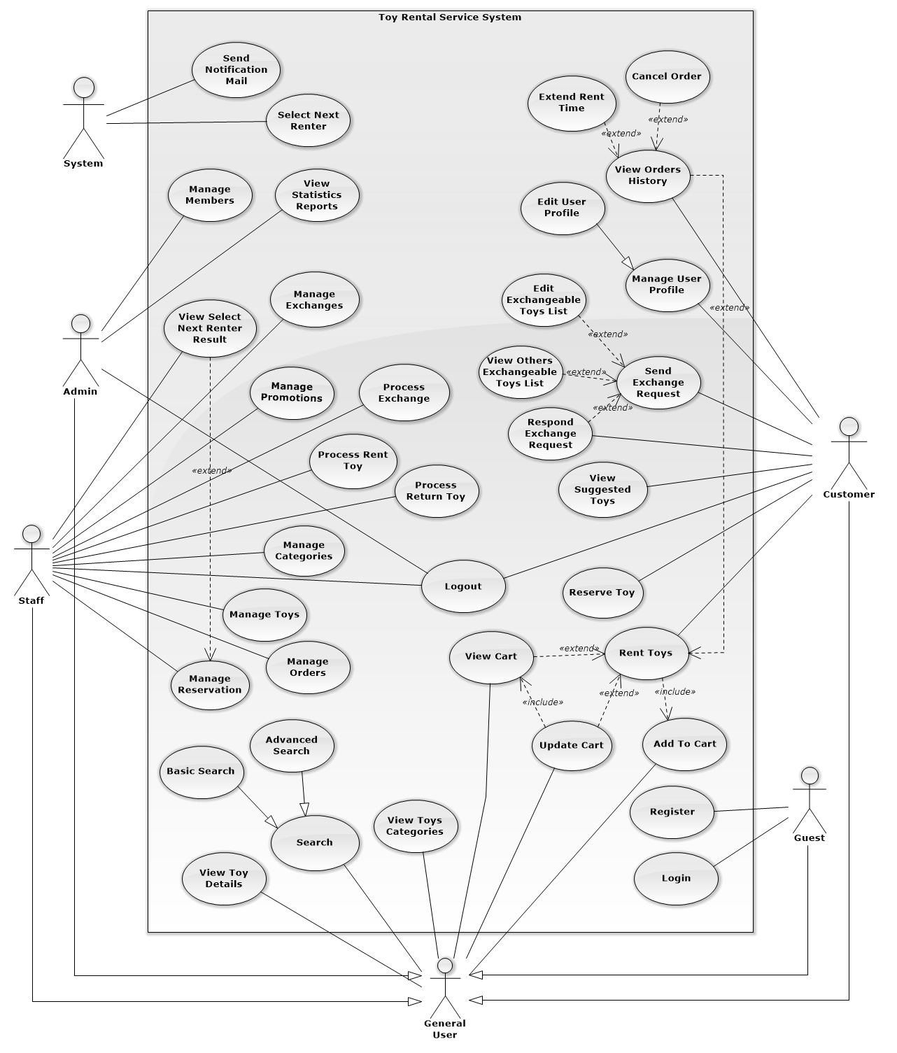

*Figure 2: Use Case Overview*

### System Overview Use Case:

##### **<Guest>Overview Use Case**

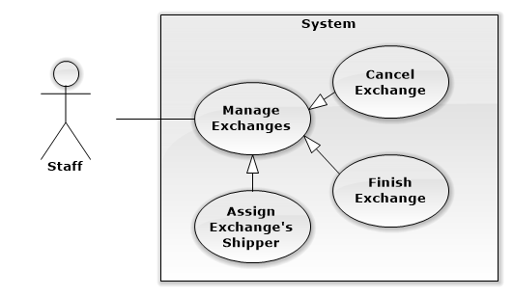

*Figure 3: <Guest>Overview Use Case*

##### **<Guest> Register**

**Use Case Diagram**

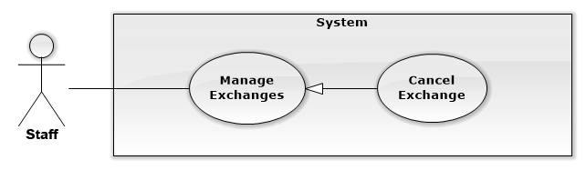

*Figure 4: <Guest> Register*

**Use Case Specification**

|  |  |  |  |
| --- | --- | --- | --- |
| **USE CASE CANCEL EXCHANGE** | | | |
| **Use Case No.** | UC001 | **Use Case Version** | 1.0 |
| **Use Case Name** | Cancel Exchange | | |
| **Author** | Nguyễn Ngọc Tường Vy | | |
| **Date** | 13/09/2014 | **Priority** | Normal |
| **Actor:**   * Staff   **Summary:**   * This use case allows staff to cancel exchange.   **Goal:**   * Staff can cancel an exchange process.   **Triggers:**   * From the sidebar:   + Select “Quản lý trao đổi” menu.   + Select “Trao đổi đã xác nhận” or “Trao đổi đang tiến hành” sub menu   + Clicks “Hủy” button on details of exchange he want to cancel   **Preconditions:**   * User must log in the system with Staff role. * Staff wants to cancel exchange.   **Post Conditions:**   * **Success:** Exchange’s status is update to “cancelled”. * **Fail:** Exchange’s status isn’t updated in database.   **Main Success Scenario:**   |  |  |  | | --- | --- | --- | | Step | Actor Action | System Response | | 1 | Clicks “Hủy” button on details of exchange he want to cancel | Display warning popup to confirm Staff’s action:   * “Bạn có chắc chắn muốn hủy yêu cầu trao đổi này không?” message * “Có” button * “Không” button | | 2 | Clicks “Có” button to confirm [Alternative 1] | Update that exchange’s status to “cancelled”.  Display success message: “Yêu cầu trao đổi đã được hủy”  [Exception 1] |   **Alternative Scenario:**   |  |  |  | | --- | --- | --- | | No | Actor Action | System Response | | 1 | Clicks “Không” button to cancel. | Close warning popup and do nothing. |   **Exceptions:**   |  |  |  | | --- | --- | --- | | No | Actor Action | System Response | | 1 | Cannot update exchange’s status due to database connection. | Display error message: “Không thể hủy trao đổi. Vui lòng thử lại sau” |   **Relationships:** Manage Exchanges  **Business Rules:**   * Exchange with finished status, which staff has finished exchange cannot be canceled. * Staff should notify to customers before cancel their exchange. | | | |

*Table 4: <Staff>Cancel Exchange*

## Software System Attribute

### Reliability

* Mean Time Between Failures is more than 6 months.
* Accuracy: 100%.
* Critical bugs: not any

## Availability

* N/A

## Security

* All input data should be validated before saving to database
* All privacy information, such as password, should be encrypted to ensure security.
* Roles permission should be specify clearly and user should be authenticated and authorized when accessing to the system.

## Maintainability

* All program files shall include comments concerning authorship and date of last change.
* The system should be divided into modules and code should be easy to maintain and extend.

## Portability

* N/A

## Performance

* All requests should be response in no more than 1 minute.

## Conceptual Diagram

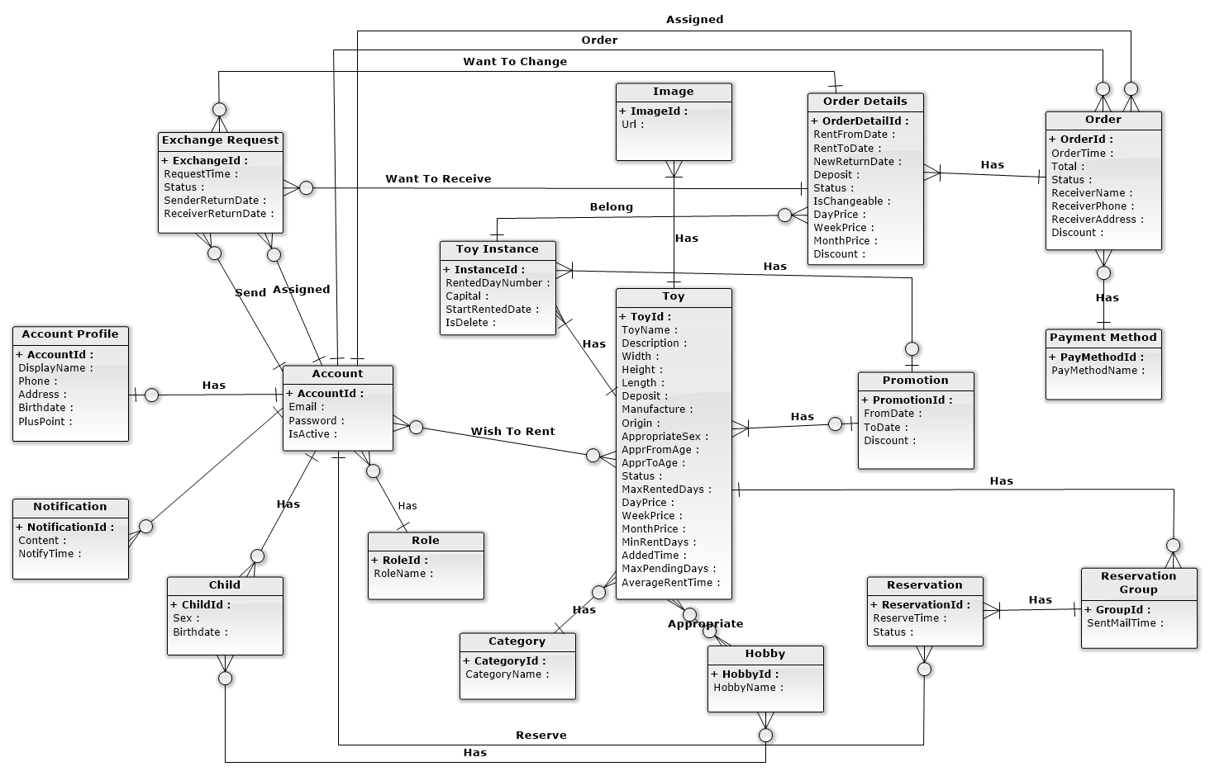

*Figure 68: Entity Relationship Diagram*

|  |  |
| --- | --- |
| **Entity Data dictionary: describe content of all entities** | |
| **Entity Name** | **Description** |
| Account | Describe account of user of system. |
| Role | Describe role of user. One user has one role. |
| Child | Describe child of customers in system. |
| Hobby | Describe all normal hobbies of real child. |
| AccountProfile | Describe information of account in system. |
| Notification | Describe all of user’s notification of the system. |
| Toy | Describe all information of toys in system. |
| Image | Describe all image of toys in system. |
| ToyInstance | Describe all instances of a toy in system. |
| Category | Describe all kind of toys in system. |
| Promotion | Describe all information of promotion in system. |
| OrderDetails | Describe all details of an order in system. |
| Order | Describe all orders of the renter in system. |
| PaymentMethod | Describe all payment method of customer in system. |
| Reservation | Describe all toys booking of customer in system. |
| ReservationGroup | Describe all booking group of each toy in system. |
| ExchangeRequest | Describe toys exchanges of customer in system. |

*Table 54: Entity Data Dictionary*

## Other material (if any)

N/A

# Software Design Description (SDD)

## Design Overview

This document describes the technical and user interface design of the Children's Toy Rental Service Website. Document includes the system architectural design, component diagram, detailed description of the components, user interface, and database design.

The system architectural design describes the overall architecture of the system, general description of the model used, including detailed information for each component, the function of each component in the system, description how the system works and the way that sub-components communicate together.

The component diagram show the physical structure of the command line in accordance with the concept of part code. Contains information about the class or classes that logic execution, component diagram also shows the dependencies between the components together.

The detailed design describes includes class diagrams, class diagram explanations, and sequence diagrams of all use cases. Class diagram describes the static view of system with class concepts and the relationships between them. Sequence diagram describes in detail the interactions between objects.

All diagram using UML 2.0

The user interface design describes the layout of the system.

The database design describes detail entities and relationships between them.

Document overview:

* Section 2: gives an overall description of the system architecture design.
* Section 3: gives component diagrams that describe the connection and integration of the system.
* Section 4: gives the detail design description include class diagram, class explanation
* Section 5: sequence diagram to details the application functions.
* Section 6: overview some main user interface of system.
* Section 7: describe database design and details of database with data dictionary.
* Section 8: describe in details all algorithms used in the system.

## System Architectural Design

### Choice of System Architecture

The system is developed using MVC combine with 3-tiers architechture.

For the view of MVC Architecture:

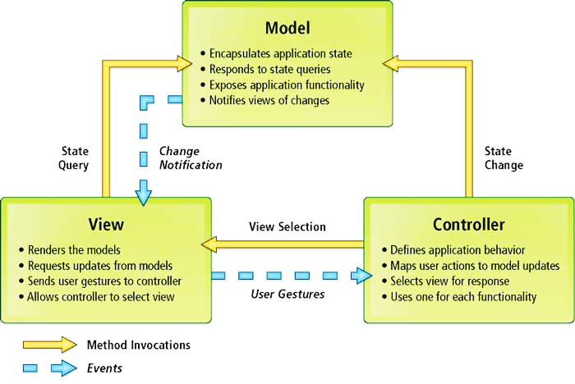

*Figure 69: MVC Architecture*

* **Model.** The model manages the behavior and data of the application domain, responds to requests for information about its state (usually from the view), and responds to instructions to change state (usually from the controller).
* **View.** The view manages the display of information.
* **Controller**. The controller interprets the mouse and keyboard inputs from the user, informing the model and/or the view to change as appropriate.

[<http://msdn.microsoft.com/en-us/library/ff649643.aspx> ]

 3-tier application typically consists of the following levels:

**MODEL**

3-Tier Architecture

MVC Architecture

*Figure 70: 3-tiers Architecture*

* **Data Access** - used for actually interacting with your database and accessing data.
* **Business Logic** - used for adding in your specific business rules, processing and manipulating data and other calculations.
* **Presentation** - used for presenting the actual data to the user.

In the view of 3-tiers, model of MVC includes business layer and data access layer.

### Discussion of Alternative Designs

N/A

### Description of System Interface

N/A

## Component Diagram

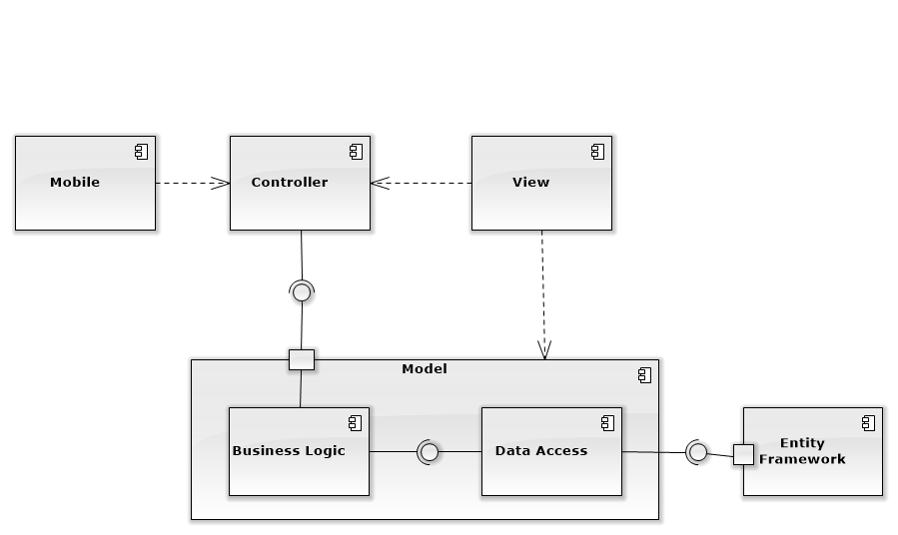

*Figure 71: Component Diagram*

## Detailed Description of Components

### Class Diagram

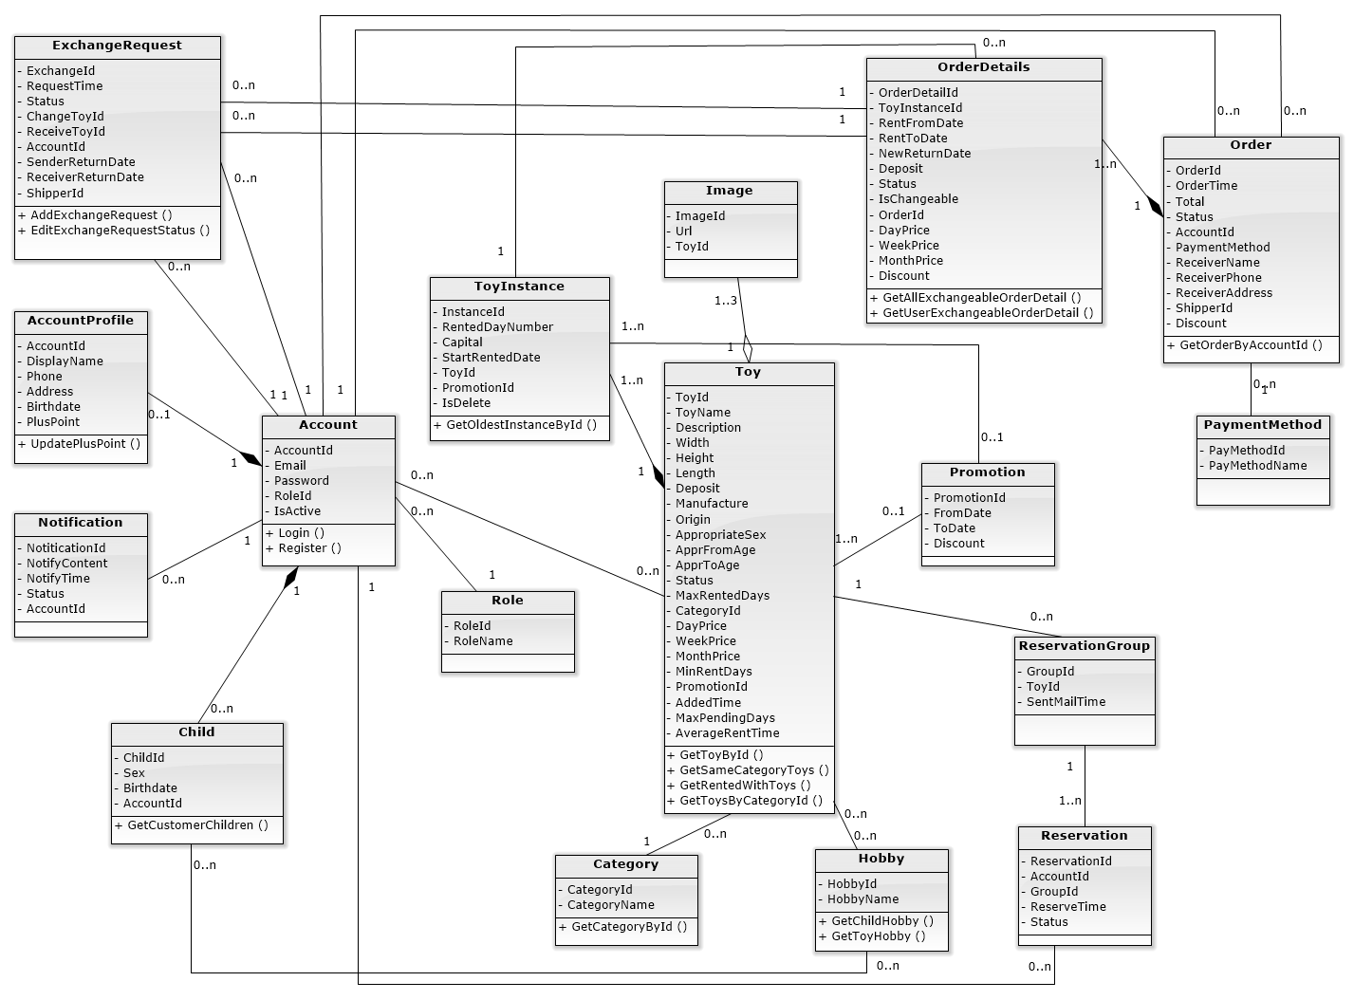

*Figure 72: Class Diagram*

### Class Diagram Explanation

#### OrderDetails

Attribute

|  |  |  |  |
| --- | --- | --- | --- |
| **Attribute** | **Type** | **Visibility** | **Description** |
| OrderDetailId | Int | Public | Unique ID of each order detail |
| ToyInstanceId | Int | Public | ID of rented toy instance |
| RentFromDate | DateTime | Public | Start renting date of this order detail |
| RentToDate | DateTime | Public | Return rented toy date of this order detail |
| NewReturnDate | DateTime | Public | New return rented toy date of this order detail |
| Deposit | Long | Public | Deposit money of rented toy |
| Status | String | Public | Renting status of this order detail |
| IsChangeable | Boolean | Public | State that rented toy is exchangeable or not |
| OrderId | Int | Public | ID of order that order detail belongs to |
| DayPrice | Long | Public | Price for renting toy 1 day |
| WeekPrice | Long | Public | Price for renting toy 1 week |
| MonthPrice | Long | Public | Price for renting toy 1 month |
| Discount | Int | Public | Discount percent of this order detail |

Method

|  |  |  |  |
| --- | --- | --- | --- |
| **Method** | **Return Type** | **Visibility** | **Description** |
| GetAllExchangeableOrderDetail | List<OrderDetail> | Public | Get all order details that can be exchanged |
| GetUserExchangeableOrderDetail | List<OrderDetail> | Public | Get all order detail of current user that can be exchanged |

#### Order

Attribute

|  |  |  |  |
| --- | --- | --- | --- |
| **Attribute** | **Type** | **Visibility** | **Description** |
| OrderId | Int | Public | Unique ID of each order |
| OrderTime | DateTime | Public | Order time of this order |
| Total | Long | Public | Total price of this order |
| Status | String | Public | Renting status of this order |
| AccountId | Int | Public | Account ID of customer |
| PaymentMethod | Int | Public | ID of this order payment method |
| ReceiverName | String | Public | Name of order receiver |
| ReceiverPhone | String | Public | Phone number of order receiver |
| ReceiverAddress | String | Public | Address to deliver order |
| ShipperId | Int | Public | ShipperId of order |
| Discount | Int | Public | Discount of order |

Method

|  |  |  |  |
| --- | --- | --- | --- |
| **Method** | **Return Type** | **Visibility** | **Description** |
| GetOrderByAccountId | List<Order> | Public | Get all order of current customer |

#### ExchangeRequest

Attribute

|  |  |  |  |
| --- | --- | --- | --- |
| **Attribute** | **Type** | **Visibility** | **Description** |
| ExchangeId | Int | Public | Unique ID of each exchange request |
| ChangeToyId | Int | Public | ID of exchange order detail of request sender |
| ReceiveToyId | Int | Public | ID of exchange order detail of request receiver |
| Status | String | Public | Renting status of exchange request |
| RequestTime | DateTime | Public | Time when sender send exchange request |
| AccountId | Int | Public | ID of exchange request sender |
| SenderReturnDate | DateTime | Public | Sender selected return date of exchange toy |
| ReceiverReturnDate | DateTime | Public | Receiver selected return date of exchange toy |
| ShipperId | Int | Public | ShipperId of order |

Method

|  |  |  |  |
| --- | --- | --- | --- |
| **Method** | **Return Type** | **Visibility** | **Description** |
| AddExchangeRequest | Boolean | Public | Create new exchange request |
| EditExchangeRequestStatus | Boolean | Public | Edit exchange request status when customer confirm/ deny request or staff complete delivering |

#### Reservation

Attribute

|  |  |  |  |
| --- | --- | --- | --- |
| **Attribute** | **Type** | **Visibility** | **Description** |
| ReservationId | Int | Public | Unique ID of each reservation |
| AccountId | Int | Public | ID of customer who make this reservation |
| GroupId | Int | Public | ID of group that reservation belong to |
| ReserveTime | DateTime | Public | Time when customer make this reservation |
| Status | Boolean | Public | Describe this reservation is done or not |

#### ReservationGroup

Attribute

|  |  |  |  |
| --- | --- | --- | --- |
| **Attribute** | **Type** | **Visibility** | **Description** |
| GroupId | Int | Public | Unique ID of each reservation group |
| ToyId | String | Public | ID of toy that reservation group reserved |
| SentMailTime | DateTime | Public | Time when system send mail to customer group to notify reserved toy availability |

#### PaymentMethod

Attribute

|  |  |  |  |
| --- | --- | --- | --- |
| **Attribute** | **Type** | **Visibility** | **Description** |
| PayMethodId | Int | Public | Unique ID of each payment method |
| PayMethodName | String | Public | Name of payment method |

#### Toy

Attribute

|  |  |  |  |
| --- | --- | --- | --- |
| **Attribute** | **Type** | **Visibility** | **Description** |
| ToyId | String | Public | Unique identifier of a toy |
| ToyName | String | Public | Name of a toy |
| Description | String | Public | Information about a toy |
| Width | Float | Public | Width of a toy |
| Height | Float | Public | Height of a toy |
| Length | Float | Public | Length of a toy |
| Deposit | Long | Public | Price to deposit a toy |
| Manufacture | String | Public | Manufacture of a toy |
| Origin | String | Public | Origin of a toy |
| AppropriateSex | Int | Public | Sex suitable with a toy |
| AppropFromAge | Int | Public | Suitable age for start to play a toy |
| AppropToAge | Int | Public | Suitable age for end to play a toy |
| Status | String | Public | Status shows state of a toy |
| MaxRentedDays | Int | Public | Sum of days for rent a toy |
| CategoryId | Int | Public | Id of kind of toy. |
| DayPrice | Long | Public | Price of toy in a day |
| WeekPrice | Long | Public | Price of toy in week |
| MonthPrice | Long | Public | Price of toy in a month |
| MinRentDays | Int | Public | Limit day for rent a toy |
| AddedTime | DateTime | Public | Time starts add to order |
| MaxPendingDays | Int | Public | Time limit to start rent a toy |
| PromotionId | Int | Public | ID of promotion for each toy |
| AverageRentTime | Float | Public | Average rent time of toy |

Method

|  |  |  |  |
| --- | --- | --- | --- |
| **Method** | **Return Type** | **Visibility** | **Description** |
| GetNewestToys | List<Toy> | Public | Get the toy newest. |
| GetToyById | Toy | Public | Get the toy follow id |
| GetSameCategoryToys | List<Toy> | Public | Get all toys that same category |
| GetRentedWithToy | List<Toy> | Public |  |
| GetToyByCategoryId | List<Toy> | Public | Get all toys follow categoryId |
| GetQuantityInstancesById | Int | Public | Get amount instance exist in storage. |
| GetSuggestToyForChild | List<Toy> | Public | Get all toy suitable for child |
| UpdateStatusOfToy | Boolean | Public | Edit status of toy |

#### ToyInstance

Attribute

|  |  |  |  |
| --- | --- | --- | --- |
| **Attribute** | **Type** | **Visibility** | **Description** |
| InstanceId | Int | Public | Unique Id of each instance. |
| RentedDayNumber | Int | Public | Amount of days instance is rented |
| Capital | Long | Public | Funds of a toy. |
| StartRentedDate | DateTime | Public | The date a toys start to rent |
| ToyId | String | Public | ID of main toy |
| PromotionId | Int | Public | ID of promotion |
| IsDelete | Boolean | Public | Describe this toy instance is deleted or not |

Method

|  |  |  |  |
| --- | --- | --- | --- |
| **Method** | **Return Type** | **Visibility** | **Description** |
| GetOldestInstanceById | ToyInstance | Public | Get instance that is the oldest in all instances same id |

#### Account

Attribute

|  |  |  |  |
| --- | --- | --- | --- |
| **Attribute** | **Type** | **Visibility** | **Description** |
| AccountId | Int | Public | Unique identifier of an account |
| Email | String | Public | Email using to login into system |
| Password | String | Public | Password to login into system |
| RoleId | Int | Public | Role ID of each account |
| isActive | Boolean | Public | Describe this account is active or not |

Method

|  |  |  |  |
| --- | --- | --- | --- |
| **Method** | **Return Type** | **Visibility** | **Description** |
| GetAccountById | Account | Public | Get all information of current account by id |
| CheckLogin | Account | Public | Check username, password and login in system |
| GetAccountRegisterByEmail | Account | Public | Get account by email |
| CheckExistEmail | Account | Public | Check email input exist or not |
| CreateNewAccount | Boolean | Public | Create new account |
| CreateNewAccountProfile | Boolean | Public | Create new account profile |

#### AccountProfile

Attribute

|  |  |  |  |
| --- | --- | --- | --- |
| **Attribute** | **Type** | **Visibility** | **Description** |
| AccountId | Int | Public | Unique identifier of an account |
| DisplayName | String | Public | Name of customer |
| Phone | String | Public | Phone number of customer |
| Address | String | Public | Address of customer |
| Birthdate | DateTime | Public | Birthdate of customer |
| PlusPoint | Int | Public | Plus point having when customer rented toy |

Method

|  |  |  |  |
| --- | --- | --- | --- |
| **Method** | **Return Type** | **Visibility** | **Description** |
| UpdatePlusPoint | Boolean | Public | Update plus point of a customer |
| GetCusProfileById | CustomerProfile | Public | Get profile of a customer. |
| UpdateCusProfile | Boolean | Public | Edit profile of a customer |

#### Image

Attribute

|  |  |  |  |
| --- | --- | --- | --- |
| **Attribute** | **Type** | **Visibility** | **Description** |
| ImageId | Int | Public | Unique identifier of an image |
| Url | String | Public | This is link of a image in system. |
| ToyId | String | Public | Id of toy |

#### Promotion

Attribute

|  |  |  |  |
| --- | --- | --- | --- |
| **Attribute** | **Type** | **Visibility** | **Description** |
| PromotionId | Int | Public | Unique identifier of a promotion |
| FromDate | DateTime | Public | The date start a promotion. |
| ToDate | DateTime | Public | The date end of a promotion |
| Discount | Int | Public | Percent discount toys. |

#### Category

Attribute

|  |  |  |  |
| --- | --- | --- | --- |
| **Attribute** | **Type** | **Visibility** | **Description** |
| CategoryId | Int | Public | Unique identifier of a category |
| CategoryName | String | Public | Name of a category |

#### Notification

Attribute

|  |  |  |  |
| --- | --- | --- | --- |
| **Attribute** | **Type** | **Visibility** | **Description** |
| NotificationId | Int | Public | Unique ID of each notify. |
| NotifyContent | String | Public | Include content of notify. |
| NotifyTime | DateTime | Public | Time that notification is sent |
| Status | String | Public | Reading status of this notification |
| AccountId | int | Public | Id of account receive notification |

#### Role

Attribute

|  |  |  |  |
| --- | --- | --- | --- |
| **Attribute** | **Type** | **Visibility** | **Description** |
| RoleId | Int | Public | Unique ID of each role |
| RoleName | String | Public | Name of each role |

#### Child

Attribute

|  |  |  |  |
| --- | --- | --- | --- |
| **Attribute** | **Type** | **Visibility** | **Description** |
| ChildId | Int | Public | Unique ID of each child |
| Sex | Boolean | Public | Gender of child |
| Birthdate | DateTime | Public | Birthdate of child |
| AccountId | Int | Public | ID of customer who this child belongs to |

Method

|  |  |  |  |
| --- | --- | --- | --- |
| **Method** | **Return Type** | **Visibility** | **Description** |
| GetChildById | Child | Public | Get child by child id |
| GetCustomerChildren | List <Child> | Public | Get all customer children by account id |

#### Hobby

Attribute

|  |  |  |  |
| --- | --- | --- | --- |
| **Attribute** | **Type** | **Visibility** | **Description** |
| HobbyId | Int | Public | Unique ID of each hobby |
| HobbyName | String | Public | Name of each hobby |

Method

|  |  |  |  |
| --- | --- | --- | --- |
| **Method** | **Return Type** | **Visibility** | **Description** |
| GetChildHobby | List <Hobby> | Public | Get all hobby of child |
| GetToyHobby | List <Hobby> | Public | Get all hobby of toy |

## Sequence Diagram

### Add Exchangeable Toy

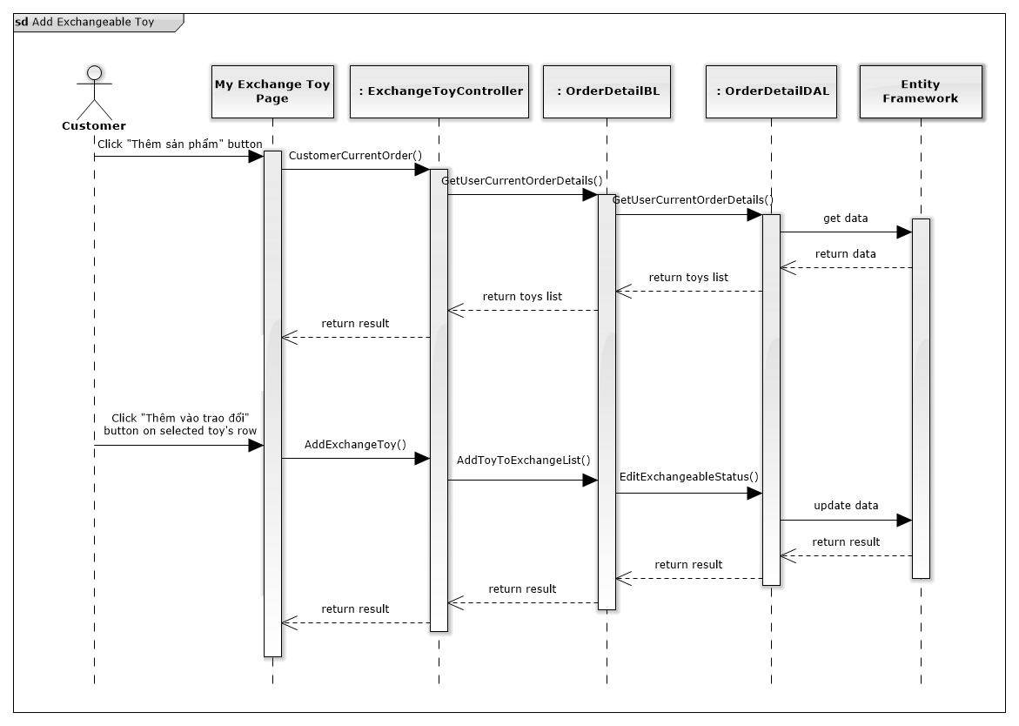

*Figure 73: Add Exchangeable Toy Sequence Diagram*

### Remove Exchangeable Toy

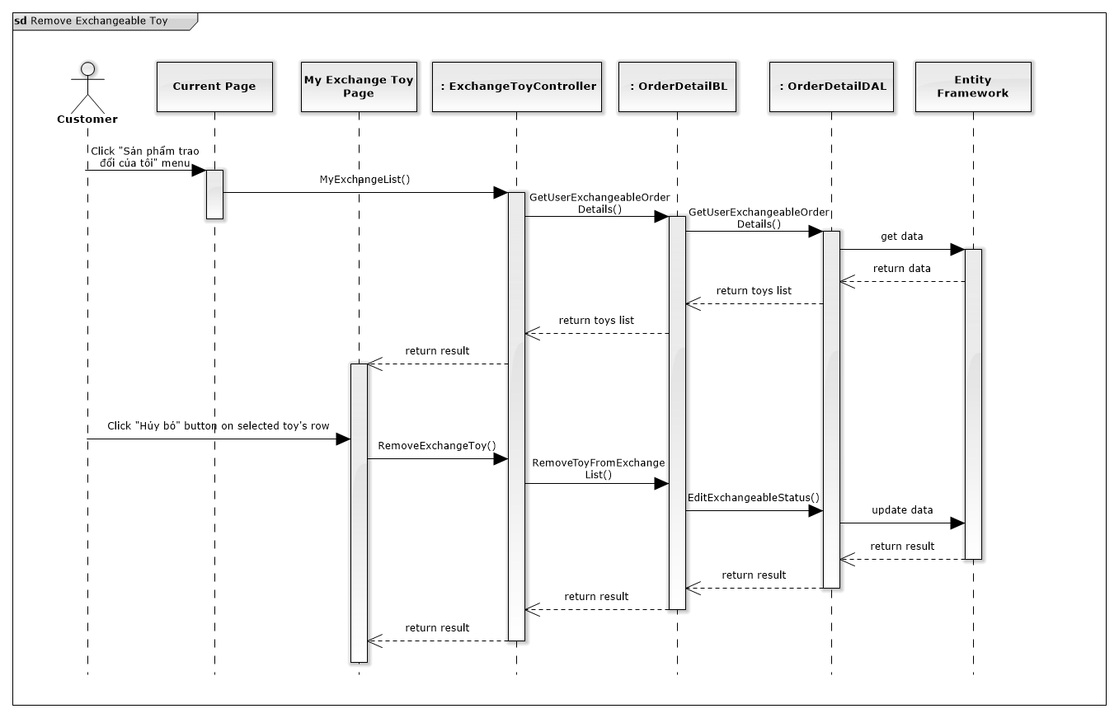

*Figure 74: Remove Exchangeable Toy Sequence Diagram*

### View All Exchangeable Toys

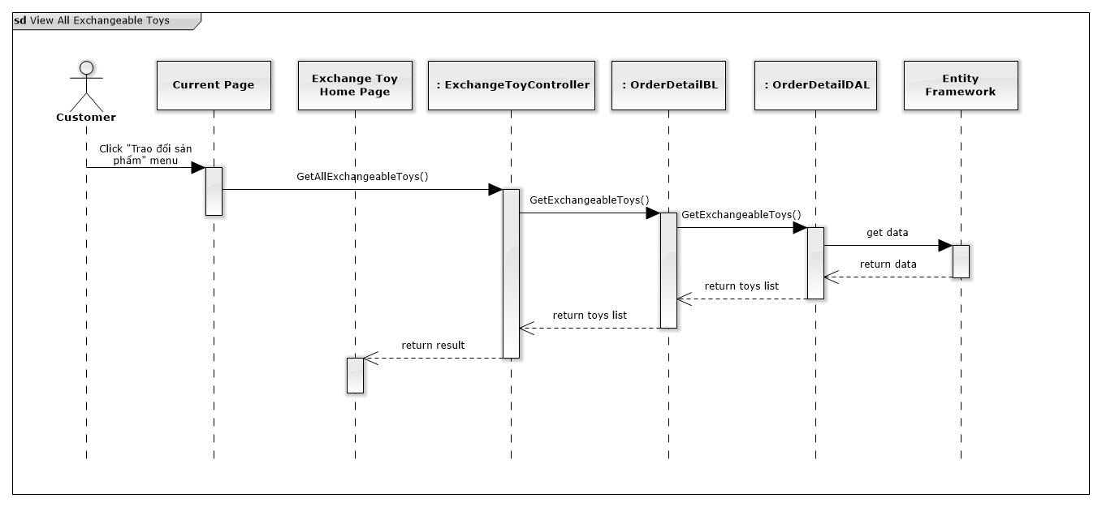

*Figure 75: View All Exchangeable Toys*

### Send Exchange Request

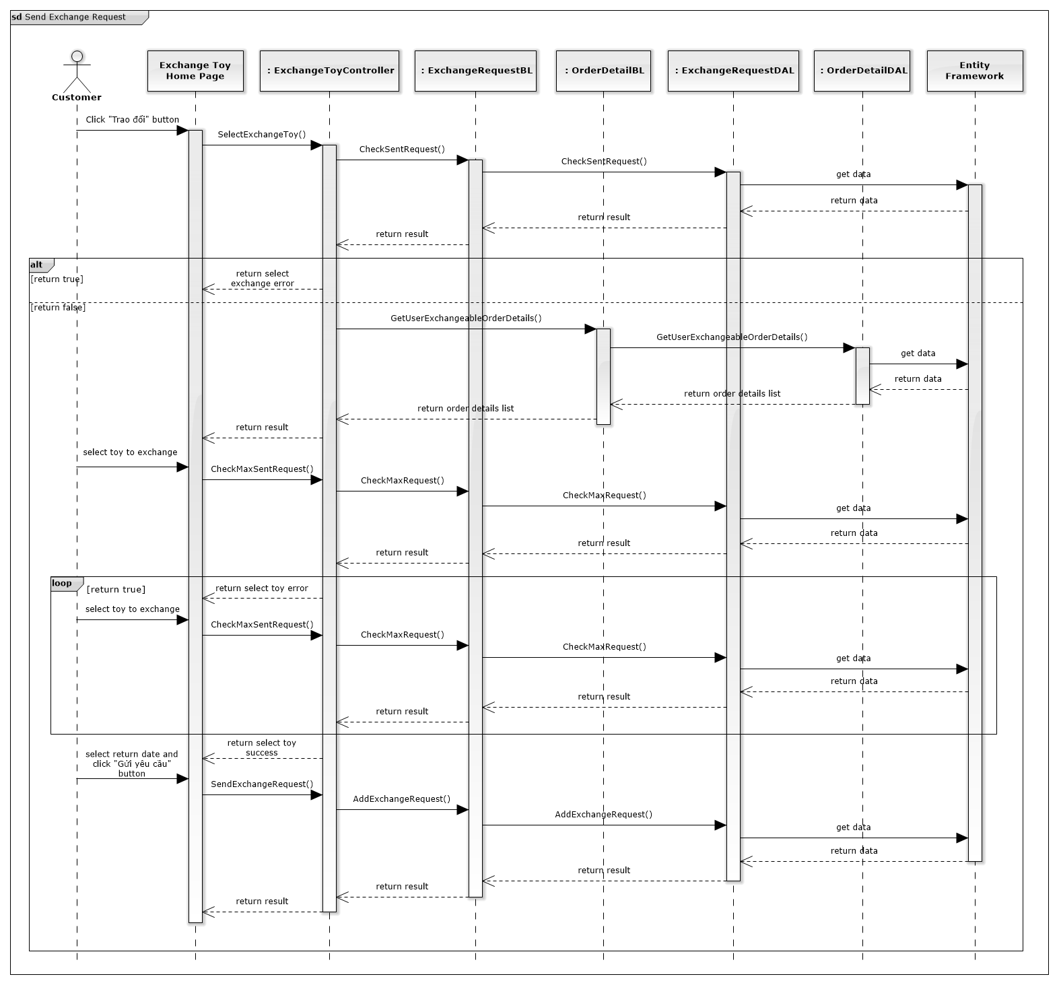

*Figure 76: Send Exchange Request Sequence Diagram*

### View Exchange Request

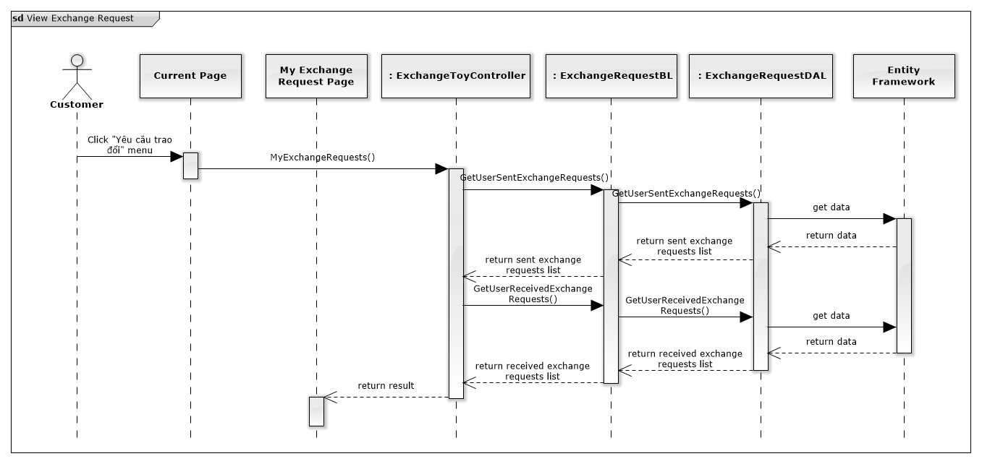

*Figure 77: View Exchange Request*

### Respond Exchange Request

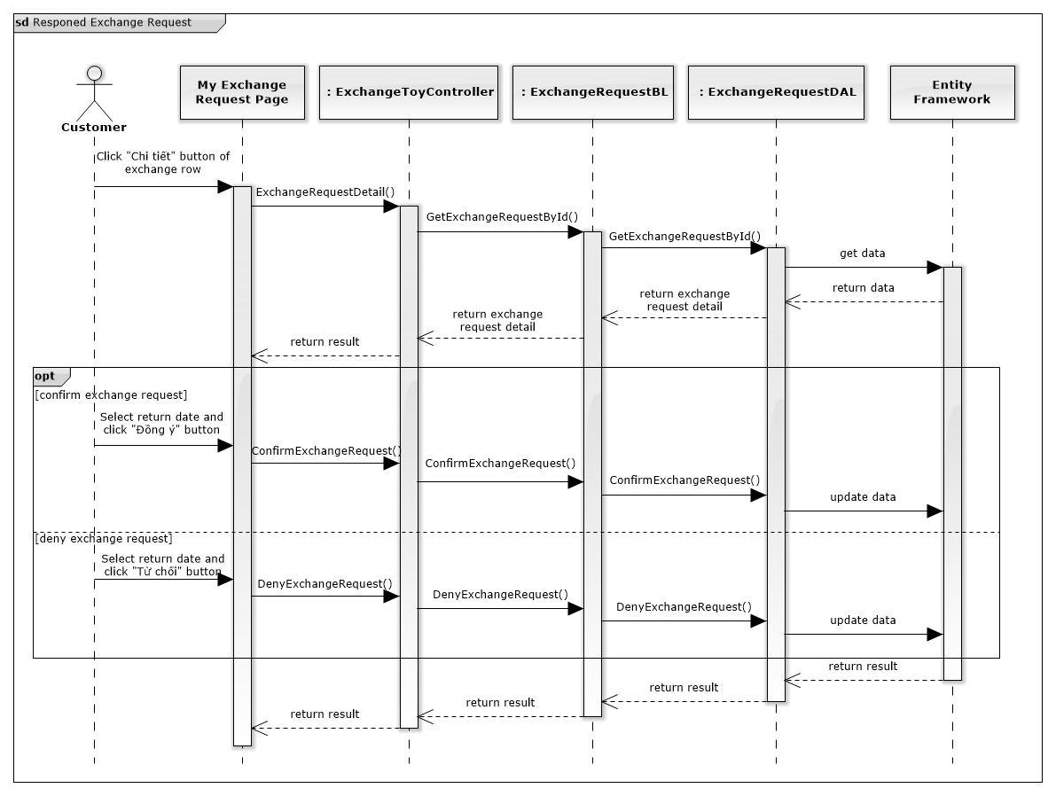

*Figure 78: Respond Exchange Request Sequence Diagram*

### Finish Exchange

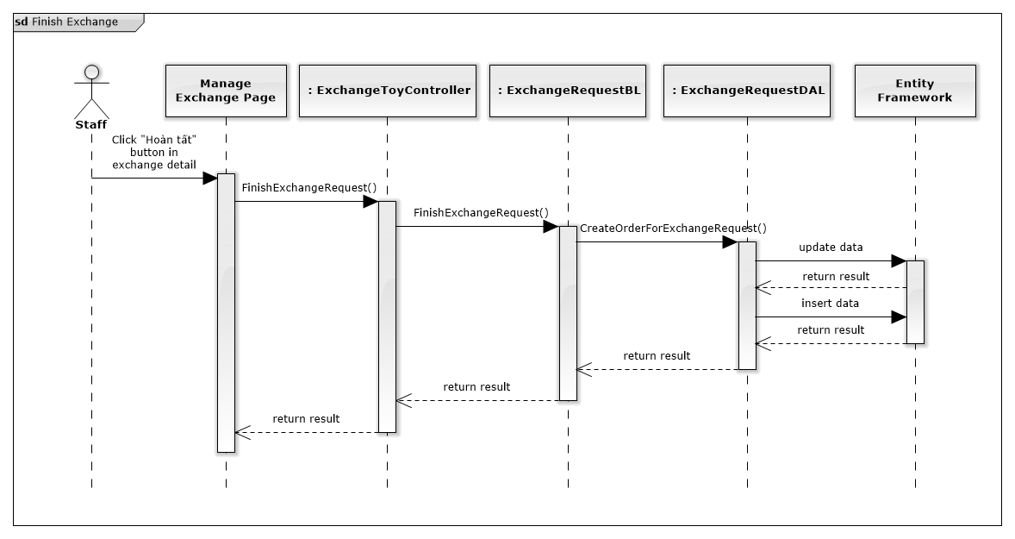

*Figure 79: Finish Exchange Sequence Diagram*

### Cancel Exchange

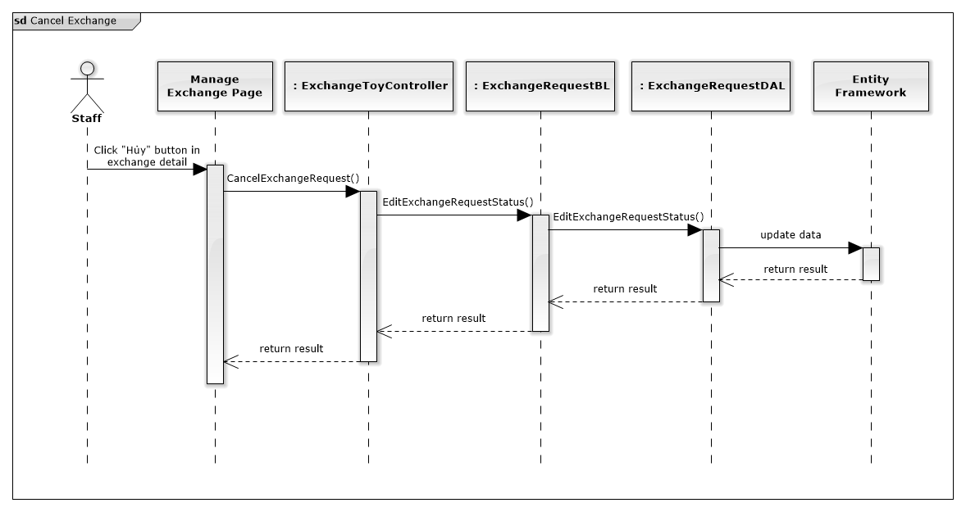

*Figure 80: Cancel Exchange Sequence Diagram*

### Assign Shipper For Exchange

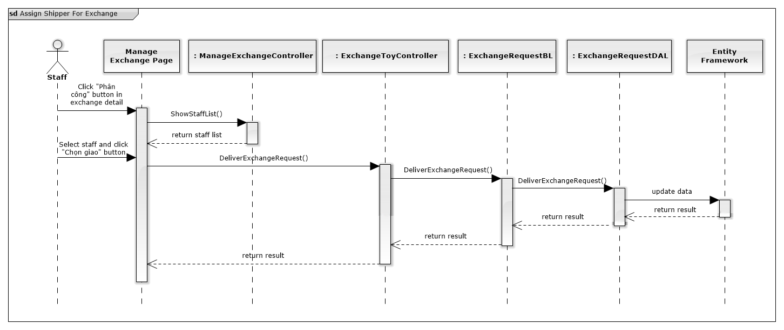

*Figure 81: Assign Shipper For Sequence Diagram*

### Add To Cart

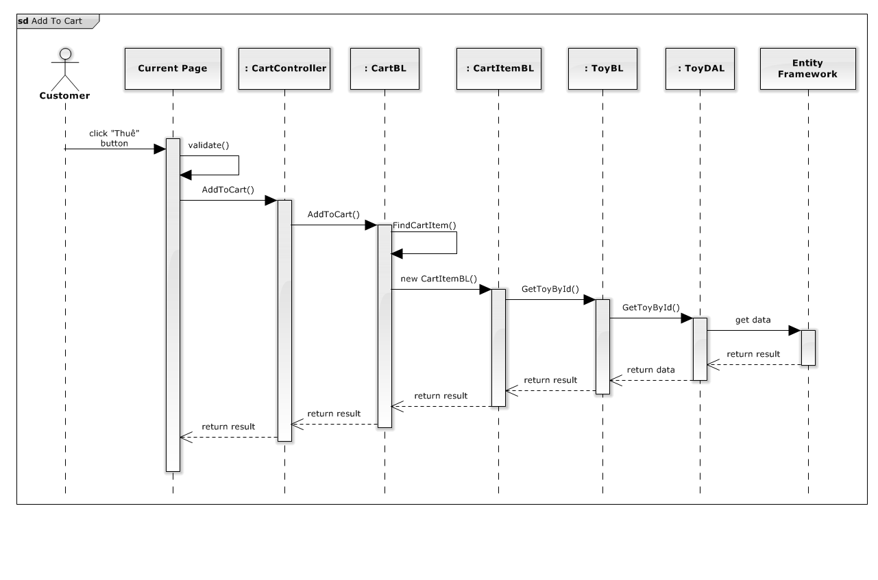

*Figure 82: Add To Cart Sequence Diagram*

### Update Cart

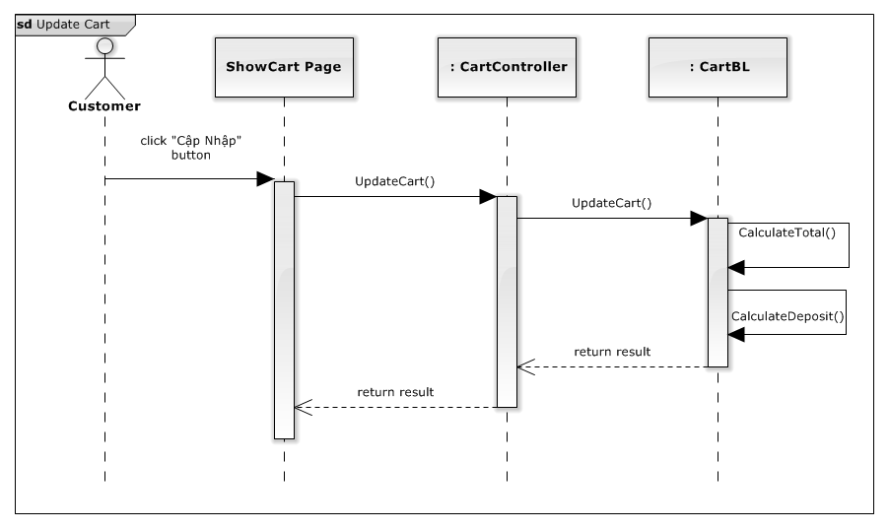

*Figure 83: Update Cart Sequence Diagram*

### Remove Cart

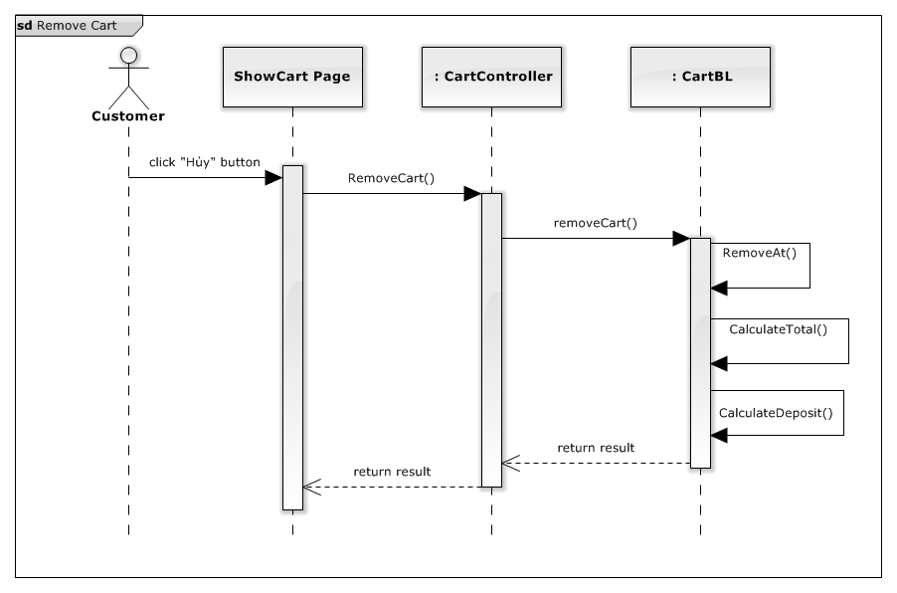

*Figure 84: Remove Cart Sequence Diagram*

### View Cart

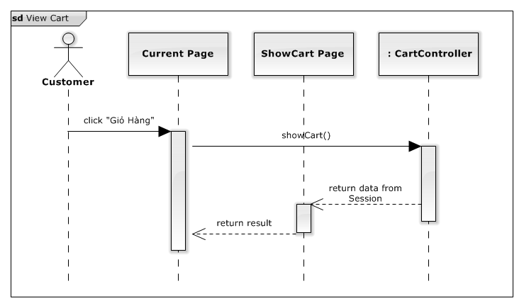

*Figure 85: View Cart Sequence Diagram*

### View Order History

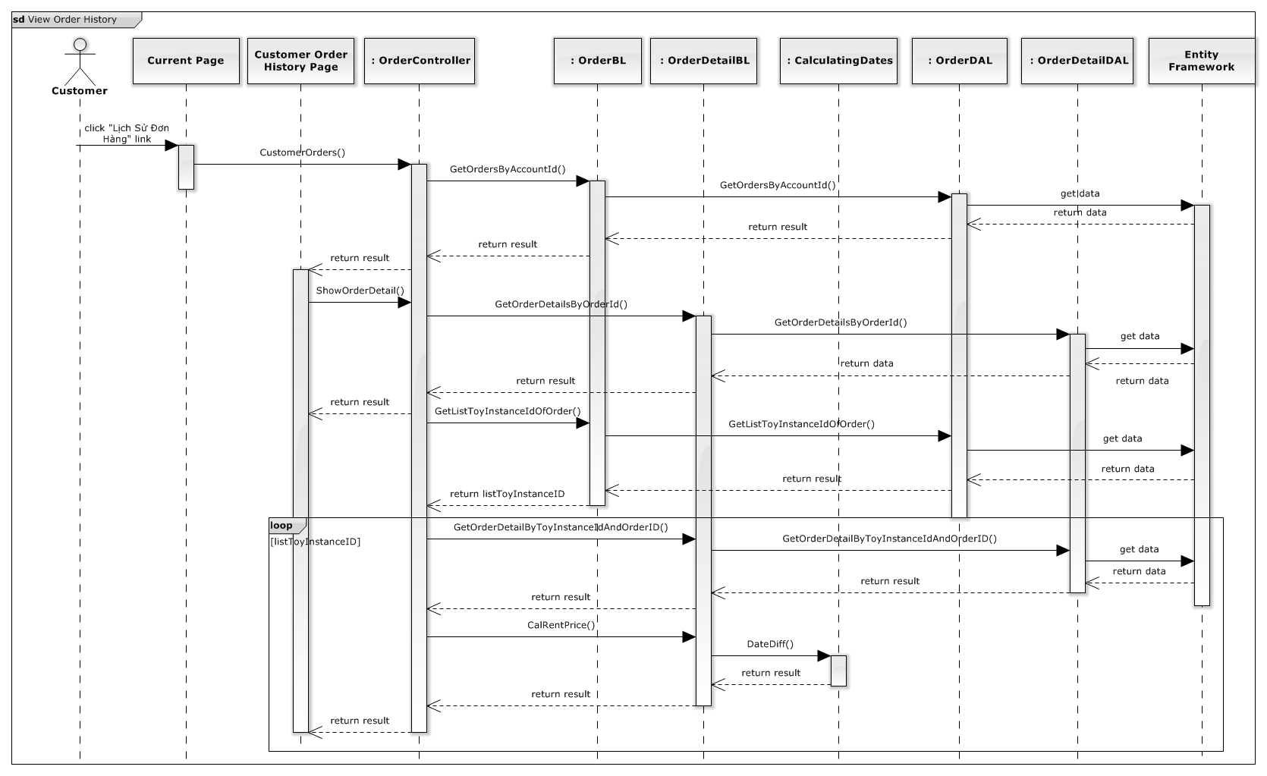

*Figure 86: View Order History Sequence Diagram*

### Cancel Order

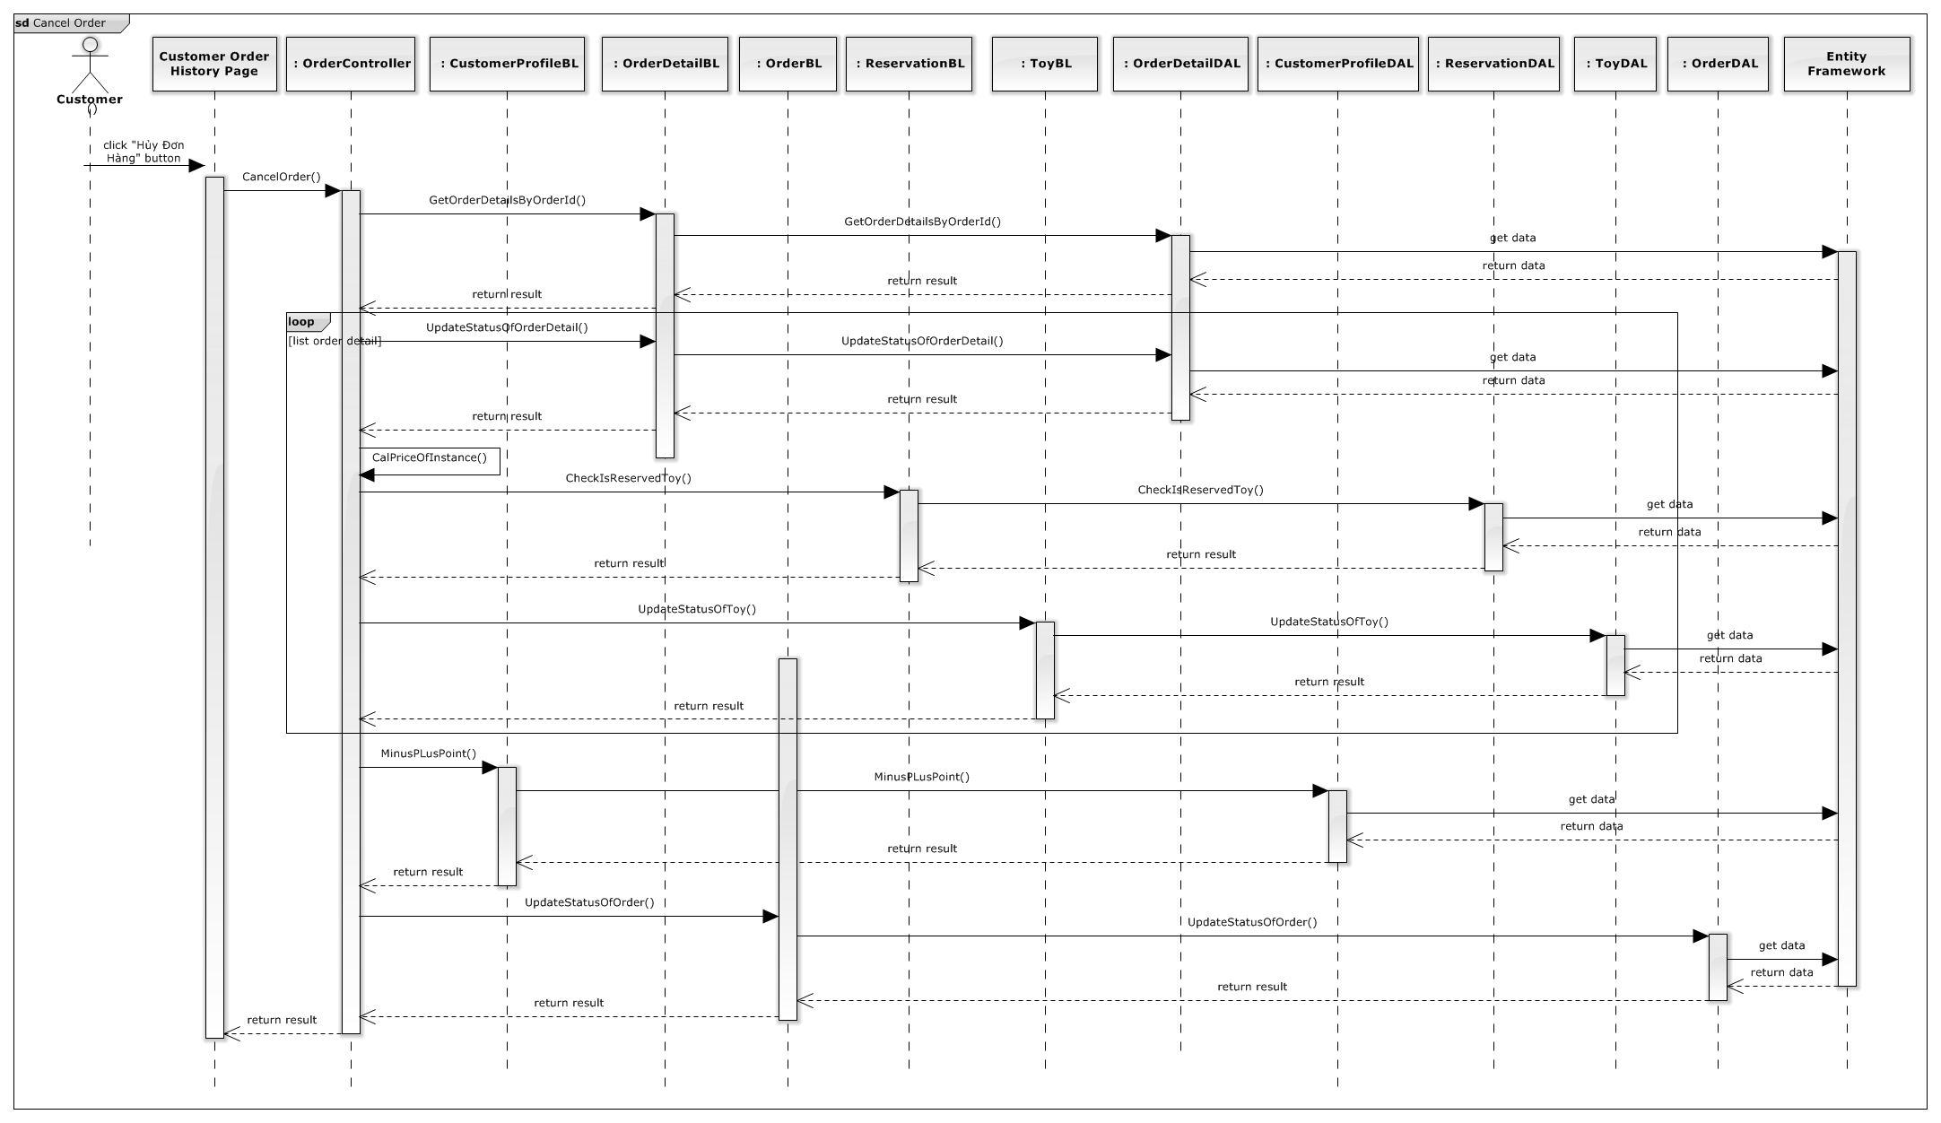

*Figure 87: Cancel Order Sequence Diagram*

### Cancel Rented Toy

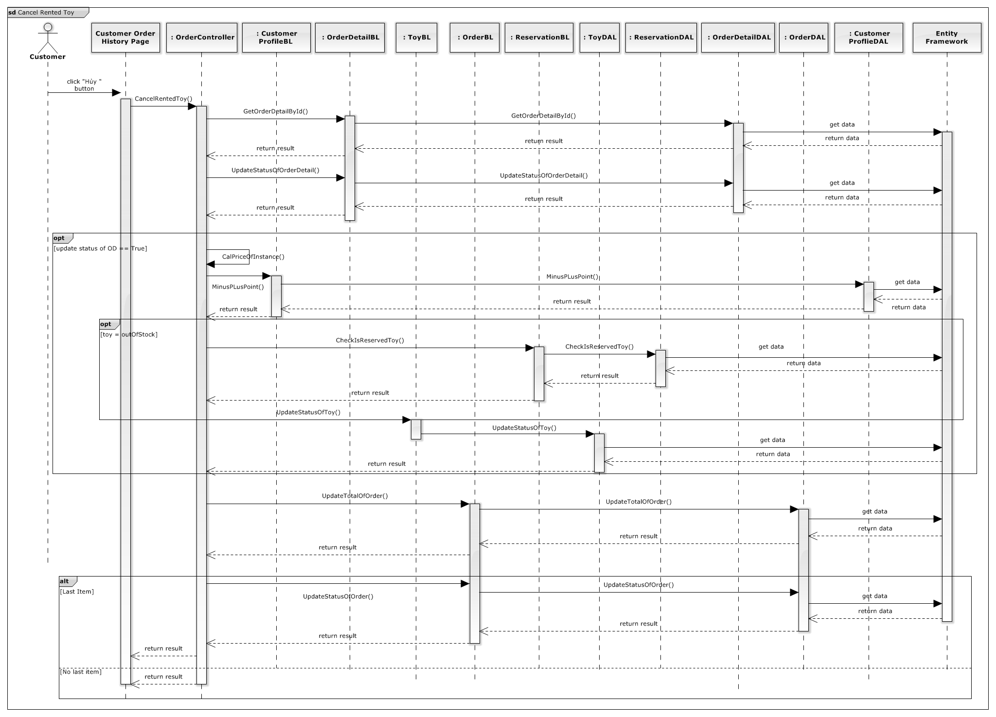

*Figure 88: Cancel Rented Toy Sequence Diagram*

### Return Toy Soon

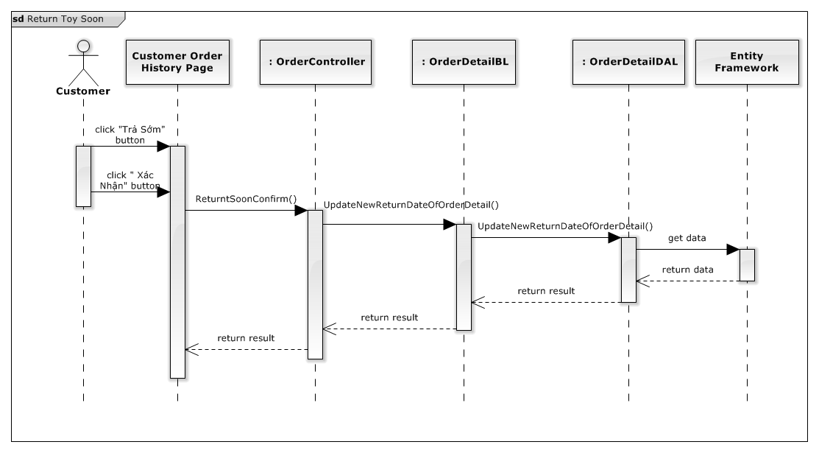

*Figure 89: Return Toy Soon Sequence Diagram*

### Login

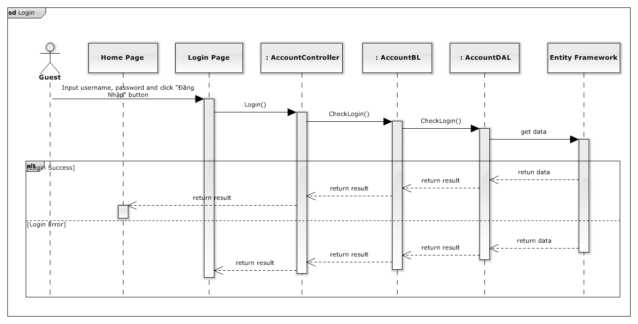

*Figure 90: Login Sequence Diagram*

### Logout

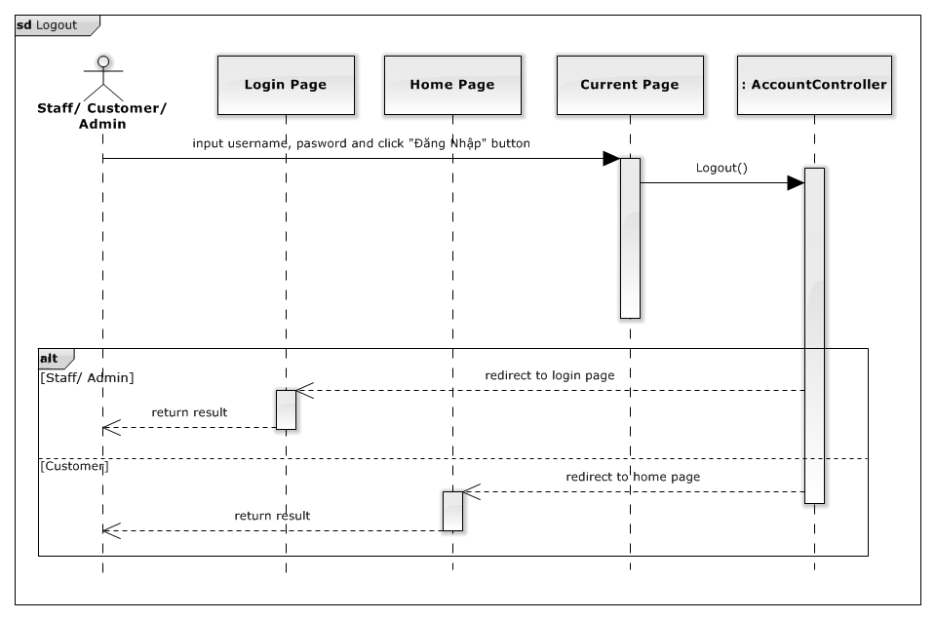

*Figure 91: Logout Sequence Diagram*

### View Toy Details

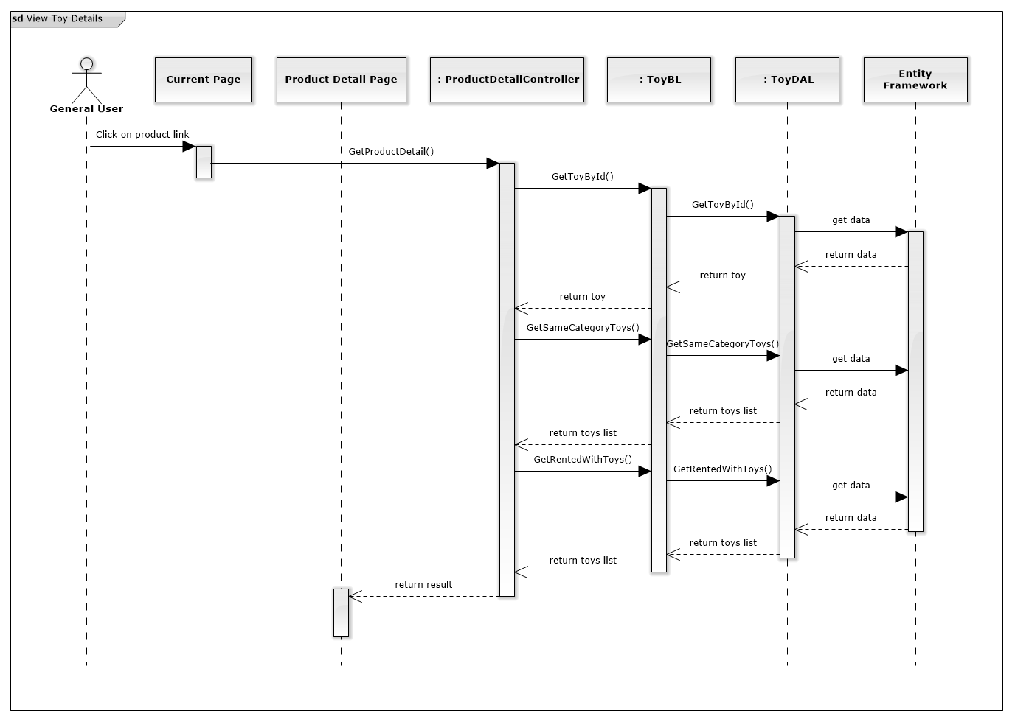

*Figure 92: View Toy Detail Sequence Diagram*

### View Toy Categories

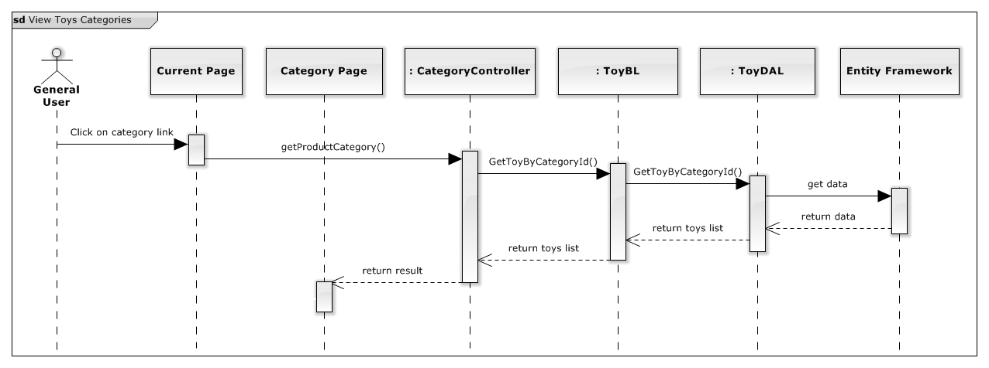

*Figure 93: View Toy Categories Sequence Diagram*

### Checkout Payment Cash On Delivery

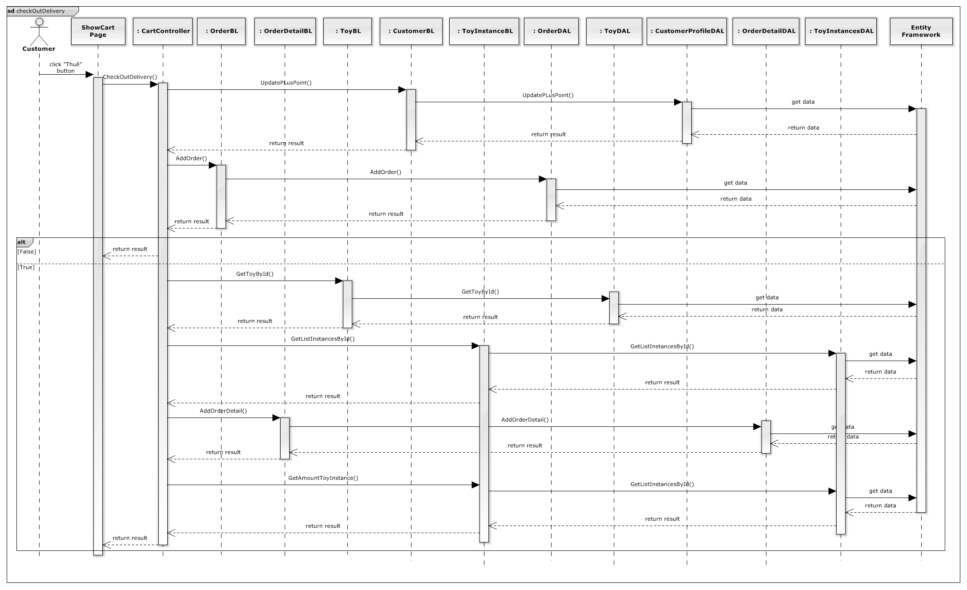

*Figure 94: Checkout Payment Cash On Delivery Sequence Diagram*

### Checkout Payment Online

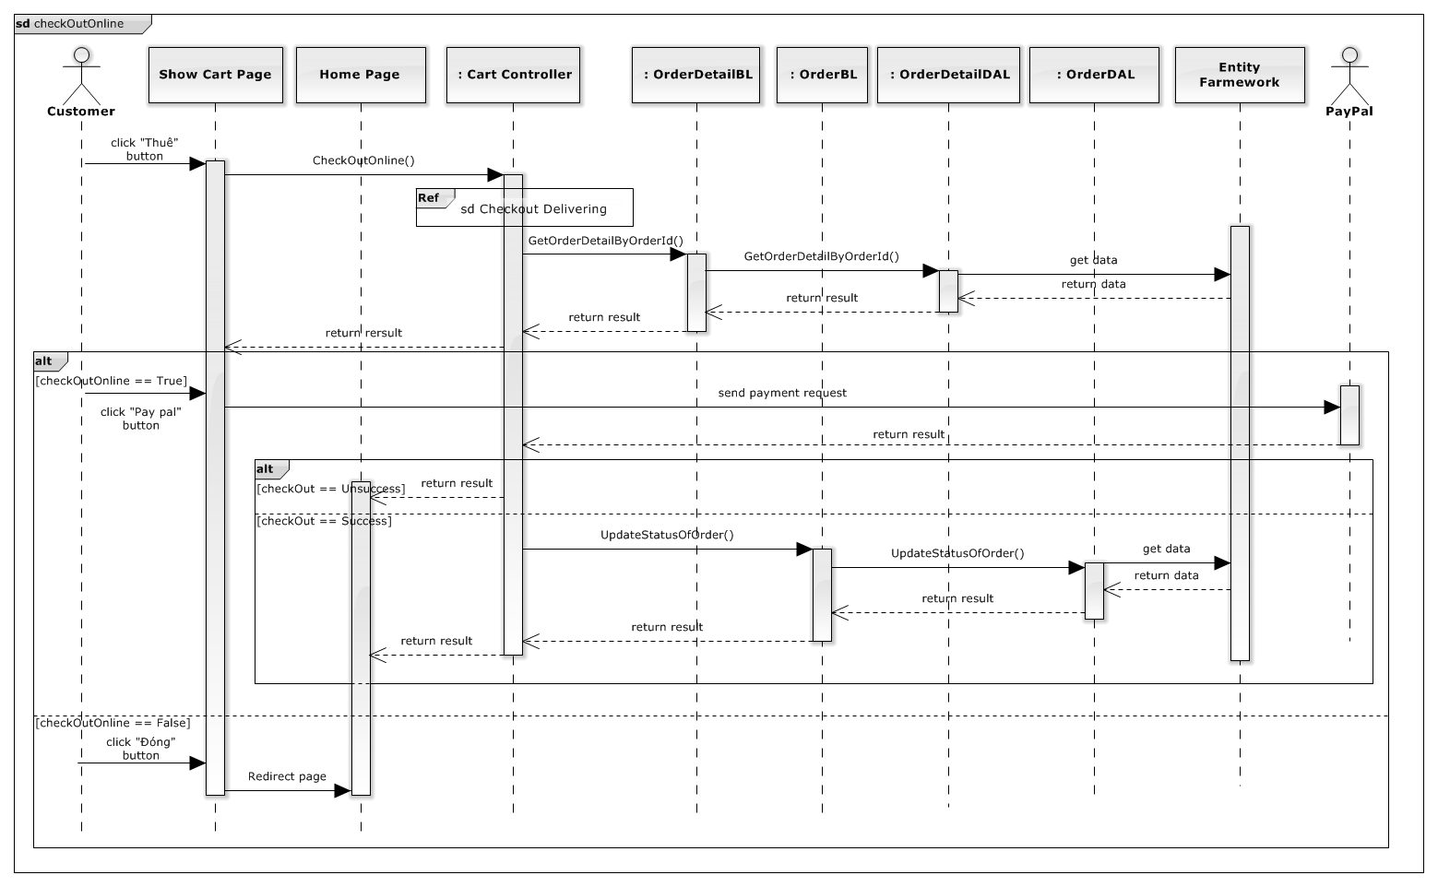

*Figure 95: Checkout Payment Online Sequence Diagram*

### Return Toy

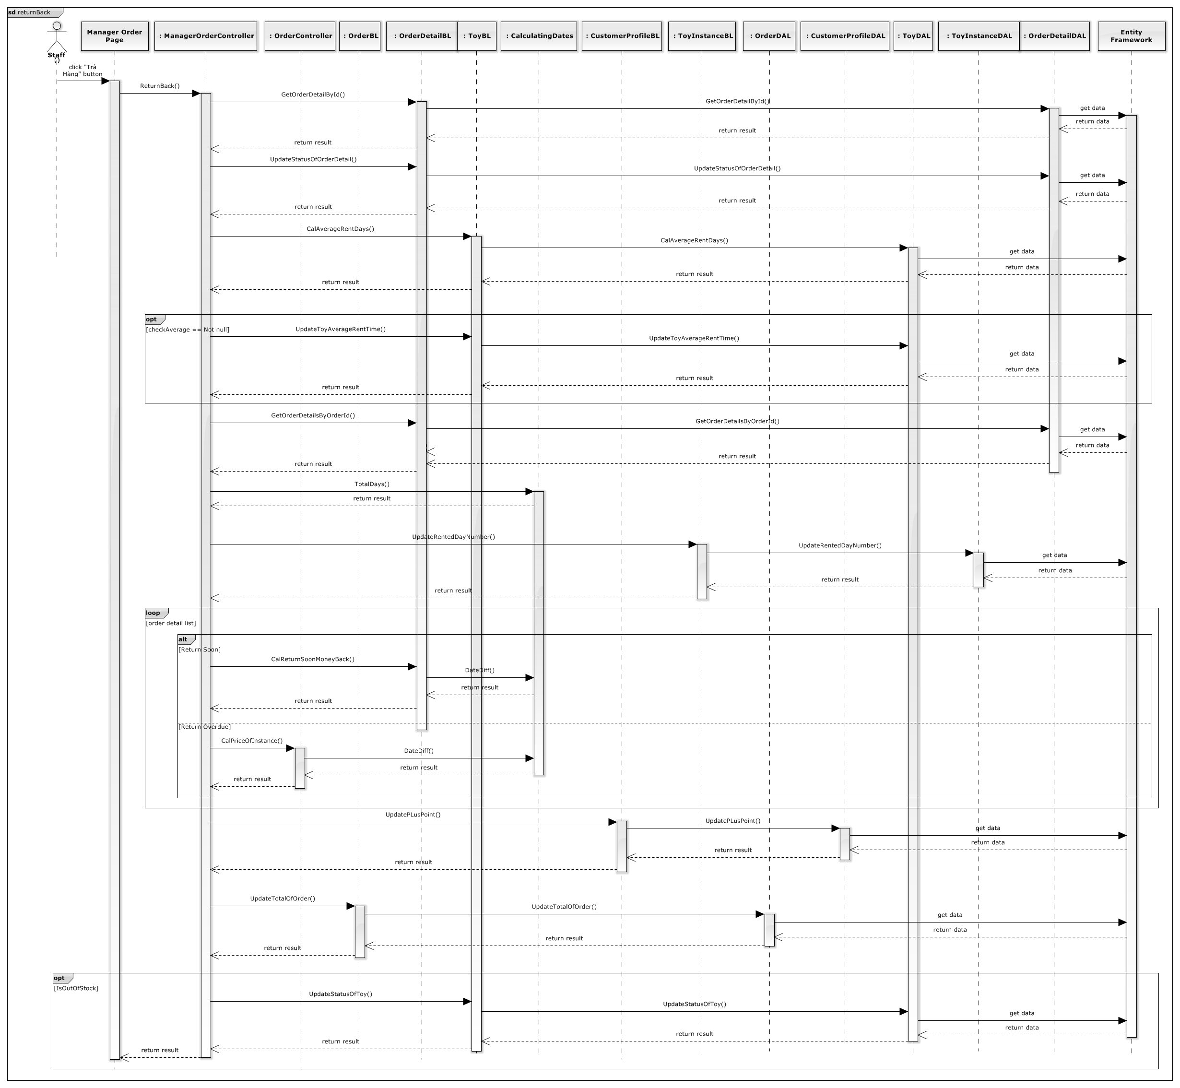

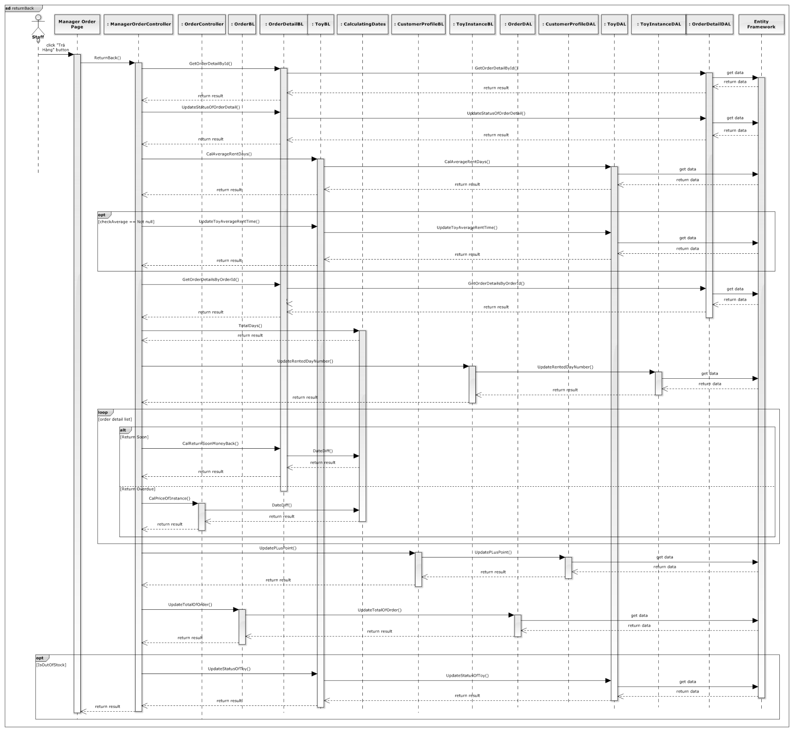

*Figure 96: Return Toy Sequence Diagram*

### Advanced Search

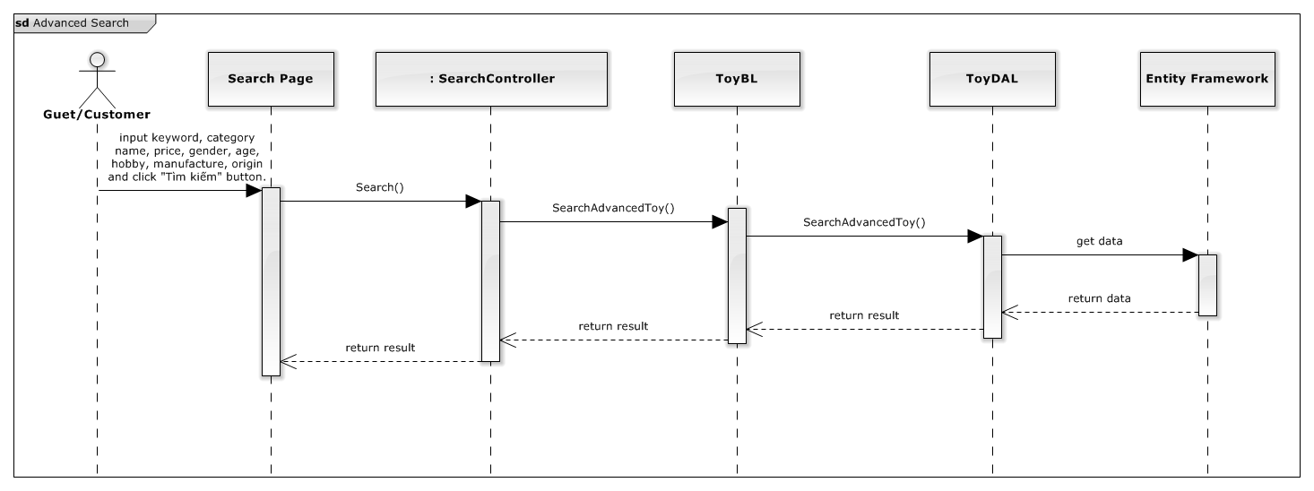

*Figure 97: Advanced Search Sequence Diagram*

### Basic Search

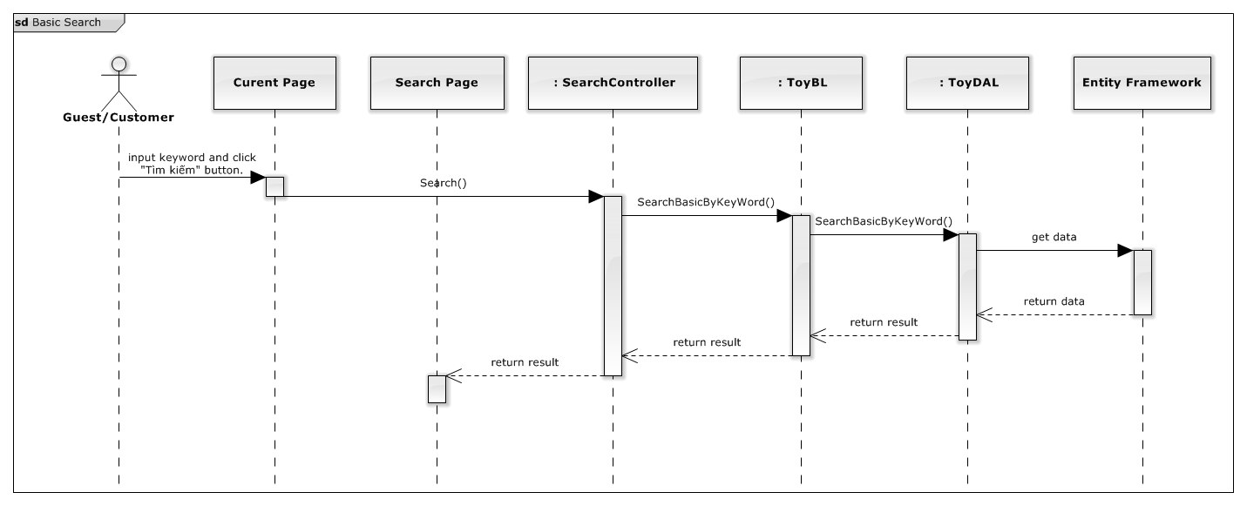

*Figure 98: Basic Search Sequence Diagram*

### Reserve Toy

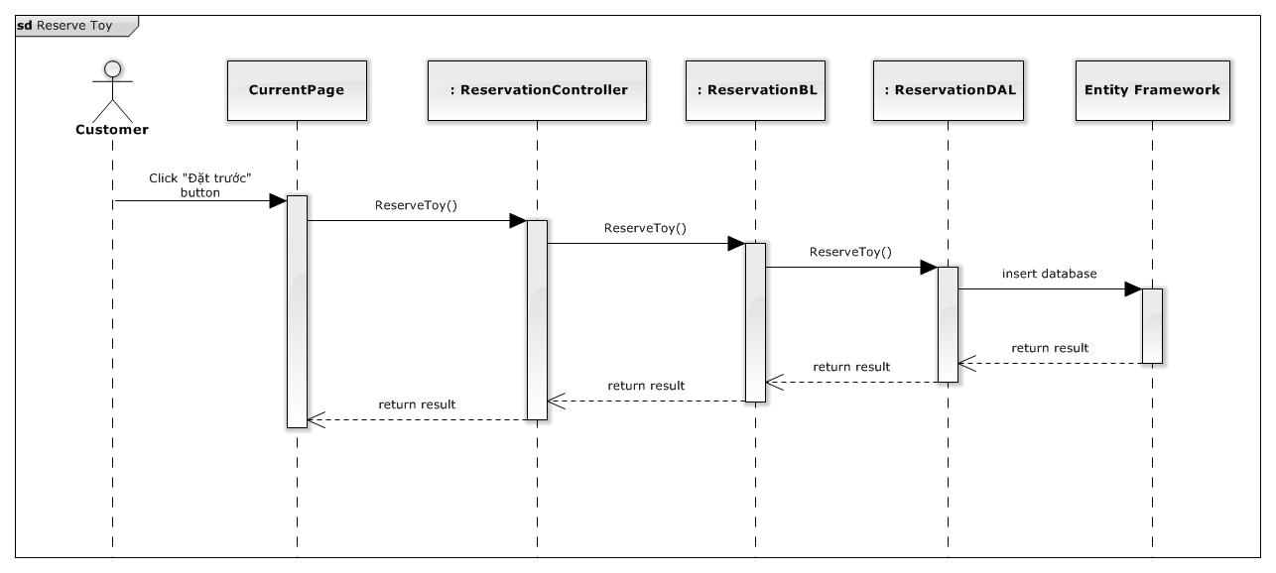

*Figure 99: Reserve Toy Sequence Diagram*

### View Suggested Toys

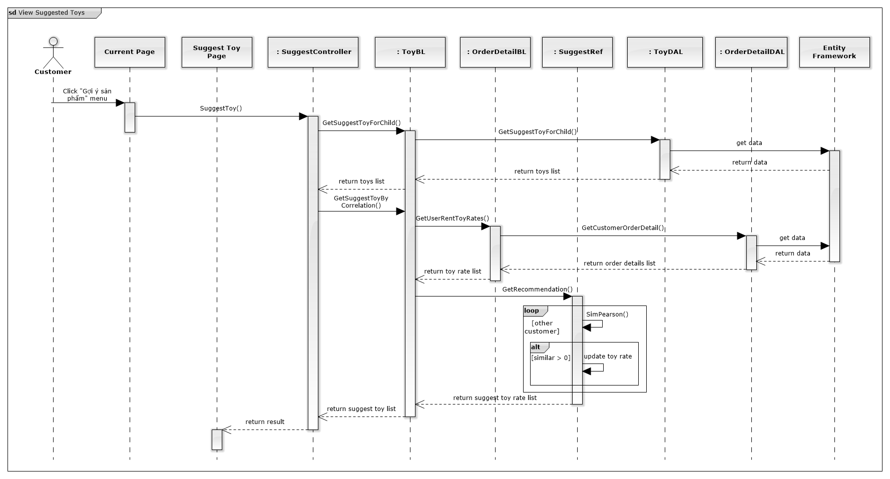

*Figure 100: View Suggested Toy Sequence Diagram*

### Extend Rent Time

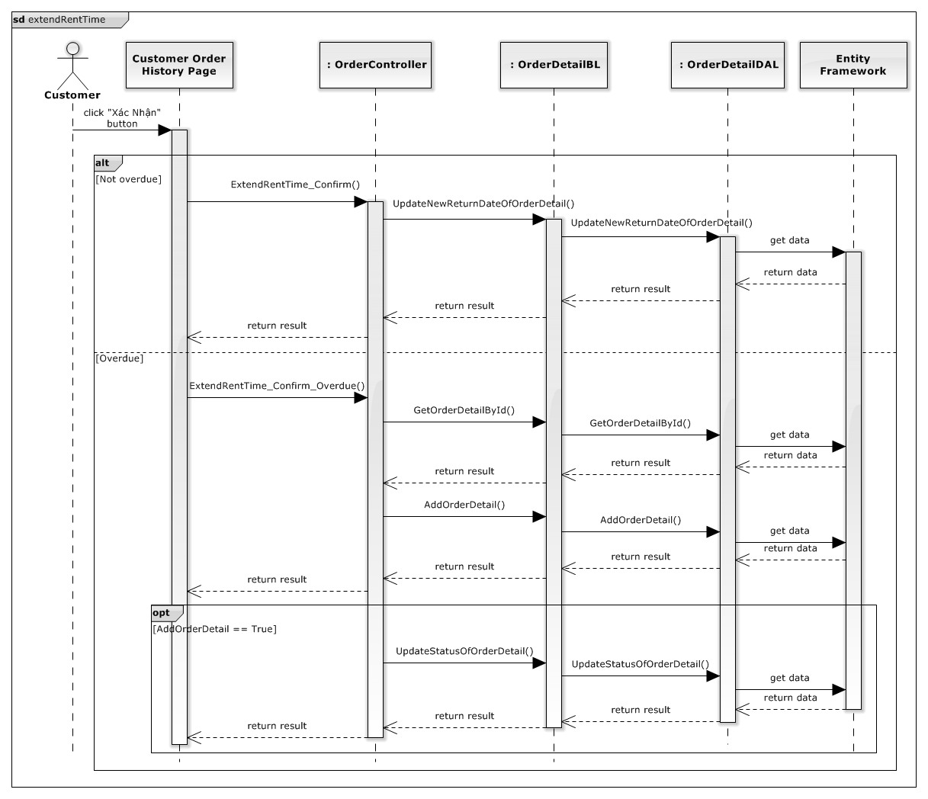



*Figure 101: Extend Rent Time Sequence Diagram*

### Edit Customer Profile

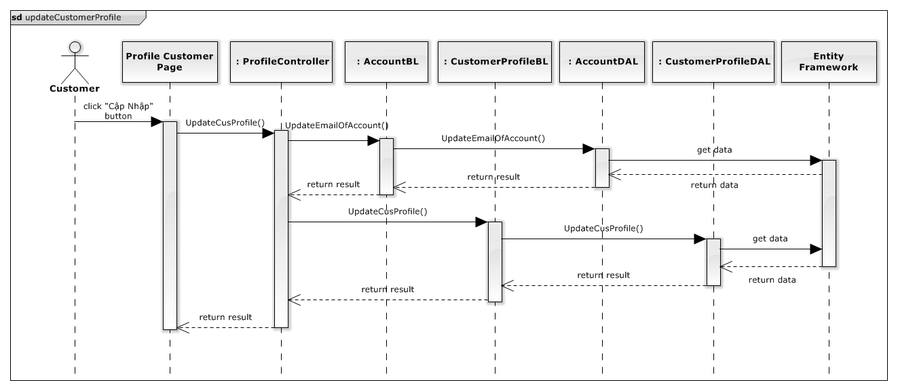

*Figure 102: Extend Rent Time Sequence Diagram*

### Mobile Finish Deliver Order

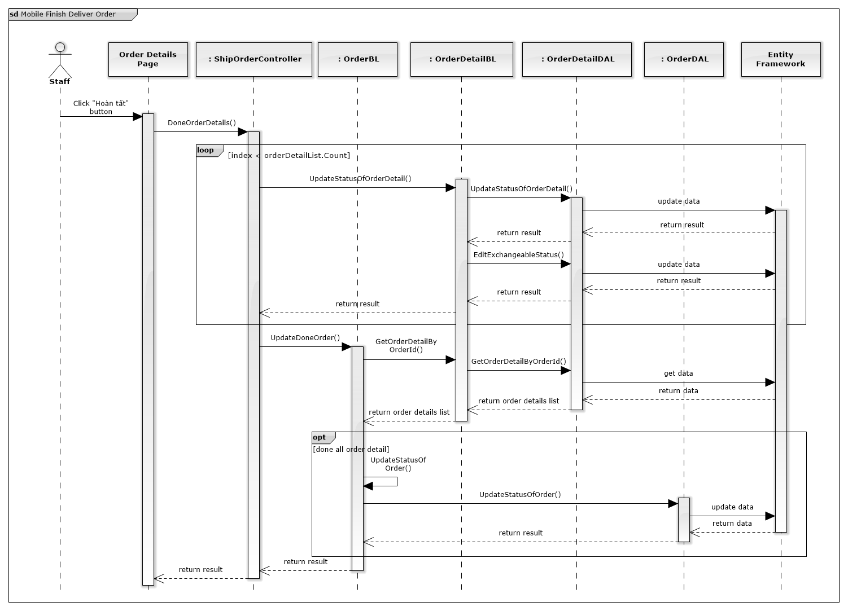

*Figure 103: Mobile Finish Deliver Order*

### Mobile Return Toy

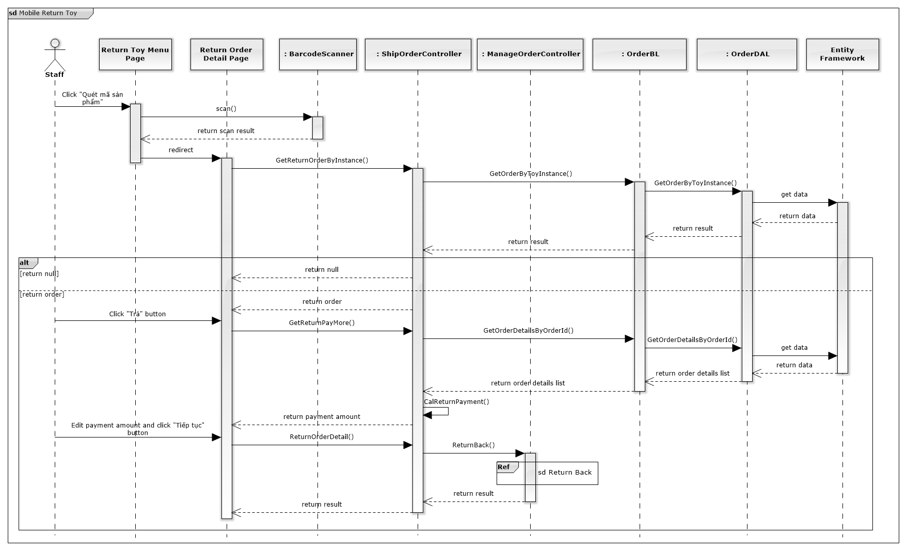

*Figure 104: Mobile Return Toy*

### Mobile Finish Exchange

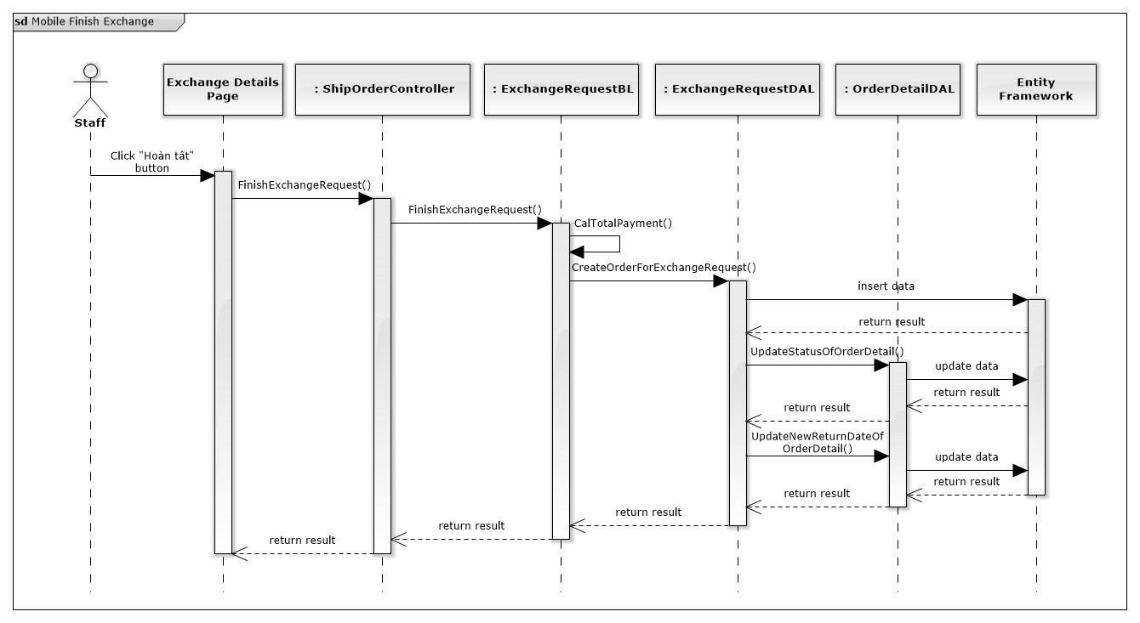

*Figure 105: Mobile Finish Exchange*

## User Interface Design

### Login

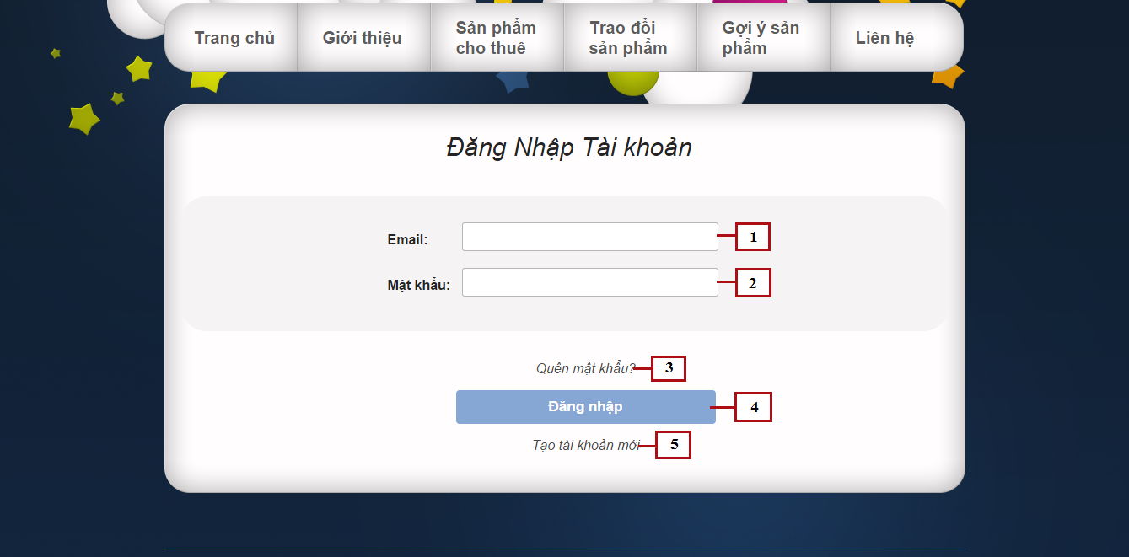

*Figure 106: Login*

**Fields**

|  |  |  |  |  |  |  |  |
| --- | --- | --- | --- | --- | --- | --- | --- |
| **No** | **Field Name** | **Description** | **Read only** | **Mandatory** | **Control Type** | **Data Type** | **Length** |
| 1 | Email | Fill user email | No | Yes | Textbox | String | N/A |
| 2 | Password | Fill password | No | Yes | Password | String | [8-32] |

**Buttons/Hyperlinks**

|  |  |  |  |  |
| --- | --- | --- | --- | --- |
| **No** | **Function** | **Description** | **Validation** | **Outcome** |
| 3 | Forget password | Click when forget password, to request new password | N/A | N/A |
| 3 | Login | Click to login into the system | Yes | Transfer to home page |
| 5 | Register | Click to register a new account | N/A | Transfer to register page |

### View suggest toys

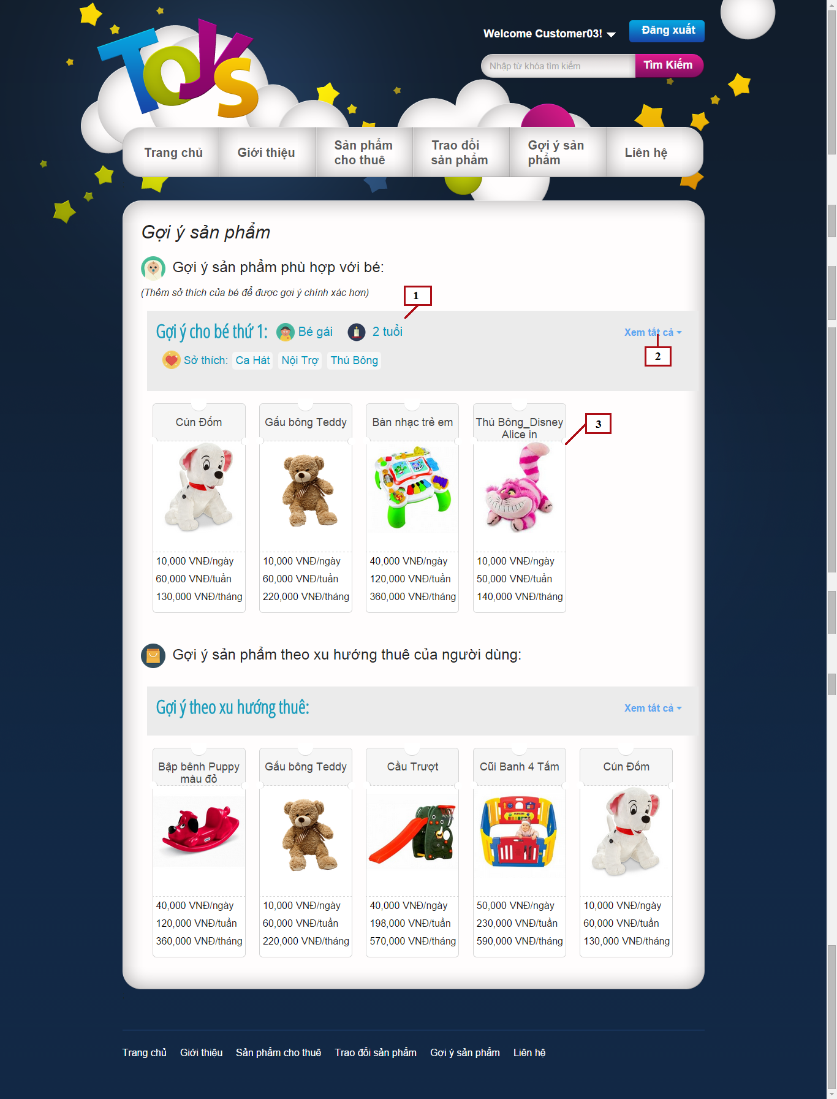

*Figure 107: View Suggest Toys*

**Fields**

|  |  |  |  |  |  |  |  |
| --- | --- | --- | --- | --- | --- | --- | --- |
| **No** | **Field Name** | **Description** | **Read only** | **Mandatory** | **Control Type** | **Data Type** | **Length** |
| 3 | Suggest Product List | List of suggested products | No | Yes | Grid list view | N/A | N/A |

**Buttons/Hyperlinks**

|  |  |  |  |  |
| --- | --- | --- | --- | --- |
| **No** | **Function** | **Description** | **Validation** | **Outcome** |
| 2 | Show/hide all | Click to show all suggested toys or to hide and display only 5 top toys | No | Show/hide products |

**Child’s information includes**

|  |  |  |  |  |  |
| --- | --- | --- | --- | --- | --- |
| **Field Name** | **Description** | **Read only** | **Control Type** | **Data Type** | **Length** |
| Child gender | Gender of child | Yes | Textview | String | N/A |
| Child age | Age of child | Yes | Textview | Integer | N/A |
| Child hobbies | Hobbies list of child | Yes | Textview | String | N/A |

**Suggest Product List includes**

|  |  |  |  |  |  |
| --- | --- | --- | --- | --- | --- |
| **Field Name** | **Description** | **Read only** | **Control Type** | **Data Type** | **Length** |
| Product name | Name of product | Yes | Textview | String | N/A |
| Product image | Image of product | Yes | Image | Bitmap | N/A |
| Product price | Day price, week price and month price of product | Yes | Textview | Integer | N/A |

### My Exchangeable List

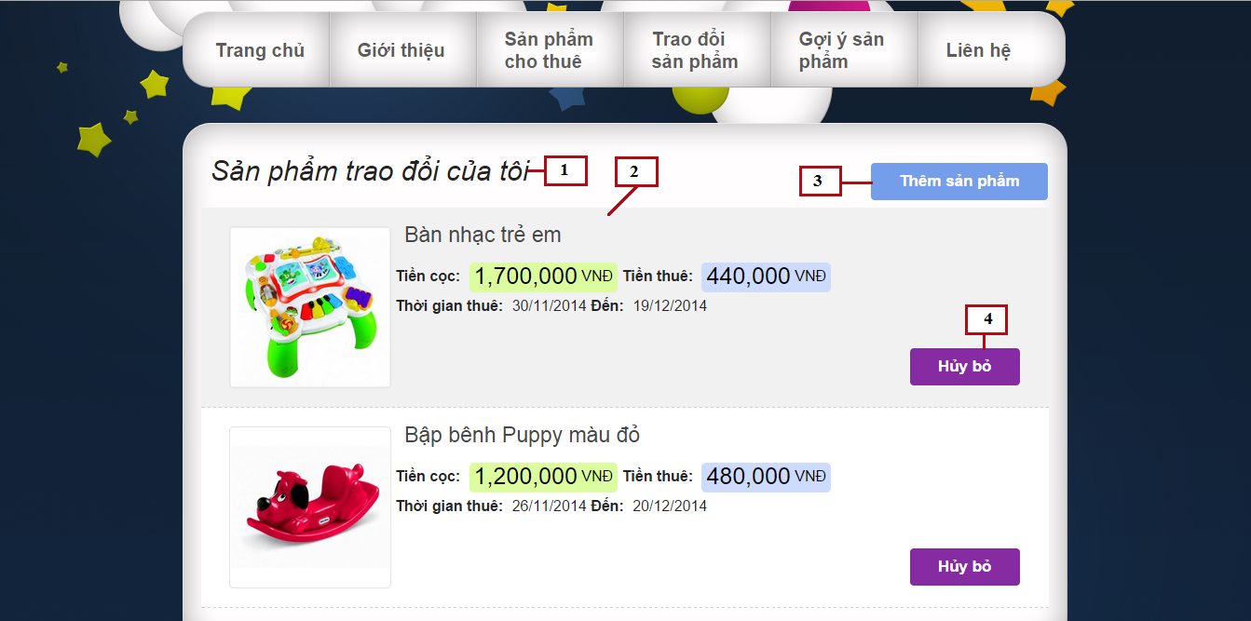

*Figure 108: My Exchangeable List*

**Fields**

|  |  |  |  |  |  |  |  |
| --- | --- | --- | --- | --- | --- | --- | --- |
| **No** | **Field Name** | **Description** | **Read only** | **Mandatory** | **Control Type** | **Data Type** | **Length** |
| 1 | Page title | Title of my exchange page | Yes | Yes | Label | N/A | N/A |
| 2 | Exchangeable Product List | List of suggested products | Yes | Yes | List view | N/A | N/A |

**Buttons/Hyperlinks**

|  |  |  |  |  |
| --- | --- | --- | --- | --- |
| **No** | **Function** | **Description** | **Validation** | **Outcome** |
| 3 | Add product | Add renting toy to exchangeable list | No | Display popup to select renting toys |
| 4 | Remove product | Remove renting toy from exchangeable list | No | Display popup to confirm removing |

**Exchangeable Product List includes**

|  |  |  |  |  |  |
| --- | --- | --- | --- | --- | --- |
| **Field Name** | **Description** | **Read only** | **Control Type** | **Data Type** | **Length** |
| Product name | Name of product | Yes | Textview | String | N/A |
| Product image | Image of product | Yes | Image | Bitmap | N/A |
| Product rent price | Rent price of product | Yes | Textview | Integer | N/A |
| Product deposit price | Deposit price of product | Yes | Textview | Integer | N/A |
| Rent time | Rent time of product | Yes | Textview | Datetime | N/A |

### Add exchangeable products

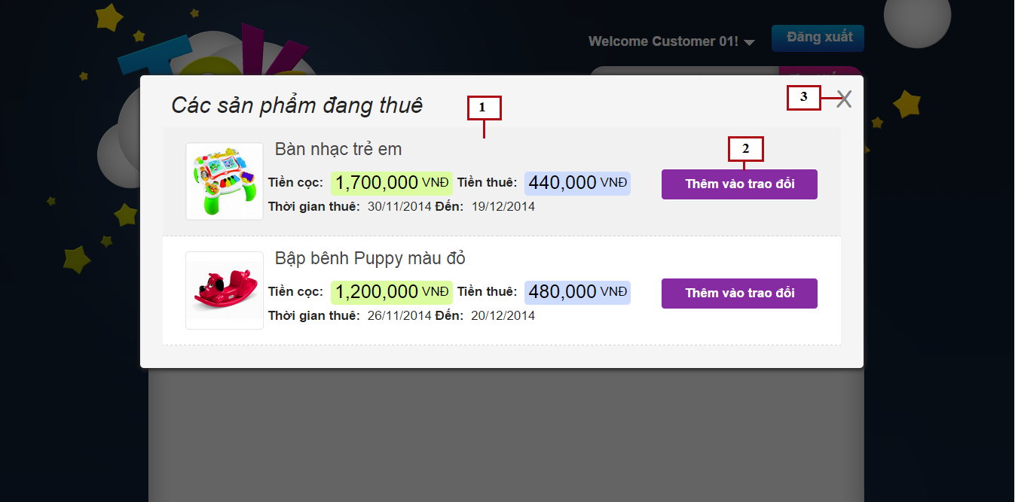

*Figure 109: Add Exchangeable Products*

**Fields**

|  |  |  |  |  |  |  |  |
| --- | --- | --- | --- | --- | --- | --- | --- |
| **No** | **Field Name** | **Description** | **Read only** | **Mandatory** | **Control Type** | **Data Type** | **Length** |
| 1 | Renting Product List | List of renting products | Yes | Yes | List view | N/A | N/A |

**Buttons/Hyperlinks**

|  |  |  |  |  |
| --- | --- | --- | --- | --- |
| **No** | **Function** | **Description** | **Validation** | **Outcome** |
| 2 | Add product | Click to add renting product to exchange list | No | Display popup to confirm adding product |
| 3 | Close | Click to close popup | No | Close popup |

**Renting Product List includes**

|  |  |  |  |  |  |
| --- | --- | --- | --- | --- | --- |
| **Field Name** | **Description** | **Read only** | **Control Type** | **Data Type** | **Length** |
| Product name | Name of product | Yes | Textview | String | N/A |
| Product image | Image of product | Yes | Image | Bitmap | N/A |
| Product rent price | Rent price of product | Yes | Textview | Integer | N/A |
| Product deposit price | Deposit price of product | Yes | Textview | Integer | N/A |
| Rent time | Rent time of product | Yes | Textview | Datetime | N/A |

### Other Customer Exchangeable List

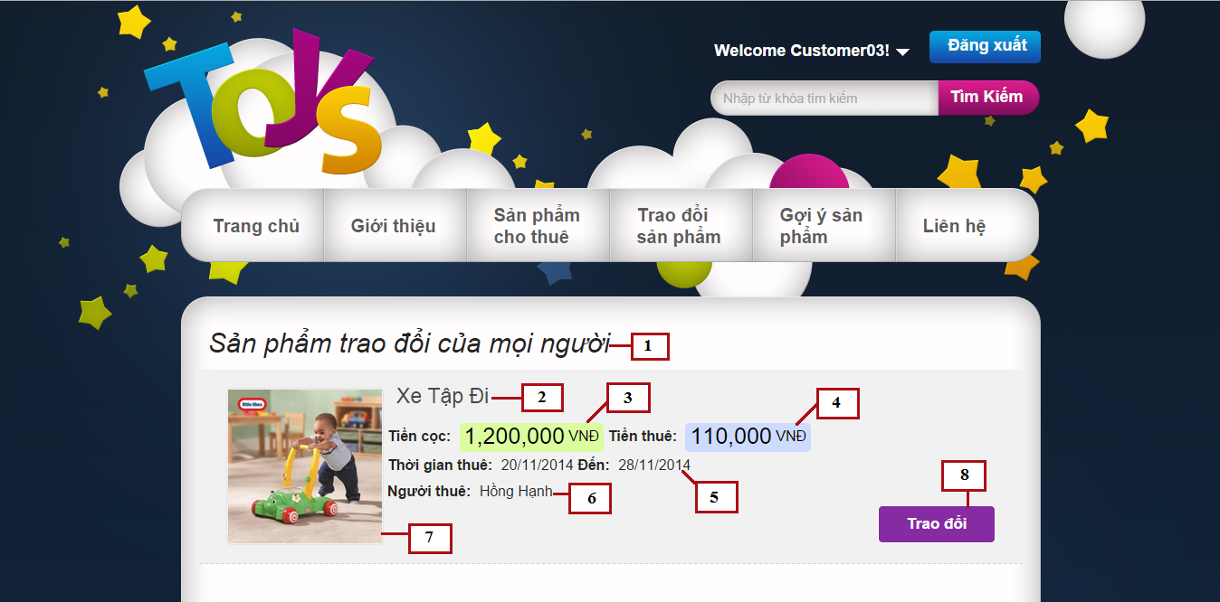

*Figure 110: Other Customer Exchangeable List*

**Fields**

|  |  |  |  |  |  |  |  |
| --- | --- | --- | --- | --- | --- | --- | --- |
| **No** | **Field Name** | **Description** | **Read only** | **Mandatory** | **Control Type** | **Data Type** | **Length** |
| 1 | Page title | Title of other customer exchange page | Yes | Yes | Label | N/A | N/A |
| 2 | Product name | Name of product | Yes | Yes | Textview | String | N/A |
| 3 | Product deposit price | Deposit price of product | Yes | Yes | Textview | Integer | N/A |
| 4 | Product rent price | Rent price of product | Yes | Yes | Textview | Integer | N/A |
| 5 | Rent time | Rent time of product | Yes | Yes | Textview | Datetime | N/A |
| 6 | Customer name | Name of customer renting this toy | Yes | Yes | Textview | String | N/A |
| 7 | Product image | Image of product | Yes | Yes | Image | Bitmap | N/A |

**Buttons/Hyperlinks**

|  |  |  |  |  |
| --- | --- | --- | --- | --- |
| **No** | **Function** | **Description** | **Validation** | **Outcome** |
| 8 | Exchage | Click to send exchange request | No | Display popup to send exchange request |

### Send Exchange Request – Select product

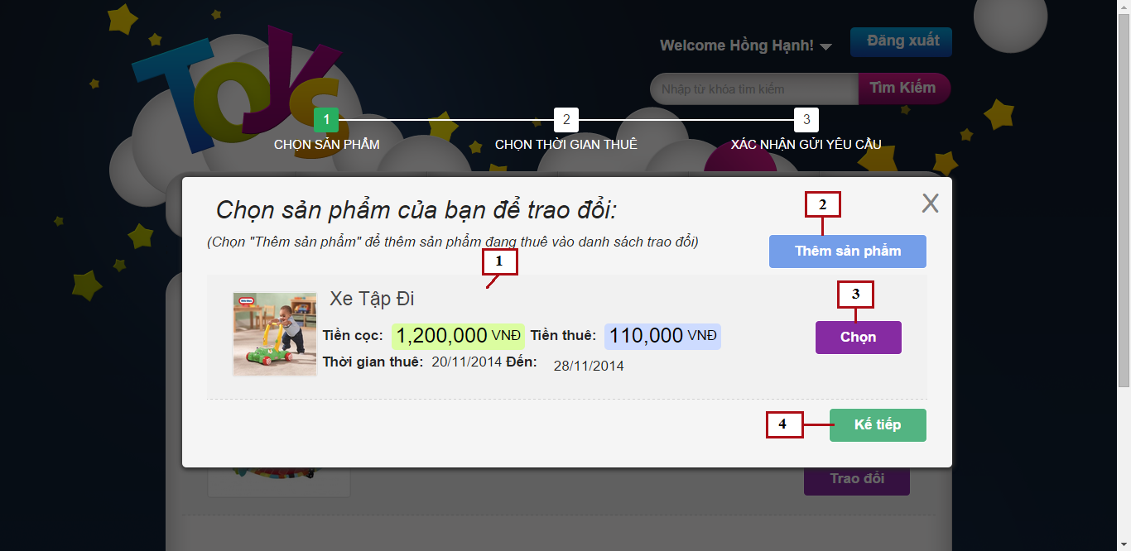

*Figure 111: Send Exchange Request – Select Product*

**Fields**

|  |  |  |  |  |  |  |  |
| --- | --- | --- | --- | --- | --- | --- | --- |
| **No** | **Field Name** | **Description** | **Read only** | **Mandatory** | **Control Type** | **Data Type** | **Length** |
| 1 | Exchangeable Product List | List of suggested products | Yes | Yes | List view | N/A | N/A |

**Buttons/Hyperlinks**

|  |  |  |  |  |
| --- | --- | --- | --- | --- |
| **No** | **Function** | **Description** | **Validation** | **Outcome** |
| 2 | Add product | Add renting toy to exchangeable list | No | Display popup to select renting toys |
| 3 | Select product | Click to select product to exchange | Yes | Mark product ad selected |
| 4 | Next step | Click to go to next step | Yes | Transfer to next step |

**Exchangeable Product List includes**

|  |  |  |  |  |  |
| --- | --- | --- | --- | --- | --- |
| **Field Name** | **Description** | **Read only** | **Control Type** | **Data Type** | **Length** |
| Product name | Name of product | Yes | Textview | String | N/A |
| Product image | Image of product | Yes | Image | Bitmap | N/A |
| Product rent price | Rent price of product | Yes | Textview | Integer | N/A |
| Product deposit price | Deposit price of product | Yes | Textview | Integer | N/A |
| Rent time | Rent time of product | Yes | Textview | Datetime | N/A |

### Send Exchange Request – Select new return date

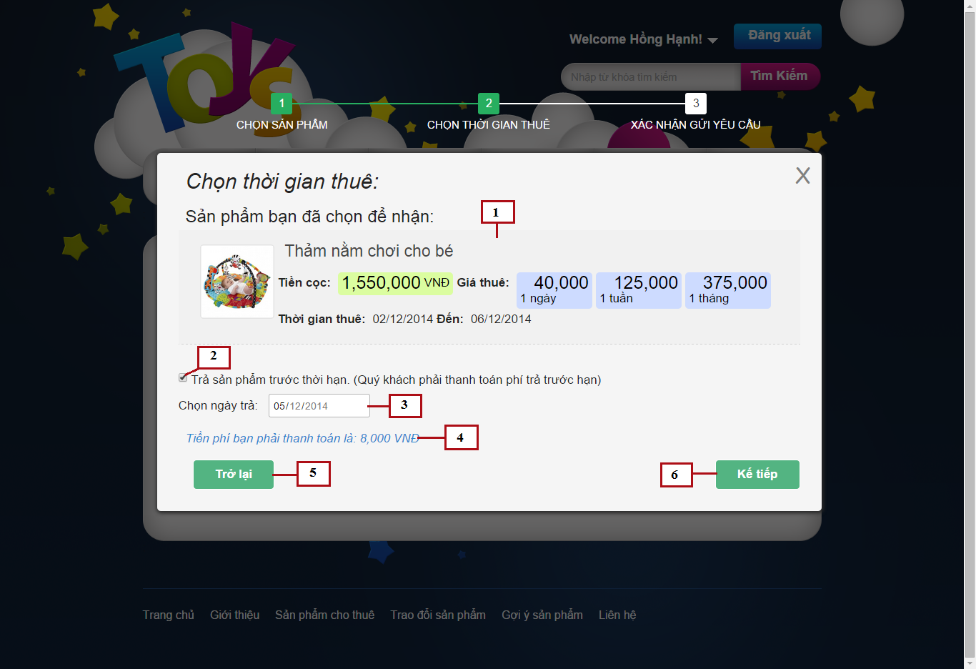

*Figure 112: Send Exchange Request – Select new return date*

**Fields**

|  |  |  |  |  |  |  |  |
| --- | --- | --- | --- | --- | --- | --- | --- |
| **No** | **Field Name** | **Description** | **Read only** | **Mandatory** | **Control Type** | **Data Type** | **Length** |
| 1 | Receive Product Detail | Short detail of receive product | Yes | Yes | List view | N/A | N/A |
| 2 | Return soon checkbox | Enable/disable return soon date | No | No | Checkbox | Bool | N/A |
| 3 | Return soon date | Select date to return soon | No | No | Date picker | Datetime | N/A |
| 4 | Return soon fee | Fee customer has to pay when return product soon | Yes | No | Textview | Integer | N/A |

**Buttons/Hyperlinks**

|  |  |  |  |  |
| --- | --- | --- | --- | --- |
| **No** | **Function** | **Description** | **Validation** | **Outcome** |
| 5 | Previous step | Click to go to previous step | No | Transfer to previous step |
| 6 | Next step | Click to go to next step | No | Transfer to next step |

**Receive Product Detail includes**

|  |  |  |  |  |  |
| --- | --- | --- | --- | --- | --- |
| **Field Name** | **Description** | **Read only** | **Control Type** | **Data Type** | **Length** |
| Product name | Name of product | Yes | Textview | String | N/A |
| Product image | Image of product | Yes | Image | Bitmap | N/A |
| Product rent price | Rent price of product for 1 day, 1 week or 1 month | Yes | Textview | Integer | N/A |
| Product deposit price | Deposit price of product | Yes | Textview | Integer | N/A |
| Rent time | Rent time of product | Yes | Textview | Datetime | N/A |

### Send Exchange Request – Confirm and send request

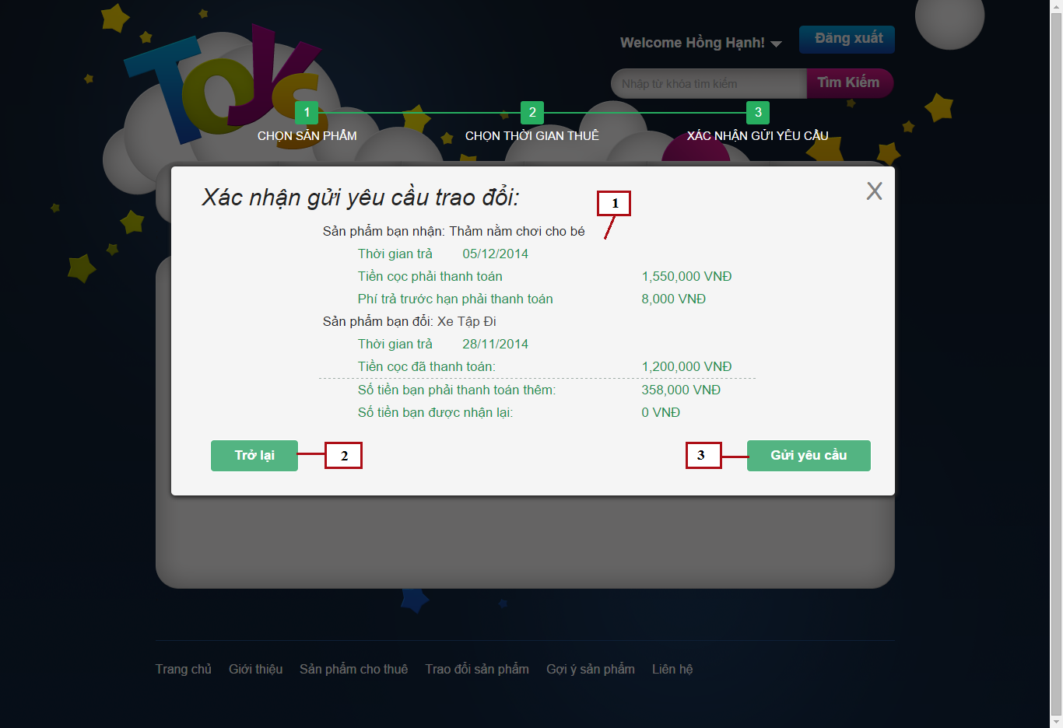

*Figure 113: Send Exchange Request – Confirm and send request*

**Fields**

|  |  |  |  |  |  |  |  |
| --- | --- | --- | --- | --- | --- | --- | --- |
| **No** | **Field Name** | **Description** | **Read only** | **Mandatory** | **Control Type** | **Data Type** | **Length** |
| 1 | Exchange details | Exchange fee details of exchange | Yes | Yes | Textview | N/A | N/A |

**Buttons/Hyperlinks**

|  |  |  |  |  |
| --- | --- | --- | --- | --- |
| **No** | **Function** | **Description** | **Validation** | **Outcome** |
| 2 | Previous step | Click to go to previous step | No | Transfer to previous step |
| 3 | Send request | Click to send exchange request | Yes | Save exchange request to system and close popup |

**Exchange details includes**

|  |  |  |  |  |  |
| --- | --- | --- | --- | --- | --- |
| **Field Name** | **Description** | **Read only** | **Control Type** | **Data Type** | **Length** |
| Product name | Name of each product | Yes | Textview | String | N/A |
| Return time | Return time of each product | Yes | Textview | Datetime | N/A |
| Receive product deposit | Deposit of receive product | Yes | Textview | Integer | N/A |
| Return soon fee | Fee for return product soon | Yes | Textview | Integer | N/A |
| Exchange product deposit | Deposit of exchange product | Yes | Textview | Integer | N/A |
| Total payment | Total price customer has to pay | Yes | Textview | Integer | N/A |
| Total return back | Total money customer receive when exchange | Yes | Textview | Integer | N/A |

### My sent exchange request

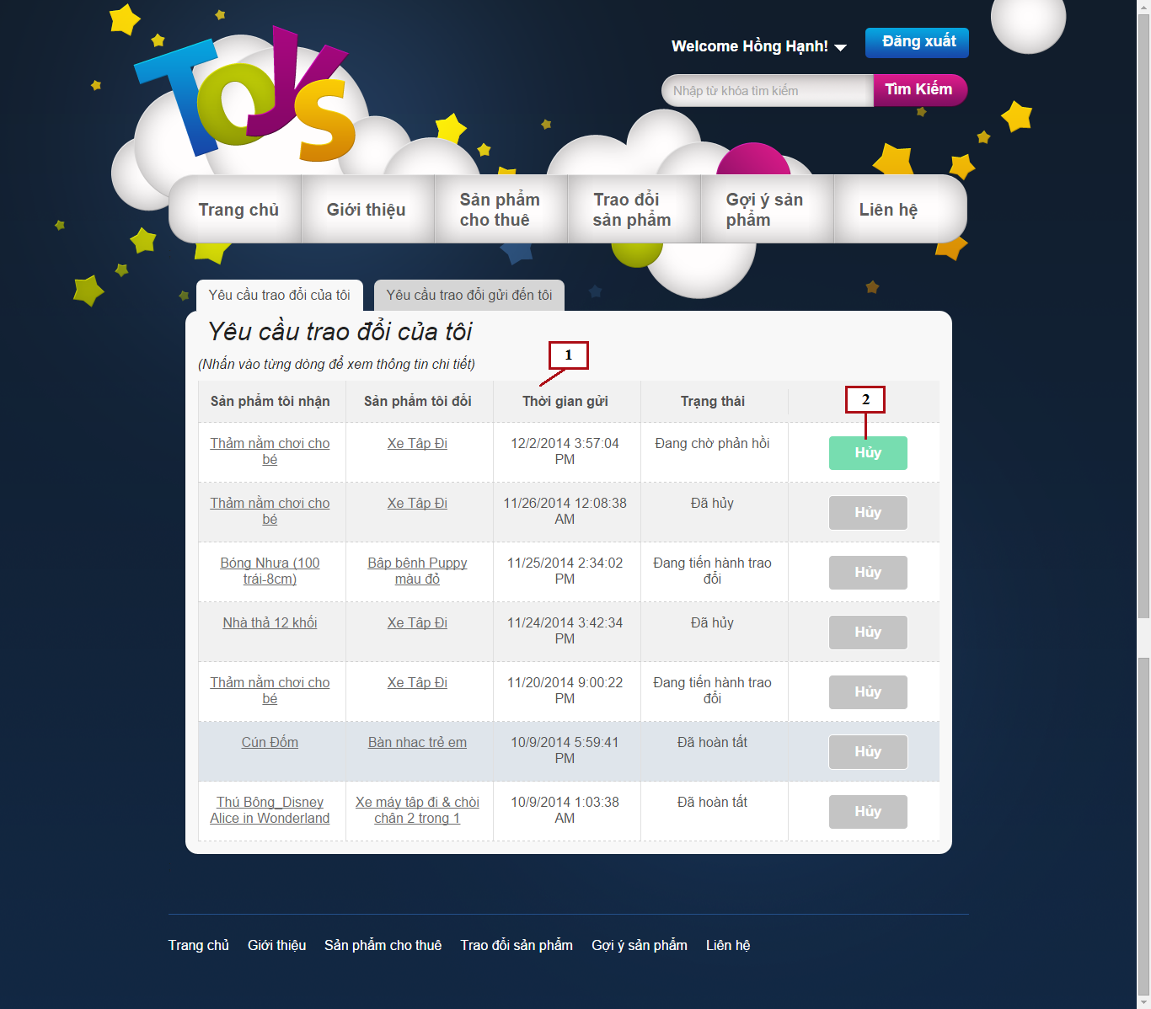

*Figure 114: My Sent Exchange Request*

**Fields**

|  |  |  |  |  |  |  |  |
| --- | --- | --- | --- | --- | --- | --- | --- |
| **No** | **Field Name** | **Description** | **Read only** | **Mandatory** | **Control Type** | **Data Type** | **Length** |
| 1 | Exchange Request List | List of exchange request current customer has sent | Yes | Yes | Listview | N/A | N/A |

**Buttons/Hyperlinks**

|  |  |  |  |  |
| --- | --- | --- | --- | --- |
| **No** | **Function** | **Description** | **Validation** | **Outcome** |
| 2 | Cancel | Click to cancel exchange request | Yes | Change exchange request status to cancel |

**Exchange Request List includes**

|  |  |  |  |  |  |
| --- | --- | --- | --- | --- | --- |
| **Field Name** | **Description** | **Read only** | **Control Type** | **Data Type** | **Length** |
| Receive product name | Name of receive product | Yes | Textview | String | N/A |
| Exchange product name | Name of exchange product | Yes | Textview | String | N/A |
| Send request time | Time that request has been sent | Yes | Textview | Datetime | N/A |
| Status | Status of exchange request | Yes | Textview | String | N/A |

### My receive exchange request

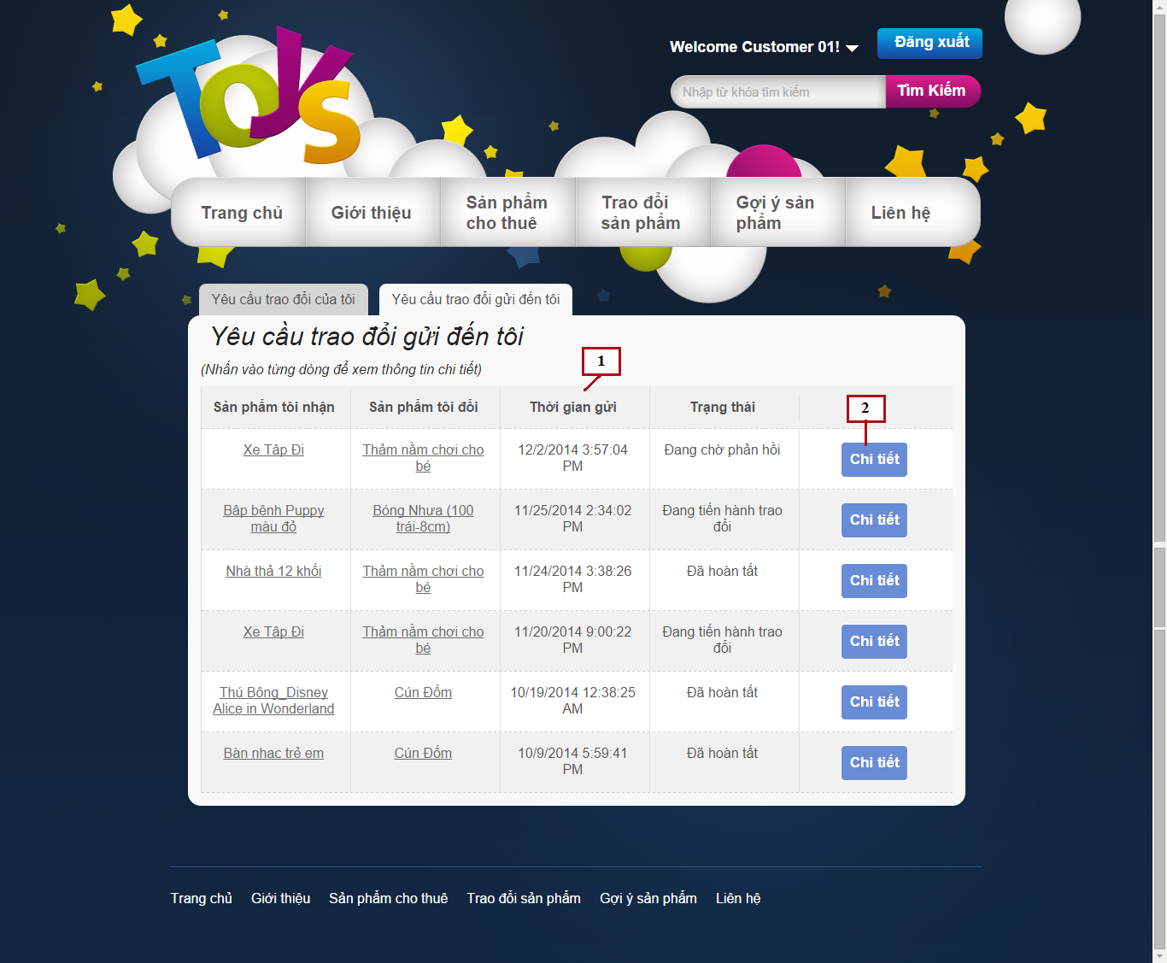

*Figure 115: My Receive Exchange Request*

**Fields**

|  |  |  |  |  |  |  |  |
| --- | --- | --- | --- | --- | --- | --- | --- |
| **No** | **Field Name** | **Description** | **Read only** | **Mandatory** | **Control Type** | **Data Type** | **Length** |
| 1 | Exchange Request List | List of exchange request current customer has sent | Yes | Yes | Listview | N/A | N/A |

**Buttons/Hyperlinks**

|  |  |  |  |  |
| --- | --- | --- | --- | --- |
| **No** | **Function** | **Description** | **Validation** | **Outcome** |
| 2 | View Detail | Click to view exchange request detail | No | Display exchange request detail |

**Exchange Request List includes**

|  |  |  |  |  |  |
| --- | --- | --- | --- | --- | --- |
| **Field Name** | **Description** | **Read only** | **Control Type** | **Data Type** | **Length** |
| Receive product name | Name of receive product | Yes | Textview | String | N/A |
| Exchange product name | Name of exchange product | Yes | Textview | String | N/A |
| Send request time | Time that request has been sent | Yes | Textview | Datetime | N/A |
| Status | Status of exchange request | Yes | Textview | String | N/A |

### Exchange Request Details

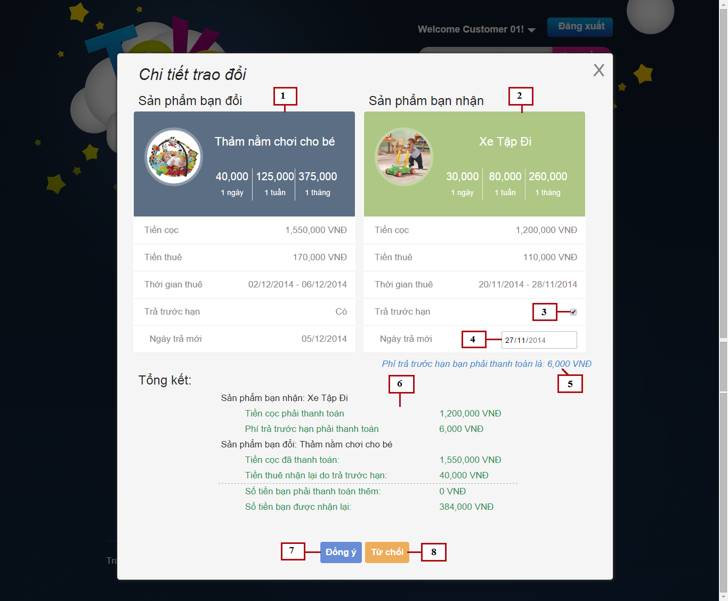

*Figure 116: Exchange Request Details*

**Fields**

|  |  |  |  |  |  |  |  |
| --- | --- | --- | --- | --- | --- | --- | --- |
| **No** | **Field Name** | **Description** | **Read only** | **Mandatory** | **Control Type** | **Data Type** | **Length** |
| 1 | Receive product detail | Detail of receive product | Yes | Yes | N/A | N/A | N/A |
| 2 | Exchange product detail | Detail of exchange product | Yes | Yes | N/A | N/A | N/A |
| 3 | Return soon checkbox | Enable/disable return soon date | No | No | Checkbox | Bool | N/A |
| 4 | Return soon date | Select date to return soon | No | No | Date picker | Datetime | N/A |
| 5 | Return soon fee | Fee customer has to pay when return product soon | Yes | No | Textview | Integer | N/A |
| 6 | Exchange details | Exchange fee details of exchange | Yes | Yes | Textview | N/A | N/A |

**Buttons/Hyperlinks**

|  |  |  |  |  |
| --- | --- | --- | --- | --- |
| **No** | **Function** | **Description** | **Validation** | **Outcome** |
| 7 | Confirm exchange | Click to confirm exchange | Yes | Change exchange request status to confirmed and close popup |
| 8 | Deny exchange | Click to deny exchange | Yes | Change exchange request status to denied and close popup |

**Receive product detail includes**

|  |  |  |  |  |  |
| --- | --- | --- | --- | --- | --- |
| **Field Name** | **Description** | **Read only** | **Control Type** | **Data Type** | **Length** |
| Product name | Name of product | Yes | Textview | String | N/A |
| Product image | Image of product | Yes | Image | Bitmap | N/A |
| Product rent price | Rent price of product | Yes | Textview | Integer | N/A |
| Product deposit price | Deposit price of product | Yes | Textview | Integer | N/A |
| Total rent price | Total rent price of product | Yes | Textview | Integer | N/A |
| Rent time | Rent time of product | Yes | Textview | Datetime | N/A |
| Return soon date | Return soon date of sender | Yes | Textview | Datetime | N/A |

**Exchange product detail includes**

|  |  |  |  |  |  |
| --- | --- | --- | --- | --- | --- |
| **Field Name** | **Description** | **Read only** | **Control Type** | **Data Type** | **Length** |
| Product name | Name of product | Yes | Textview | String | N/A |
| Product image | Image of product | Yes | Image | Bitmap | N/A |
| Product rent price | Rent price of product | Yes | Textview | Integer | N/A |
| Product deposit price | Deposit price of product | Yes | Textview | Integer | N/A |
| Total rent price | Total rent price of product | Yes | Textview | Integer | N/A |
| Rent time | Rent time of product | Yes | Textview | Datetime | N/A |

**Exchange details includes**

|  |  |  |  |  |  |
| --- | --- | --- | --- | --- | --- |
| **Field Name** | **Description** | **Read only** | **Control Type** | **Data Type** | **Length** |
| Product name | Name of each product | Yes | Textview | String | N/A |
| Receive product deposit | Deposit of receive product | Yes | Textview | Integer | N/A |
| Return soon fee | Fee for return product soon | Yes | Textview | Integer | N/A |
| Exchange product deposit | Deposit of exchange product | Yes | Textview | Integer | N/A |
| Return soon money back | Money return back when sender return soon | Yes | Textview | Integer | N/A |
| Total payment | Total price customer has to pay | Yes | Textview | Integer | N/A |
| Total return back | Total money customer receive when exchange | Yes | Textview | Integer | N/A |

### Manage Exchange

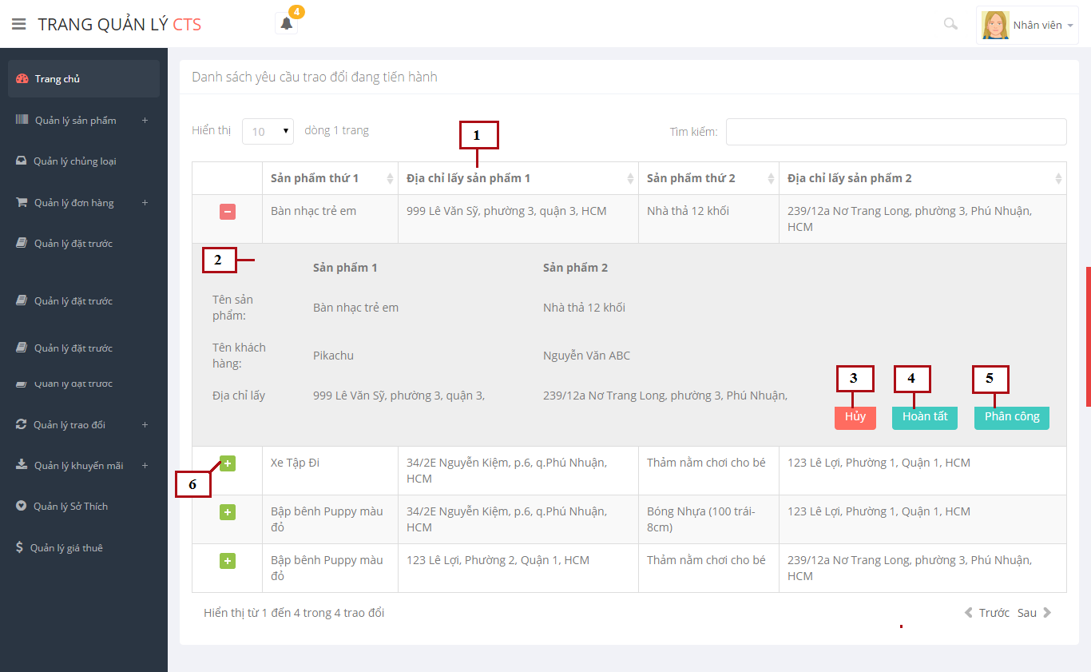

*Figure 117: Manage Exchange*

**Fields**

|  |  |  |  |  |  |  |  |
| --- | --- | --- | --- | --- | --- | --- | --- |
| **No** | **Field Name** | **Description** | **Read only** | **Mandatory** | **Control Type** | **Data Type** | **Length** |
| 1 | Exchange request list | List of exchange request | Yes | Yes | Table | N/A | N/A |
| 2 | Exchange detail | More detail of exchange request | Yes | Yes | Listview | N/A | N/A |

**Buttons/Hyperlinks**

|  |  |  |  |  |
| --- | --- | --- | --- | --- |
| **No** | **Function** | **Description** | **Validation** | **Outcome** |
| 3 | Cancel exchange | Click to cancel exchange request | Yes | Change exchange request status to cancel |
| 4 | Done exchange | Click to done exchange process | Yes | Change exchange request status to done |
| 5 | Assign shipper | Assign staff to manage this exchange | No | Display popup to select staff |
| 6 | View detail | Click to display more details of exchange | No | Display more detail of exchange |

**Exchange request list includes**

|  |  |  |  |  |  |
| --- | --- | --- | --- | --- | --- |
| **Field Name** | **Description** | **Read only** | **Control Type** | **Data Type** | **Length** |
| First product name | Name of first product | Yes | Textview | String | N/A |
| First address | Address to take first product | Yes | Textview | String | N/A |
| Second product name | Name of second product | Yes | Textview | String | N/A |
| Second address | Address to take second product | Yes | Textview | String | N/A |

**Exchange detail includes**

|  |  |  |  |  |  |
| --- | --- | --- | --- | --- | --- |
| **Field Name** | **Description** | **Read only** | **Control Type** | **Data Type** | **Length** |
| Product name | Name of product | Yes | Textview | String | N/A |
| Customer name | Name of customer renting these product | Yes | Textview | String | N/A |
| Address | Address to take these product | Yes | Textview | String | N/A |

### Product Details

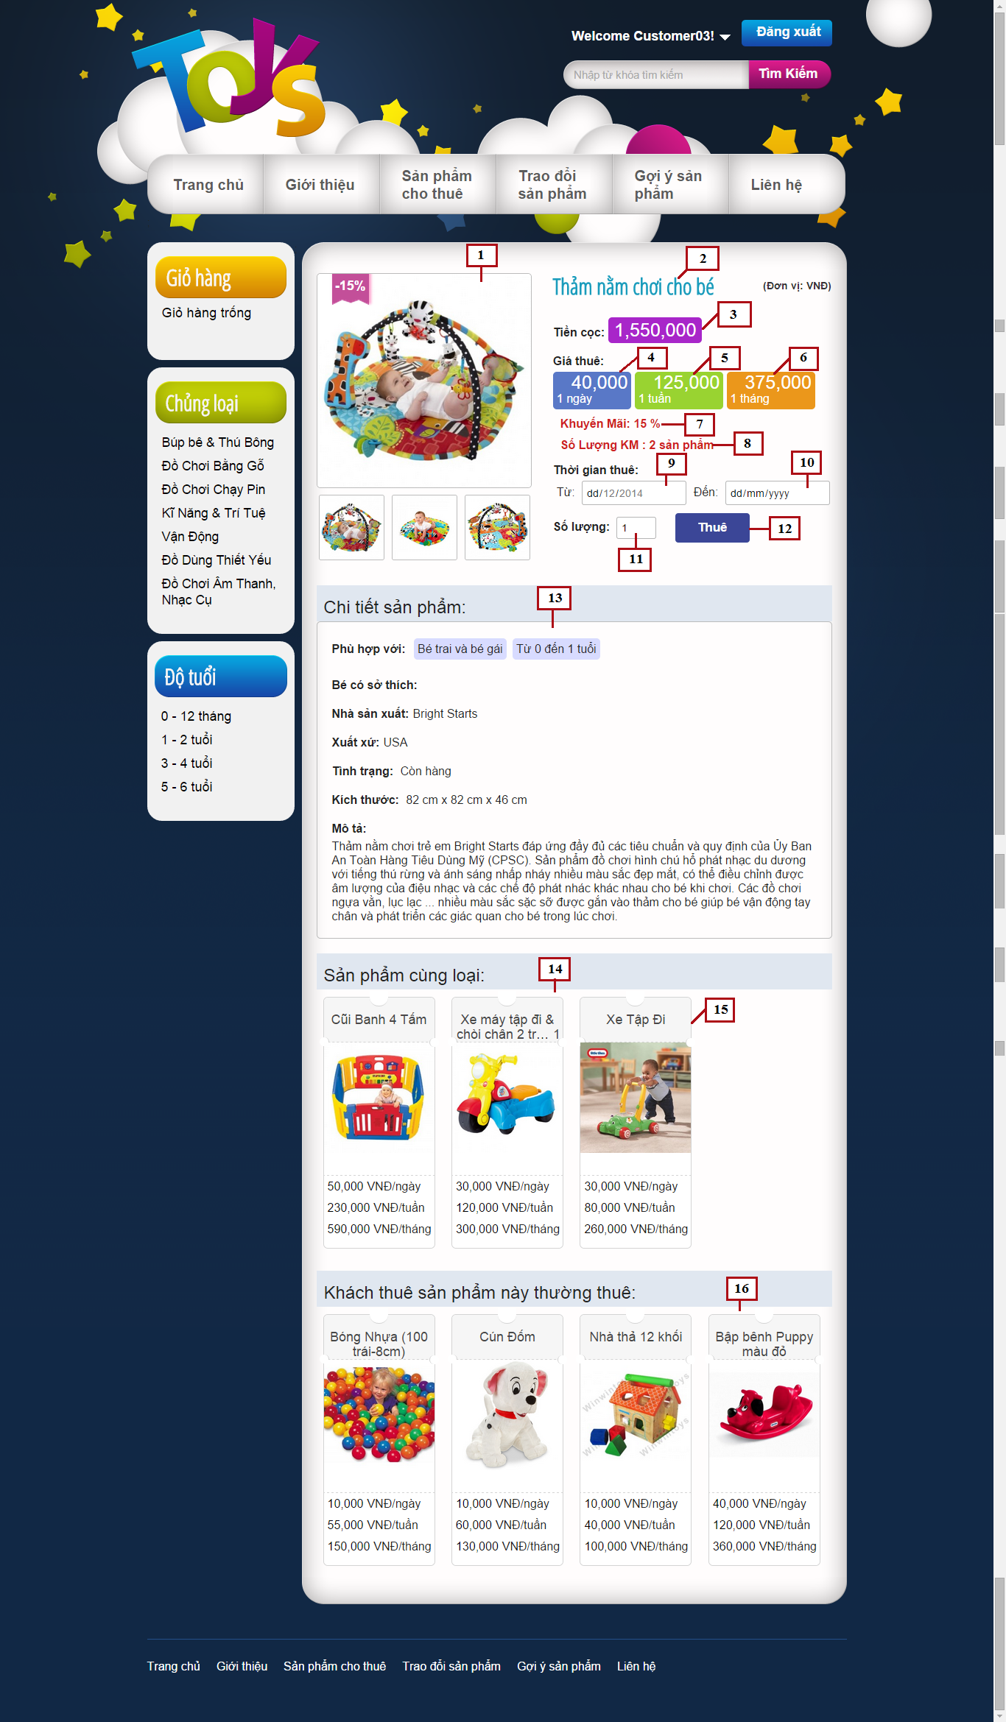

*Figure 118: Product Details*

**Fields**

|  |  |  |  |  |  |  |  |
| --- | --- | --- | --- | --- | --- | --- | --- |
| **No** | **Field Name** | **Description** | **Read only** | **Mandatory** | **Control Type** | **Data Type** | **Length** |
| 1 | Product images | Images of current product | Yes | Yes | Image | Bitmap | N/A |
| 2 | Product name | Name of current product | Yes | Yes | Textview | String | N/A |
| 3 | Deposit | Deposit price to rent this product | Yes | Yes | Textview | Integer | N/A |
| 4 | Day price | Rent price for 1 day | Yes | Yes | Textview | Integer | N/A |
| 5 | Week price | Rent price for 1 week | Yes | Yes | Textview | Integer | N/A |
| 6 | Month price | Rent price for 1 month | Yes | Yes | Textview | Integer | N/A |
| 7 | Discount percent | Discount percent of this product | Yes | Yes | Textview | Integer | N/A |
| 8 | Discount remain amount | Remaining amount of discount items in stock | Yes | Yes | Textview | Integer | N/A |
| 9 | Rent from date | Select date to start renting | No | Yes | Datepicker | Datetime | N/A |
| 10 | Rent to date | Select date to return product | No | Yes | Datepicker | Datetime | N/A |
| 11 | Amount | Select amount to rent | No | Yes | Input | Integer | N/A |
| 13 | Product details | Details of current product | Yes | Yes | Textview | N/A | N/A |
| 14 | Same category list | List of products in same category with current product | Yes | Yes | Grid list view | N/A | N/A |
| 15 | Suggest product | Suggest product for current product | No | Yes | Grid view | N/A | N/A |
| 16 | Customer often rent | List of products that customer rented this product often rent | No | Yes | Grid list view | N/A | N/A |

**Buttons/Hyperlinks**

|  |  |  |  |  |
| --- | --- | --- | --- | --- |
| **No** | **Function** | **Description** | **Validation** | **Outcome** |
| 12 | Rent product | Click to add current product to cart | Yes | Add current product to cart and display success message |

**Product Details includes**

|  |  |  |  |  |  |
| --- | --- | --- | --- | --- | --- |
| **Field Name** | **Description** | **Read only** | **Control Type** | **Data Type** | **Length** |
| Appropriate age | Appropriate age to use this product | Yes | Textview | Integer | N/A |
| Appropriate gender | Appropriate gender to use this product | Yes | Textview | String | N/A |
| Appropriate hobbies | Appropriate hobbies to use this product | Yes | Textview | String | N/A |
| Manufacturer | Manufacturer of this product | Yes | Textview | String | N/A |
| Origin | Origin of this product | Yes | Textview | String | N/A |
| Status | Status of this product | Yes | Textview | String | N/A |
| Dimensions | Dimensions of this product | Yes | Textview | Double | N/A |
| Short description | Short description of this product | Yes | Textview | String | N/A |

**Suggest Product includes**

|  |  |  |  |  |  |
| --- | --- | --- | --- | --- | --- |
| **Field Name** | **Description** | **Read only** | **Control Type** | **Data Type** | **Length** |
| Product name | Name of product | Yes | Textview | String | N/A |
| Product image | Image of product | Yes | Image | Bitmap | N/A |
| Product price | Day price, week price and month price of product | Yes | Textview | Integer | N/A |

### View statistic report by year

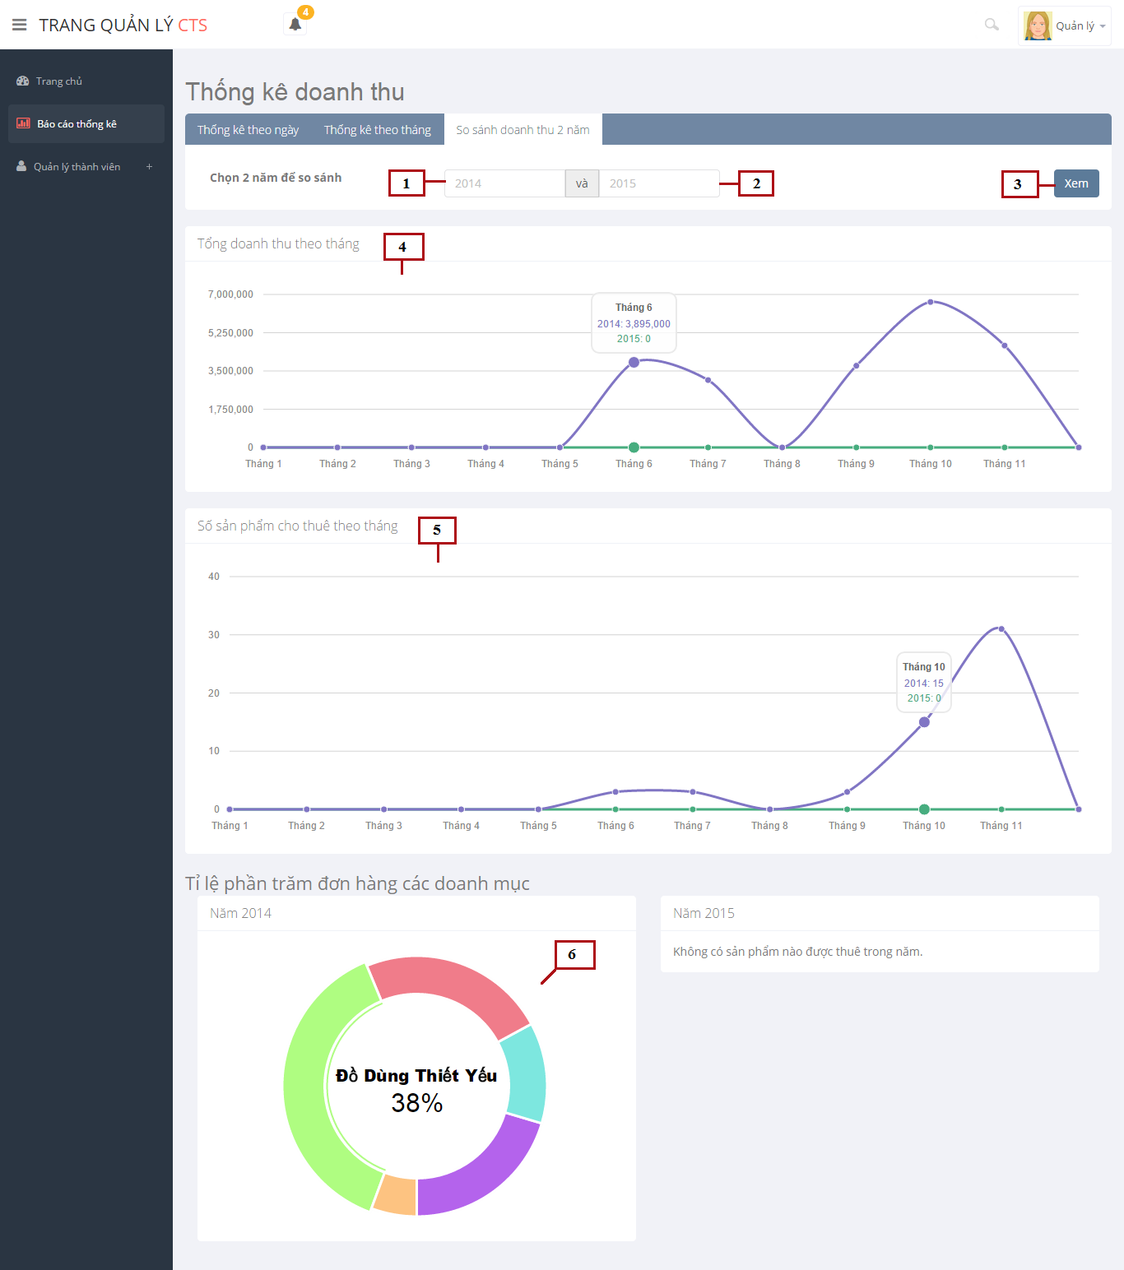

*Figure 119: View Statistic Report*

**Fields**

|  |  |  |  |  |  |  |  |
| --- | --- | --- | --- | --- | --- | --- | --- |
| **No** | **Field Name** | **Description** | **Read only** | **Mandatory** | **Control Type** | **Data Type** | **Length** |
| 1 | First | Input first year to compare | No | Yes | Input | Integer | N/A |
| 2 | Second year | Input second year to compare | No | Yes | Input | Integer | N/A |
| 4 | Incomes line chart | Line chart compares incomes of 2 years | Yes | Yes | Line Chart | N/A | N/A |
| 5 | Rent amount line chart | Line chart compares rented amount of products of 2 years | Yes | Yes | Line Chart | N/A | N/A |
| 6 | Category portion pie chart | Pie charts show rented percent of product categories | Yes | Yes | Pie Chart | N/A | N/A |

**Buttons/Hyperlinks**

|  |  |  |  |  |
| --- | --- | --- | --- | --- |
| **No** | **Function** | **Description** | **Validation** | **Outcome** |
| 3 | Compare | Click to start compare 2 years | Yes | Compare and display charts as result |

### Mobile app menu

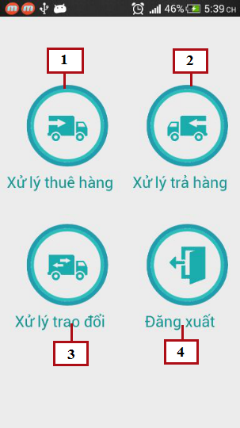

*Figure 120: Mobile App Menu*

**Buttons/Hyperlinks**

|  |  |  |  |  |
| --- | --- | --- | --- | --- |
| **No** | **Function** | **Description** | **Validation** | **Outcome** |
| 1 | Process rent toys | Click to go to process rent toys page | No | Transfer to Process Rent Toys page |
| 2 | Process return toys | Click to go to process return toys page | No | Transfer to Process Return Toys page |
| 3 | Process exchange toys | Click to go to process exchange toys page | No | Transfer to Process Exchange Toys page |
| 4 | Logout | Click to logout of mobile app | No | Transfer to Login page |

### Mobile Assigned Orders

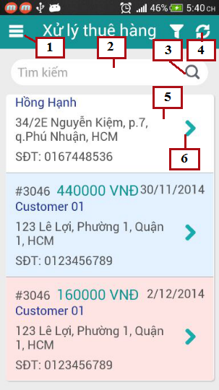

*Figure 121: Mobile Assigned Orders*

**Fields**

|  |  |  |  |  |  |  |  |
| --- | --- | --- | --- | --- | --- | --- | --- |
| **No** | **Field Name** | **Description** | **Read only** | **Mandatory** | **Control Type** | **Data Type** | **Length** |
| 2 | Search field | Input keyword to search order | No | Yes | Input | String | N/A |
| 5 | Order list | List of assigned orders | Yes | Yes | List view | N/A | N/A |

**Buttons/Hyperlinks**

|  |  |  |  |  |
| --- | --- | --- | --- | --- |
| **No** | **Function** | **Description** | **Validation** | **Outcome** |
| 1 | Menu | Click to open menu | No | Show application menu |
| 3 | Search | Click to search order by keyword | No | Search and show results |
| 4 | Refresh | Refresh orders list, get new orders | No | Refresh orders list |
| 6 | View detail | Click to view order details | No | Transfer to order details page |

**Order List includes**

|  |  |  |  |  |  |
| --- | --- | --- | --- | --- | --- |
| **Field Name** | **Description** | **Read only** | **Control Type** | **Data Type** | **Length** |
| Order Id | ID of order | Yes | Textview | Integer | N/A |
| Total | Total price of order | Yes | Textview | Integer | N/A |
| Deliver date | Date to deliver order | Yes | Textview | Datetime | N/A |
| Customer name | Name of customer | Yes | Textview | String | N/A |
| Address | Address of customer | Yes | Textview | String | N/A |
| Phone | Phone of customer | Yes | Textview | String | [10-11] |

### Mobile order details

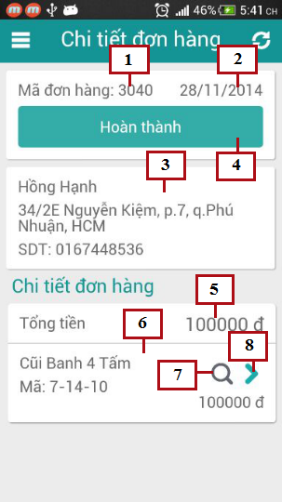

*Figure 122: Mobile Order Details*

**Fields**

|  |  |  |  |  |  |  |  |
| --- | --- | --- | --- | --- | --- | --- | --- |
| **No** | **Field Name** | **Description** | **Read only** | **Mandatory** | **Control Type** | **Data Type** | **Length** |
| 1 | Order Id | Id of order | Yes | Yes | Textview | Integer | N/A |
| 2 | Deliver date | Date to deliver order | Yes | Yes | Textview | Datetime | N/A |
| 3 | Customer information | Information of receive customer | Yes | Yes | Textview | N/A | N/A |
| 5 | Total | Total price of order | Yes | Yes | Textview | Integer | N/A |
| 6 | Order details | Details of order | Yes | Yes | List view | N/A | N/A |

**Buttons/Hyperlinks**

|  |  |  |  |  |
| --- | --- | --- | --- | --- |
| **No** | **Function** | **Description** | **Validation** | **Outcome** |
| 4 | Done | Click to done deliver process | No | Change order status to done |
| 7 | Scan | Click to scan QR code of product | No | Open camera to start scan QR code |
| 8 | View Detail | Click to view detail of product | No | Transfer to product details page |

**Customer Information includes**

|  |  |  |  |  |  |
| --- | --- | --- | --- | --- | --- |
| **Field Name** | **Description** | **Read only** | **Control Type** | **Data Type** | **Length** |
| Customer name | Name of customer | Yes | Textview | String | N/A |
| Customer address | Address of customer | Yes | Textview | String | N/A |
| Customer phone | Phone of customer | Yes | Textview | String | [10-11] |

**Order Detail includes**

|  |  |  |  |  |  |
| --- | --- | --- | --- | --- | --- |
| **Field Name** | **Description** | **Read only** | **Control Type** | **Data Type** | **Length** |
| Product name | Name of product | Yes | Textview | String | N/A |
| Product code | QR code of product | Yes | Textview | String | N/A |

### Mobile product details

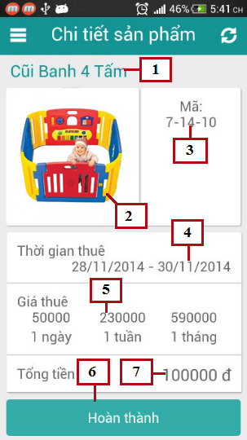

*Figure 123: Mobile Product Details*

**Fields**

|  |  |  |  |  |  |  |  |
| --- | --- | --- | --- | --- | --- | --- | --- |
| **No** | **Field Name** | **Description** | **Read only** | **Mandatory** | **Control Type** | **Data Type** | **Length** |
| 1 | Product name | Name of product | Yes | Yes | Textview | String | N/A |
| 2 | Product image | Image of product | Yes | Yes | Image | Bitmap | N/A |
| 3 | Product code | QR code of product | Yes | Yes | Textview | String | N/A |
| 4 | Rent time | Product’s rent time | Yes | Yes | Textview | Datetime | N/A |
| 5 | Rent price | Rent price of product for 1 day, 1 week or 1 month | Yes | Yes | Textview | Integer | N/A |
| 7 | Total | Total rent price of product | Yes | Yes | Textview | Integer | N/A |

**Buttons/Hyperlinks**

|  |  |  |  |  |
| --- | --- | --- | --- | --- |
| **No** | **Function** | **Description** | **Validation** | **Outcome** |
| 6 | Done | Click to done deliver product | No | Change order detail status to done |

### Mobile Assigned Exchange List

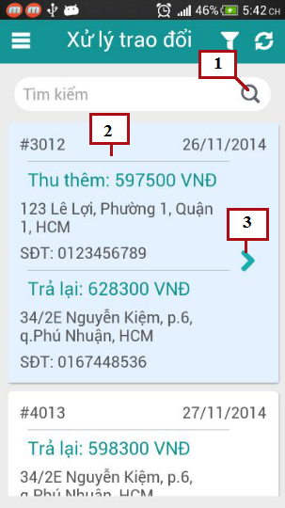

*Figure 124: Mobile Assigned Exchange List*

**Fields**

|  |  |  |  |  |  |  |  |
| --- | --- | --- | --- | --- | --- | --- | --- |
| **No** | **Field Name** | **Description** | **Read only** | **Mandatory** | **Control Type** | **Data Type** | **Length** |
| 2 | Exchange List | List of assigned exchange | Yes | Yes | List view | N/A | N/A |

**Buttons/Hyperlinks**

|  |  |  |  |  |
| --- | --- | --- | --- | --- |
| **No** | **Function** | **Description** | **Validation** | **Outcome** |
| 1 | Search | Search exchange by Id | No | Search exchange by Id |
| 3 | View detail | View details of exchange | No | Transfer to Exchange detail page |

**Exchange List includes**

|  |  |  |  |  |  |
| --- | --- | --- | --- | --- | --- |
| **Field Name** | **Description** | **Read only** | **Control Type** | **Data Type** | **Length** |
| Exchange Id | ID of exchange | Yes | Textview | Integer | N/A |
| Exchange date | Date to exchange | Yes | Textview | Datetime | N/A |
| First product fee | Money first customer has to pay or receive | Yes | Textview | Integer | N/A |
| First Address | Address of first customer | Yes | Textview | String | N/A |
| First Phone | Phone of first customer | Yes | Textview | String | [10-11] |
| Second product fee | Money second customer has to pay or receive | Yes | Textview | Integer | N/A |
| Second Address | Address of second customer | Yes | Textview | String | N/A |
| Second Phone | Phone of second customer | Yes | Textview | String | [10-11] |

### Mobile Exchange Details

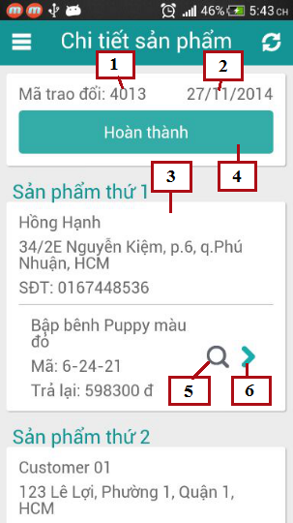

*Figure 125: Mobile Exchange Details*

**Fields**

|  |  |  |  |  |  |  |  |
| --- | --- | --- | --- | --- | --- | --- | --- |
| **No** | **Field Name** | **Description** | **Read only** | **Mandatory** | **Control Type** | **Data Type** | **Length** |
| 1 | Exchange Id | Id of exchange | Yes | Yes | Textview | Integer | N/A |
| 2 | Exchange date | Date to exchange | Yes | Yes | Textview | Datetime | N/A |
| 3 | Exchange detail | Information of exchange | Yes | Yes | Textview | N/A | N/A |

**Buttons/Hyperlinks**

|  |  |  |  |  |
| --- | --- | --- | --- | --- |
| **No** | **Function** | **Description** | **Validation** | **Outcome** |
| 4 | Done | Click to done exchange process | No | Change exchange status to done |
| 5 | Scan | Click to scan QR code of product | No | Open camera to start scan QR code |
| 6 | View Detail | Click to view detail of product | No | Transfer to product details page |

**Exchange Details includes**

|  |  |  |  |  |  |
| --- | --- | --- | --- | --- | --- |
| **Field Name** | **Description** | **Read only** | **Control Type** | **Data Type** | **Length** |
| Customer name | Name of customer | Yes | Textview | String | N/A |
| Customer address | Address of customer | Yes | Textview | String | N/A |
| Customer phone | Phone of customer | Yes | Textview | String | [10-11] |
| Product name | Name of product | Yes | Textview | String | N/A |
| Product code | QR code of product | Yes | Textview | String | N/A |
| Total | Total pay or return back to customer | Yes | Textview | Integer | N/A |

### Mobile Search Return Product Options

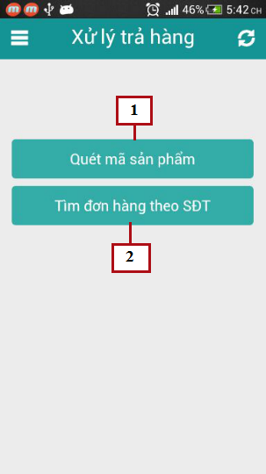

*Figure 126: Mobile Search Return Product Options*

**Buttons/Hyperlinks**

|  |  |  |  |  |
| --- | --- | --- | --- | --- |
| **No** | **Function** | **Description** | **Validation** | **Outcome** |
| 1 | Scan | Click to scan QR code of product | No | Open camera to start scan QR code |
| 2 | Search order by phone | Click to search order by phone | No | Transfer to search order page |

### Rent Toy

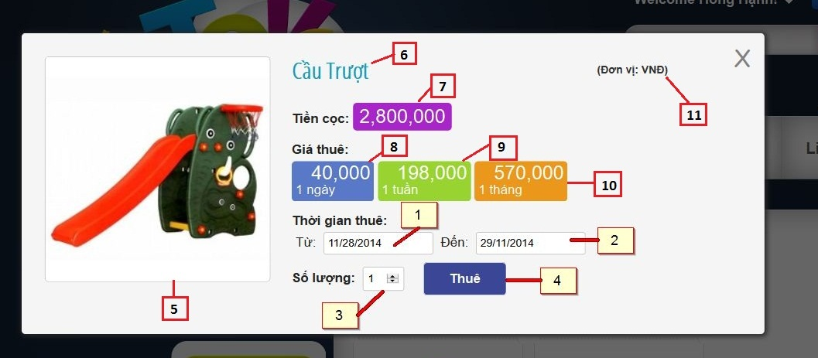

*Figure 127: Rent Toy*

**Fields**

|  |  |  |  |  |  |  |  |
| --- | --- | --- | --- | --- | --- | --- | --- |
| **No** | **Field Name** | **Description** | **Read only** | **Mandatory** | **Control Type** | **Data Type** | **Length** |
| 1 | FromDate | Fill rent from date | No | Yes | Date time picker | String | N/A |
| 2 | ToDate | Fill rent to date | No | Yes | Date time picker | String | N/A |
| 3 | Amount | Fill quantity toy want to rent | No | Yes | Textbox | String | N/A |
| 5 | Image | Description image of toy | Yes | Yes | Image | N/A | N/A |
| 6 | Name | Name of toy | Yes | Yes | Label | String | N/A |
| 7 | Deposit | Deposit of toy | Yes | Yes | Label | String | N/A |
| 8 | Day price | Price of toy in a day | Yes | Yes | Label | String | N/A |
| 9 | Week price | Price of toy in a week | Yes | Yes | Label | String | N/A |
| 10 | Month price | Price of toy in a month | Yes | Yes | Label | String | N/A |
| 11 | Unit | Unit of price | Yes | Yes | Label | String | N/A |

**Buttons/Hyperlinks**

|  |  |  |  |  |
| --- | --- | --- | --- | --- |
| **No** | **Function** | **Description** | **Validation** | **Outcome** |
| 4 | Rent | Click to rent current toy | Yes | N/A |

### View Order History

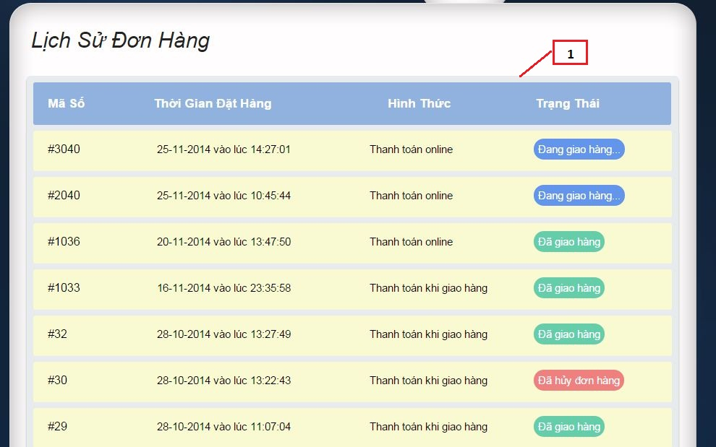

*Figure 128: View Order History*

**Fields**

|  |  |  |  |  |  |  |  |
| --- | --- | --- | --- | --- | --- | --- | --- |
| **No** | **Field Name** | **Description** | **Read only** | **Mandatory** | **Control Type** | **Data Type** | **Length** |
| 1 | Order list | List of all orders of current user | Yes | Yes | Table | N/A | N/A |

**Order List Include**

|  |  |  |  |  |  |  |  |
| --- | --- | --- | --- | --- | --- | --- | --- |
| **No** | **Field Name** | **Description** | **Read only** | **Mandatory** | **Control Type** | **Data Type** | **Length** |
| 1 | Code | List of all orders of current user | Yes | Yes | Label | String | N/A |
| 2 | Rent time | Time that start to rent order | Yes | Yes | Label | String | N/A |
| 3 | Form | Way to payment of order | Yes | Yes | Label | String | N/A |
| 4 | Status | Status of order in difference time | Yes | Yes | Label | String | N/A |

### Extend Rent Time

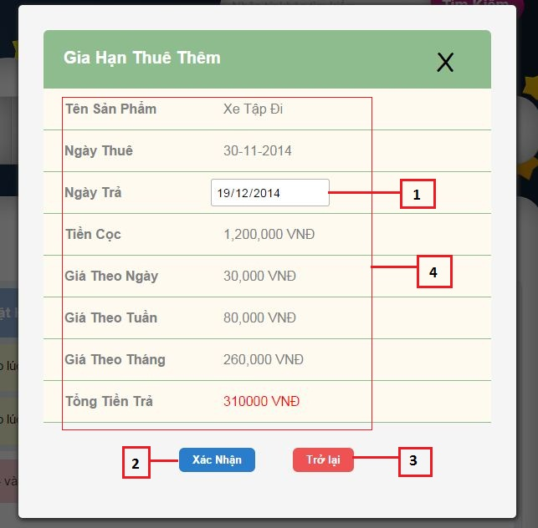

*Figure 129: Extend Rent Time*

**Fields**

|  |  |  |  |  |  |  |  |
| --- | --- | --- | --- | --- | --- | --- | --- |
| **No** | **Field Name** | **Description** | **Read only** | **Mandatory** | **Control Type** | **Data Type** | **Length** |
| 1 | ToDate | Fill new return date that customer ant to extend rent time | No | Yes | Date time picker | String | N/A |
| 4 | Information of order detail | All core information of renting a toy | Yes | Yes | Label | N/A | N/A |

**Information of order detail include**

|  |  |  |  |  |  |  |  |
| --- | --- | --- | --- | --- | --- | --- | --- |
| **No** | **Field Name** | **Description** | **Read only** | **Mandatory** | **Control Type** | **Data Type** | **Length** |
| 1 | Name | Name of toy | Yes | Yes | Label | String | N/A |
| 2 | Rent from date | The date start to rent toy | Yes | Yes | Label | String | N/A |
| 3 | Deposit | Deposit of toy | Yes | Yes | Label | String | N/A |
| 4 | Day price | Price of toy in a day | Yes | Yes | Label | String | N/A |
| 5 | Week price | Price of toy in a week | Yes | Yes | Label | String | N/A |
| 6 | Month price | Price of toy in a month | Yes | Yes | Label | String | N/A |

**Buttons/Hyperlinks**

|  |  |  |  |  |
| --- | --- | --- | --- | --- |
| **No** | **Function** | **Description** | **Validation** | **Outcome** |
| 2 | Confirm | Click to confirm extend rent time | Yes | Transfer to view order history page |
| 3 | Return back | Click to cancel process and return back current page | No | Transfer to view order history page |

### View Cart

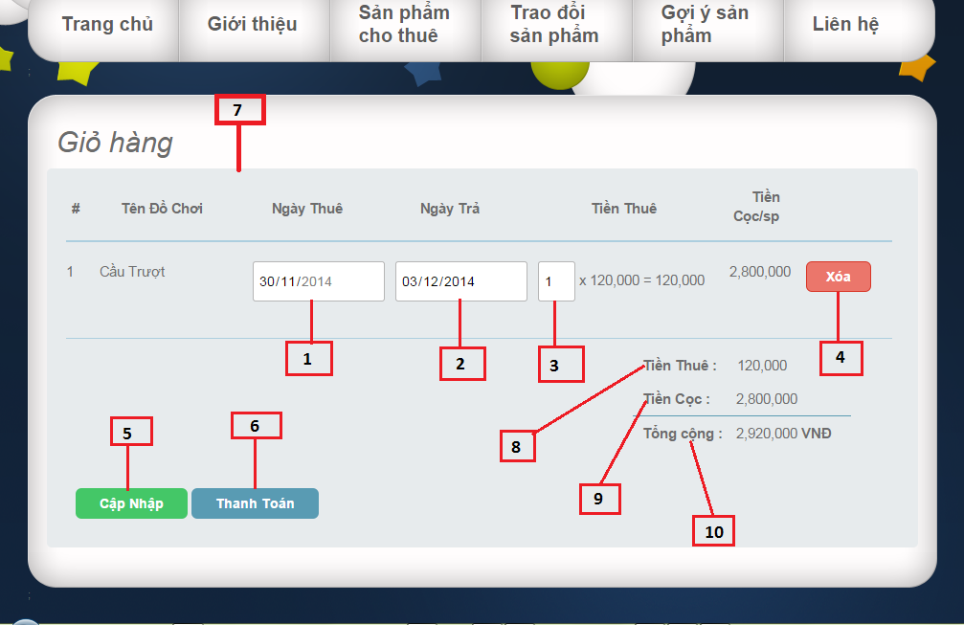

*Figure 130: View Cart*

**Fields**

|  |  |  |  |  |  |  |  |
| --- | --- | --- | --- | --- | --- | --- | --- |
| **No** | **Field Name** | **Description** | **Read only** | **Mandatory** | **Control Type** | **Data Type** | **Length** |
| 1 | FromDate | Fill rent from date | No | Yes | Date time picker | String | N/A |
| 2 | ToDate | Fill rent to date | No | Yes | Date time picker | String | N/A |
| 3 | Amount | Fill quantity toy want to rent | No | Yes | Textbox | String | N/A |
| 7 | Product list | List all products that user add to cart | Yes | Yes | Table | N/A | N/A |
| 8 | Total rent price | Total rent price of all products in cart | Yes | Yes | Label | String | N/A |
| 9 | Total deposit | Total deposit of all products in cart | Yes | Yes | Label | String | N/A |
| 10 | Total price | Total price include total rent price and total deposit | Yes | Yes | Label | String | N/A |

**Product list include:**

|  |  |  |  |  |  |  |  |
| --- | --- | --- | --- | --- | --- | --- | --- |
| **No** | **Field Name** | **Description** | **Read only** | **Mandatory** | **Control Type** | **Data Type** | **Length** |
| 1 | Ordinal | Ordinal number of product list | Yes | Yes | Label | Integer | N/A |
| 2 | Name | Name of toy | Yes | Yes | Label | String | N/A |
| 3 | Rent Price | Amount of toy | Yes | Yes | Label | String | N/A |
| 4 | Deposit | Deposit of toy | Yes | Yes | Label | Long | N/A |

**Buttons/Hyperlinks**

|  |  |  |  |  |
| --- | --- | --- | --- | --- |
| **No** | **Function** | **Description** | **Validation** | **Outcome** |
| 4 | Remove toy out of cart | Click to remove current toy out of cart | No | N/A |
| 5 | Update cart | Click to update new information of cart | Yes | N/A |
| 6 | Check out cart | Click to show popup check out cart | Yes | N/A |

### Check Out _ Choose payment way

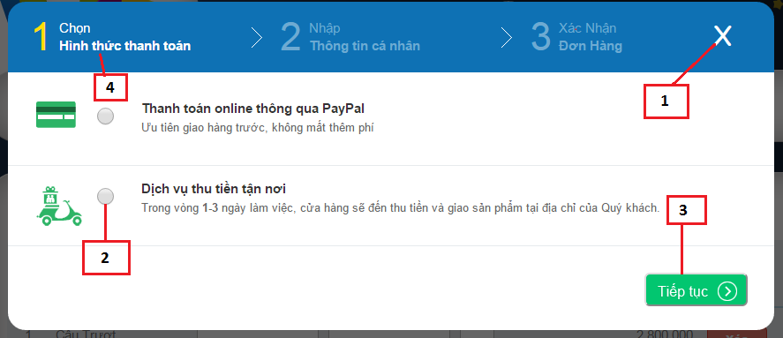

*Figure 131: Check out_ Choose payment way*

**Fields**

|  |  |  |  |  |  |  |  |
| --- | --- | --- | --- | --- | --- | --- | --- |
| **No** | **Field Name** | **Description** | **Read only** | **Mandatory** | **Control Type** | **Data Type** | **Length** |
| 2 | Way to payment | Click to choose way to payment | No | Yes | Radio button | Boolean | N/A |
| 4 | Step 1 | Step choose way to payment | Yes | Yes | Label | String | N/A |

**Buttons/Hyperlinks**

|  |  |  |  |  |
| --- | --- | --- | --- | --- |
| **No** | **Function** | **Description** | **Validation** | **Outcome** |
| 1 | Close popup | Click to close current popup | No | Transfer to view cart page |
| 3 | Continue next step | Click to continue next step of check out | Yes | Transfer to confirm information delivering popup |

### Check Out _ Confirm information delivering

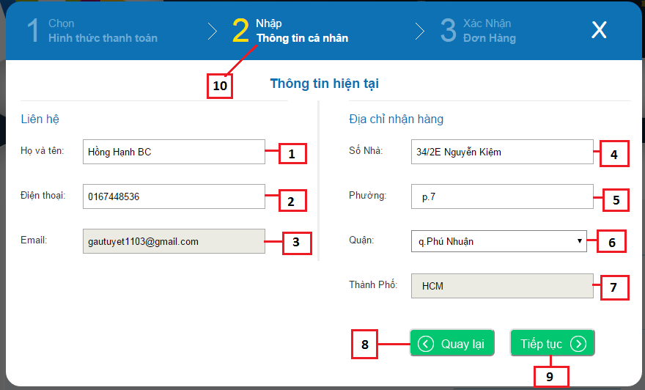

*Figure 132: Check out _ Confirm information delivering*

**Fields**

|  |  |  |  |  |  |  |  |
| --- | --- | --- | --- | --- | --- | --- | --- |
| **No** | **Field Name** | **Description** | **Read only** | **Mandatory** | **Control Type** | **Data Type** | **Length** |
| 1 | Name | Fill name of receiver | No | Yes | Textbox | String | N/A |
| 2 | Phone | Fill phone of receiver | No | Yes | Textbox | String | [10,11] |
| 3 | Email | Fill email of current user | Yes | Yes | Textbox | String | N/A |
| 4 | Address | Fill address delivering | No | Yes | Textbox | String | N/A |
| 5 | Precinct | Fill precinct of address | No | Yes | Textbox | String | N/A |
| 6 | District | Fill district of address | No | Yes | Drop down list | String | N/A |
| 7 | City | Fill name of city to delivering | Yes | Yes | Textbox | String | N/A |
| 10 | Step 2 | Step confirm profile | Yes | Yes | Label | String | N/A |

**Buttons/Hyperlinks**

|  |  |  |  |  |
| --- | --- | --- | --- | --- |
| **No** | **Function** | **Description** | **Validation** | **Outcome** |
| 8 | Return back | Click to return back previous step that choose payment way | Yes | Transfer to popup choose payment way |
| 9 | Continue | Click to continue next step that confirm all information | Yes | Transfer to popup confirm all information of cart |

### Check Out_ Confirm al information

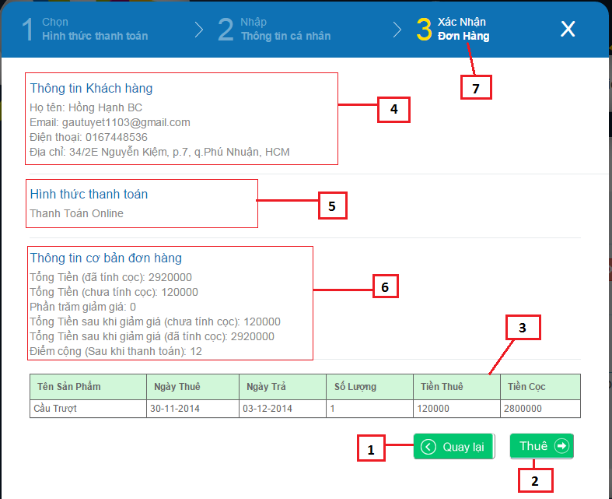

*Figure 133: Check Out_ Confirm all information*

**Fields**

|  |  |  |  |  |  |  |  |
| --- | --- | --- | --- | --- | --- | --- | --- |
| **No** | **Field Name** | **Description** | **Read only** | **Mandatory** | **Control Type** | **Data Type** | **Length** |
| 3 | Product list | List product user added to cart | Yes | Yes | Table | N/A | N/A |
| 4 | Information of user | Summary information that help to delivering | Yes | Yes | Label | String | N/A |
| 5 | Way to payment | Confirm way to payment | Yes | Yes | Label | String | N/A |
| 6 | Information payment | Summary information use need to know about price, promotion | Yes | Yes | Label | String | N/A |
| 7 | Step 3 | Step confirm all information before check out | Yes | Yes | Label | String | N/A |

**Product include**

|  |  |  |  |  |  |  |  |
| --- | --- | --- | --- | --- | --- | --- | --- |
| **No** | **Field Name** | **Description** | **Read only** | **Mandatory** | **Control Type** | **Data Type** | **Length** |
| 1 | Name | Name of toy | Yes | Yes | Label | String | N/A |
| 2 | Rent from date | The date start to rent toy | Yes | Yes | Label | String | N/A |
| 3 | Rent to date | The date end of time to rent toy | Yes | Yes | Label | String | N/A |
| 4 | Quantity | Quantity toy current user rent | Yes | Yes | Label | String | N/A |
| 5 | Amount | Total rent price | Yes | Yes | Label | String | N/A |
| 6 | Deposit | Deposit of toy | Yes | Yes | Label | String | N/A |

**Buttons/Hyperlinks**

|  |  |  |  |  |
| --- | --- | --- | --- | --- |
| **No** | **Function** | **Description** | **Validation** | **Outcome** |
| 1 | Return back | Click to return back previous step that confirm information delivering | Yes | Transfer to popup confirm information delivering |
| 2 | Check out | Click to confirm check out | Yes | Transfer to Home page |

### View User Profile

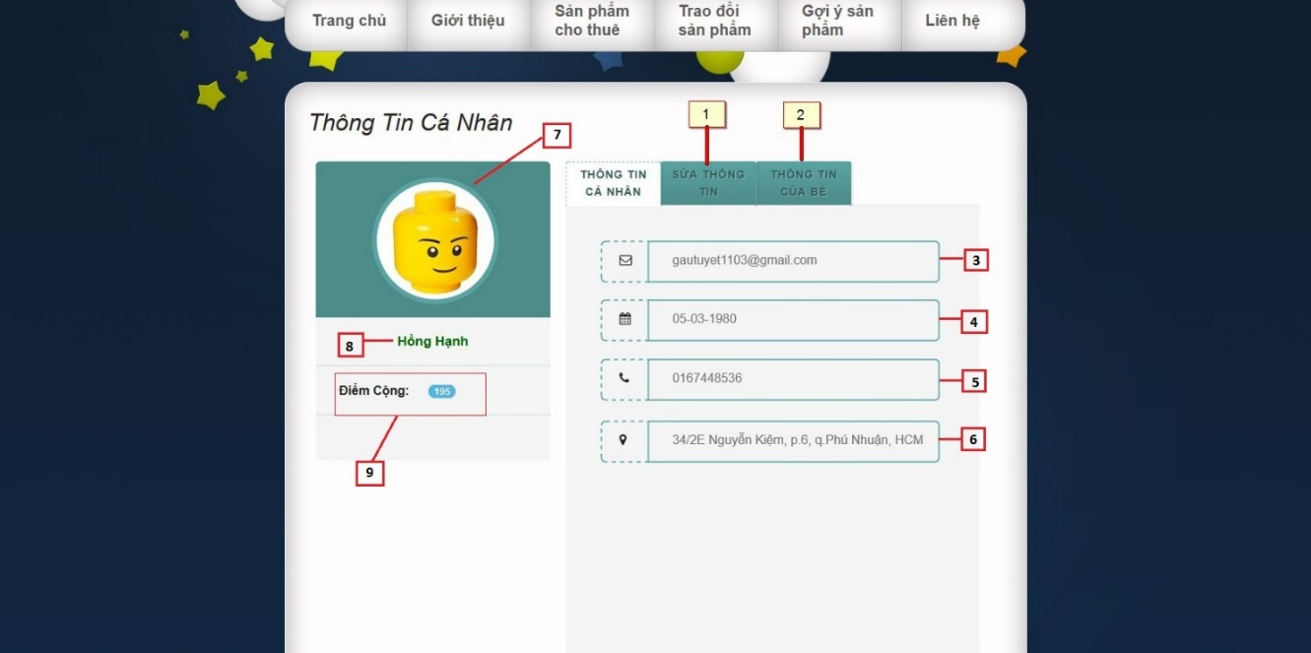

*Figure 134: View User Profile*

**Fields**

|  |  |  |  |  |  |  |  |
| --- | --- | --- | --- | --- | --- | --- | --- |
| **No** | **Field Name** | **Description** | **Read only** | **Mandatory** | **Control Type** | **Data Type** | **Length** |
| 3 | Email | Email of current user | Yes | Yes | Textbox | String | N/A |
| 4 | Birthdate | Birthdate of current user | Yes | Yes | Textbox | String | N/A |
| 5 | Phone | Phone of current user | Yes | Yes | Textbox | String | [10,11] |
| 6 | Address | Address of current user | Yes | Yes | Textbox | String | N/A |
| 7 | Image | Image default of user | Yes | Yes | Image | N/A | N/A |
| 8 | Name | Name of current user | Yes | Yes | Label | String | N/A |
| 9 | Plus point | Plus point of current user | Yes | Yes | Label | String | N/A |

**Buttons/Hyperlinks**

|  |  |  |  |  |
| --- | --- | --- | --- | --- |
| **No** | **Function** | **Description** | **Validation** | **Outcome** |
| 1 | Update information | Fill update information of current user profile | No | N/A |
| 2 | View child | Fill view information of children | No | N/A |

### Update User Profile

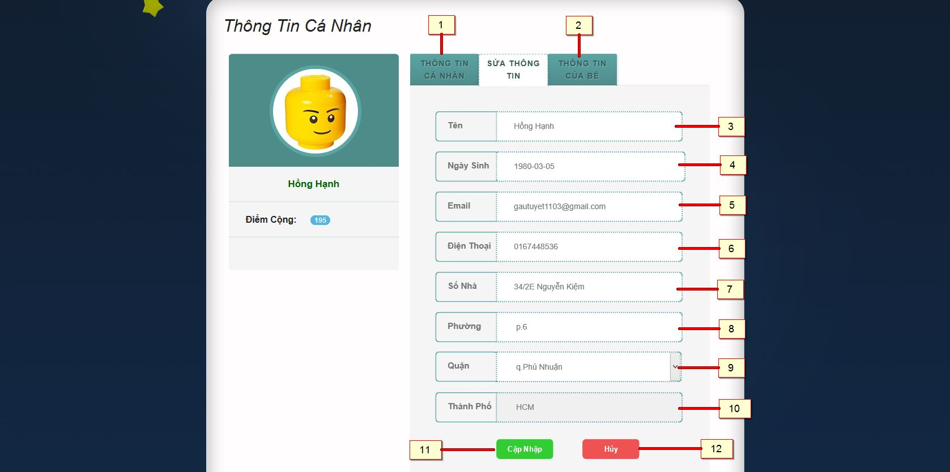

*Figure 135: Update User Profile*

**Fields**

|  |  |  |  |  |  |  |  |
| --- | --- | --- | --- | --- | --- | --- | --- |
| **No** | **Field Name** | **Description** | **Read only** | **Mandatory** | **Control Type** | **Data Type** | **Length** |
| 3 | Name | Fill name of current user | No | Yes | Textbox | String | N/A |
| 4 | Birthdate | Fill birthdate of current user | No | Yes | Date time picker | String | N/A |
| 5 | Phone | Fill phone of current user | No | Yes | Textbox | String | [10,11] |
| 6 | Email | Fill email of current user | No | Yes | Textbox | String | N/A |
| 7 | Address | Fill address delivering | No | Yes | Textbox | String | N/A |
| 8 | Precinct | Fill precinct of address | No | Yes | Textbox | String | N/A |
| 9 | District | Fill district of address | No | Yes | Drop down list | String | N/A |
| 10 | City | Fill name of city to delivering | Yes | Yes | Textbox | String | N/A |

**Buttons/Hyperlinks**

|  |  |  |  |  |
| --- | --- | --- | --- | --- |
| **No** | **Function** | **Description** | **Validation** | **Outcome** |
| 1 | User Profile | Click to view user profile | No | Transfer to user profile page |
| 2 | View child | Fill view information of children | No | N/A |
| 11 | Update | Update information of current user profile | No | Transfer to view user profile |
| 12 | Cancel | Cancel update information of profile | No | Transfer to view user profile |

### Information of Child

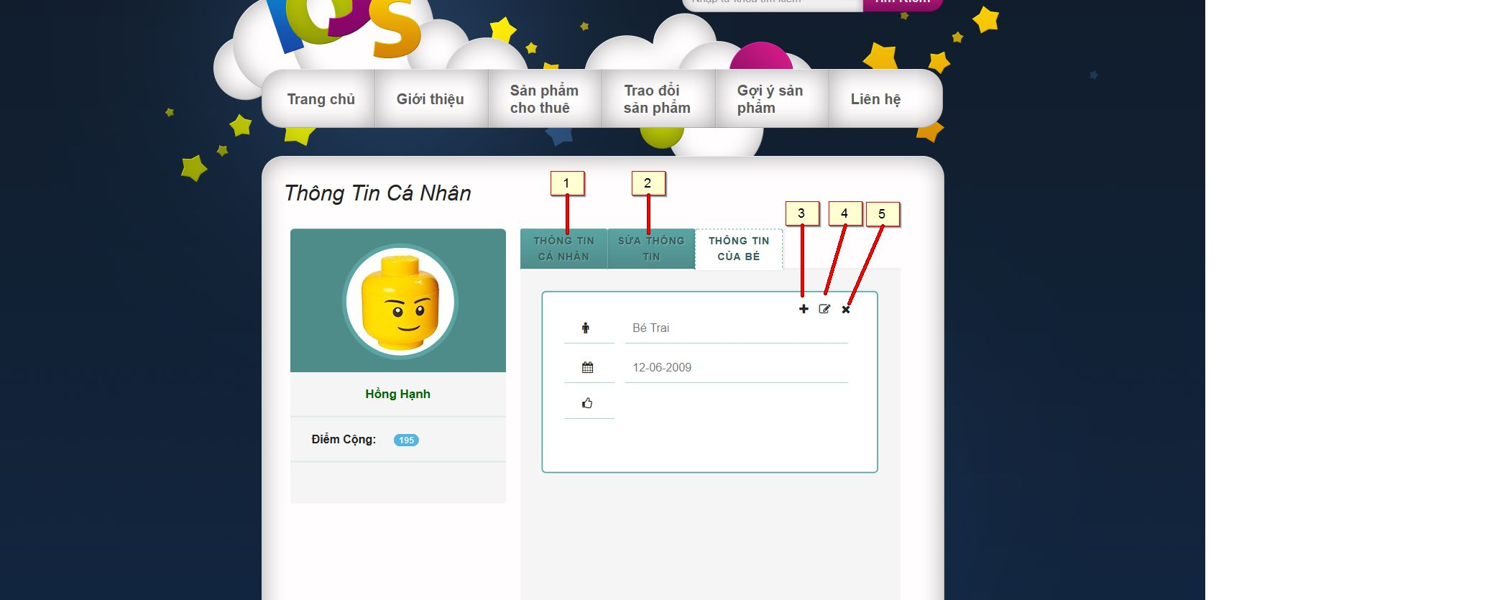

*Figure 136: Information of child*

**Buttons/Hyperlinks**

|  |  |  |  |  |
| --- | --- | --- | --- | --- |
| **No** | **Function** | **Description** | **Validation** | **Outcome** |
| 1 | User Profile | Click to view user profile | No | Transfer to user profile page |
| 2 | Update information | Fill update information of current user profile | No | N/A |
| 3 | Add new | Add new child | No | Transfer to popup add child |
| 4 | Update | Update current child | No | Transfer to popup update child |
| 5 | Delete | Remove child of user | No | Transfer to view user profile |

### Add Child

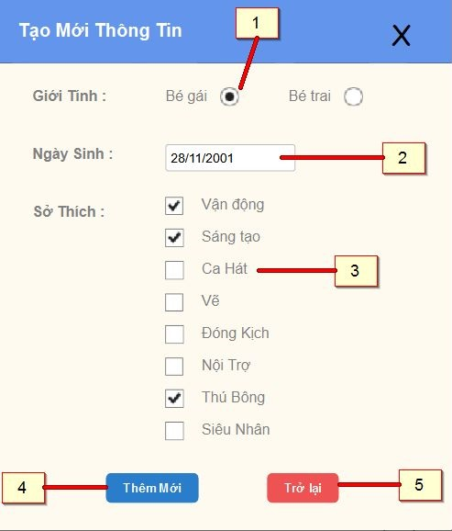

*Figure 137: Add Child*

**Fields**

|  |  |  |  |  |  |  |  |
| --- | --- | --- | --- | --- | --- | --- | --- |
| **No** | **Field Name** | **Description** | **Read only** | **Mandatory** | **Control Type** | **Data Type** | **Length** |
| 1 | Gender | Sex of child | No | Yes | Radio button | N/A | N/A |
| 2 | Birthdate | Birthdate of child | No | Yes | Date time picker | String | N/A |
| 3 | Hobby | Hobbies of child | No | Yes | Checkbox | String | N/A |

**Buttons/Hyperlinks**

|  |  |  |  |  |
| --- | --- | --- | --- | --- |
| **No** | **Function** | **Description** | **Validation** | **Outcome** |
| 1 | Add child | Click to confirm add child | Yes | Transfer to View Use Profile |
| 2 | Return Back | Click to return back information of child | No | Transfer to current page |

### Update Child

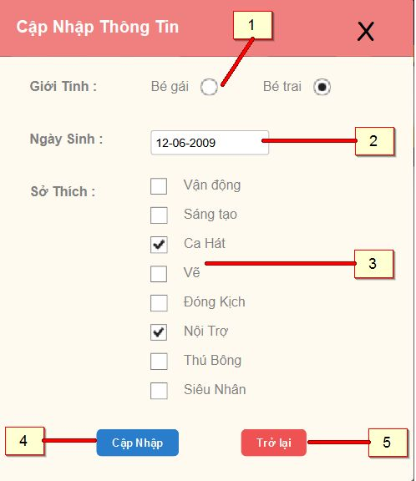

*Figure 138: Update Child*

**Fields**

|  |  |  |  |  |  |  |  |
| --- | --- | --- | --- | --- | --- | --- | --- |
| **No** | **Field Name** | **Description** | **Read only** | **Mandatory** | **Control Type** | **Data Type** | **Length** |
| 1 | Gender | Sex of child | No | Yes | Radio button | N/A | N/A |
| 2 | Birthdate | Birthdate of child | No | Yes | Date time picker | String | N/A |
| 3 | Hobby | Hobbies of child | No | Yes | Checkbox | String | N/A |

**Buttons/Hyperlinks**

|  |  |  |  |  |
| --- | --- | --- | --- | --- |
| **No** | **Function** | **Description** | **Validation** | **Outcome** |
| 1 | Update child | Click to confirm update child | Yes | Transfer to View Use Profile |
| 2 | Return Back | Click to return back information of child | No | Transfer to current page |

### Manage Order

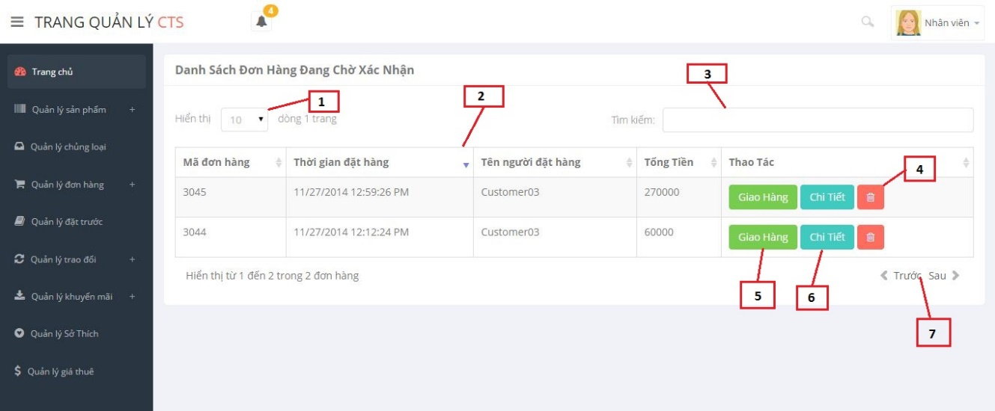

*Figure 139: Manage Order*

**Fields**

|  |  |  |  |  |  |  |  |
| --- | --- | --- | --- | --- | --- | --- | --- |
| **No** | **Field Name** | **Description** | **Read only** | **Mandatory** | **Control Type** | **Data Type** | **Length** |
| 1 | Row display | Number of rows display in current page | No | Yes | Drop down list | Integer | N/A |
| 2 | Order list | List all orders of store | Yes | Yes | Table | N/A | N/A |
| 3 | Search | Fill search order | No | Yes | Textbox | String | N/A |

**Order List include:**

|  |  |  |  |  |  |  |  |
| --- | --- | --- | --- | --- | --- | --- | --- |
| **No** | **Field Name** | **Description** | **Read only** | **Mandatory** | **Control Type** | **Data Type** | **Length** |
| 1 | Order code | Code of order | Yes | Yes | Label | Integer | N/A |
| 2 | Time to rent order | The date start to order | Yes | Yes | Label | String | N/A |
| 3 | Name of renter | Name pf customer | Yes | Yes | Label | String | N/A |
| 4 | Total price | Total price of order | Yes | Yes | Label | Long | N/A |

**Buttons/Hyperlinks**

|  |  |  |  |  |
| --- | --- | --- | --- | --- |
| **No** | **Function** | **Description** | **Validation** | **Outcome** |
| 4 | Delete order | Click to cancel order | No | N/A |
| 5 | Assign shipper | Click to assign shipper for that order | No | Transfer to popup assign |
| 6 | View order detail | Click to view order detail | No | Transfer to popup view order detail |
| 7 | Paging | Divide page previous and next | No | N/A |

### View Order Detail (staff)

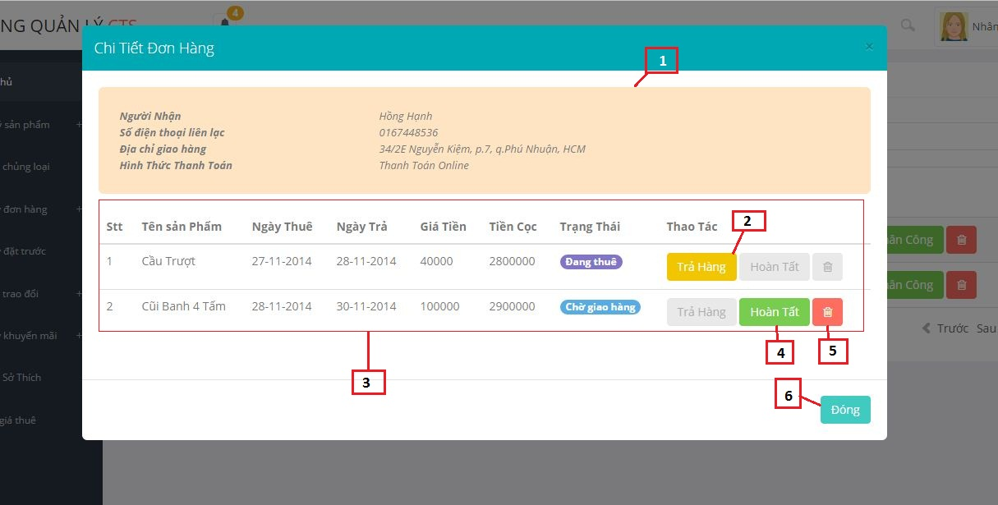

*Figure 140: View Order Detail (staff)*

**Fields**

|  |  |  |  |  |  |  |  |
| --- | --- | --- | --- | --- | --- | --- | --- |
| **No** | **Field Name** | **Description** | **Read only** | **Mandatory** | **Control Type** | **Data Type** | **Length** |
| 1 | Field information of order’s user | Description all information of order’s user and way to payment | Yes | Yes | Label | String | N/A |
| 3 | Order detail list | All product in order | Yes | Yes | Table | N/A | N/A |

**Order Detail List include**

|  |  |  |  |  |  |  |  |
| --- | --- | --- | --- | --- | --- | --- | --- |
| **No** | **Field Name** | **Description** | **Read only** | **Mandatory** | **Control Type** | **Data Type** | **Length** |
| 1 | Ordinal | Ordinal number of order detail list | Yes | Yes | Label | Integer | N/A |
| 2 | Name | Name of toy | Yes | Yes | Label | String | N/A |
| 3 | Rent from date | The date start to rent toy | Yes | Yes | Label | String | N/A |
| 4 | Rent to date | The date end of time to rent toy | Yes | Yes | Label | String | N/A |
| 5 | Amount | Total rent price | Yes | Yes | Label | String | N/A |
| 6 | Status | Status of order detail in difference time | Yes | Yes | Label | String | N/A |

**Buttons/Hyperlinks**

|  |  |  |  |  |
| --- | --- | --- | --- | --- |
| **No** | **Function** | **Description** | **Validation** | **Outcome** |
| 2 | Return back | Click to return back toy | Yes | Transfer to Manager Order Page |
| 4 | Done delivering | Click to confirm done delivering order | Yes | Transfer to Manager Order Page |
| 5 | Delete | Cancel order detail | Yes | Transfer to Manager Order Page |
| 6 | Close | Close current popup | No | Transfer to current page |

### View Order Detail (customer)

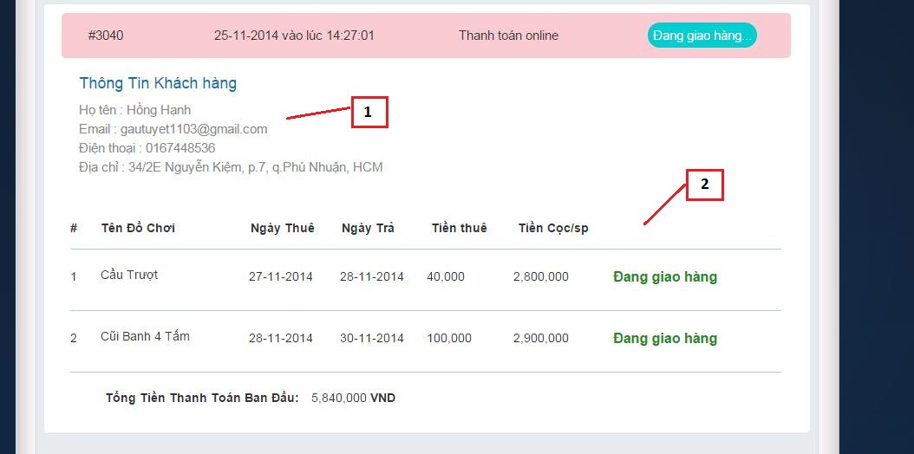

*Figure 141: View Order Detail*

**Fields**

|  |  |  |  |  |  |  |  |
| --- | --- | --- | --- | --- | --- | --- | --- |
| **No** | **Field Name** | **Description** | **Read only** | **Mandatory** | **Control Type** | **Data Type** | **Length** |
| 1 | Information profile | Description information about order’s user | Yes | Yes | Label | String | N/A |
| 2 | List order detail | All product were rented of current order. | Yes | Yes | Table | N/A | N/A |

**Order Detail List include**

|  |  |  |  |  |  |  |  |
| --- | --- | --- | --- | --- | --- | --- | --- |
| **No** | **Field Name** | **Description** | **Read only** | **Mandatory** | **Control Type** | **Data Type** | **Length** |
| 1 | Ordinal | Ordinal number of order detail list | Yes | Yes | Label | Integer | N/A |
| 2 | Name | Name of toy | Yes | Yes | Label | String | N/A |
| 3 | Rent from date | The date start to rent toy | Yes | Yes | Label | String | N/A |
| 4 | Rent to date | The date end of time to rent toy | Yes | Yes | Label | String | N/A |
| 5 | Amount | Total rent price | Yes | Yes | Label | String | N/A |
| 6 | Status | Status of order detail in difference time | Yes | Yes | Label | String | N/A |

### Return Back

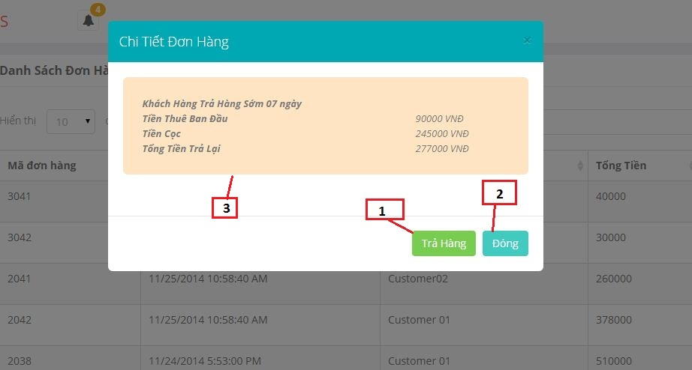

*Figure 142: Return Back*

**Fields**

|  |  |  |  |  |  |  |  |
| --- | --- | --- | --- | --- | --- | --- | --- |
| **No** | **Field Name** | **Description** | **Read only** | **Mandatory** | **Control Type** | **Data Type** | **Length** |
| 3 | Information confirm when customer return back product | Information confirm when customer return back product: rent price, deposit, total price return for customer | Yes | Yes | Label | String | N/A |

**Buttons/Hyperlinks**

|  |  |  |  |  |
| --- | --- | --- | --- | --- |
| **No** | **Function** | **Description** | **Validation** | **Outcome** |
| 1 | Return back | Click to confirm return back | Yes | Transfer to current page |
| 2 | Close | Click to close current popup | No | Transfer to current page |

### Assign Shipper

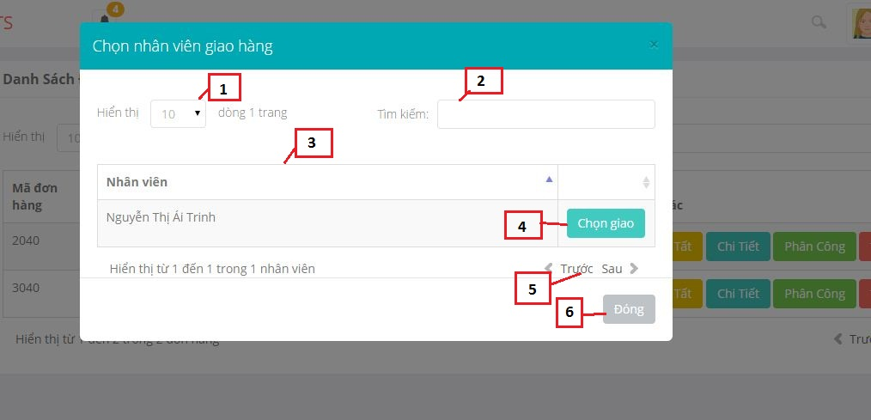

*Figure 143: Assign shipper*

**Fields**

|  |  |  |  |  |  |  |  |
| --- | --- | --- | --- | --- | --- | --- | --- |
| **No** | **Field Name** | **Description** | **Read only** | **Mandatory** | **Control Type** | **Data Type** | **Length** |
| 1 | Row display | Number of rows display in current page | No | Yes | Drop down list | Integer | N/A |
| 2 | Staff list | List all staffs of store | Yes | Yes | Table | N/A | N/A |
| 3 | Search | Fill search staff | No | Yes | Textbox | String | N/A |

**Buttons/Hyperlinks**

|  |  |  |  |  |
| --- | --- | --- | --- | --- |
| **No** | **Function** | **Description** | **Validation** | **Outcome** |
| 1 | Assign | Click to assign shipper for current order | No | Transfer to current page |
| 7 | Paging | Divide page previous and next | No |  |

### Manage Promotion

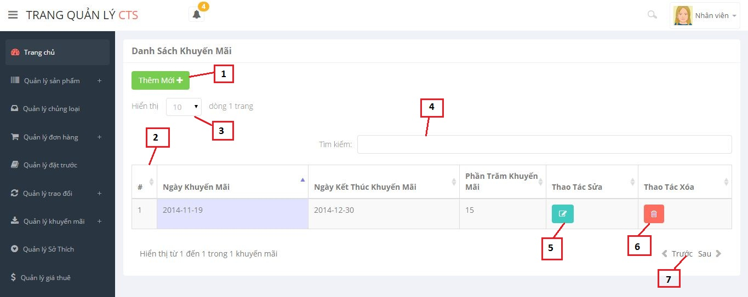

*Figure 144: Manage Promotion*

**Fields**

|  |  |  |  |  |  |  |  |
| --- | --- | --- | --- | --- | --- | --- | --- |
| **No** | **Field Name** | **Description** | **Read only** | **Mandatory** | **Control Type** | **Data Type** | **Length** |
| 3 | Row display | Number of rows display in current page | No | No | Drop down list | Integer | N/A |
| 2 | List promotion | List promotion of store | Yes | No | Table | N/A | N/A |
| 4 | Search | Fill search promotion | No | No | Textbox | String | N/A |

**Promotion list include**

|  |  |  |  |  |  |  |  |
| --- | --- | --- | --- | --- | --- | --- | --- |
| **No** | **Field Name** | **Description** | **Read only** | **Mandatory** | **Control Type** | **Data Type** | **Length** |
| 1 | Ordinal | Ordinal number of promotion list | Yes | Yes | Label | Integer | N/A |
| 2 | Start date | The date start promotion | Yes | Yes | Label | String | N/A |
| 3 | End date | The date end promotion | Yes | Yes | Label | String | N/A |
| 4 | Percent | Percent promotion | Yes | Yes | Label | String | N/A |

**Buttons/Hyperlinks**

|  |  |  |  |  |
| --- | --- | --- | --- | --- |
| **No** | **Function** | **Description** | **Validation** | **Outcome** |
| 1 | Add new | Click to add new promotion | No | Transfer to current page |
| 5 | Update | Click to update information of a promotion | Yes | Transfer to current page |
| 6 | Delete | Click to delete a promotion | No | Transfer to current page |
| 7 | Paging | Divide page previous and next | No | N/A |

### Register

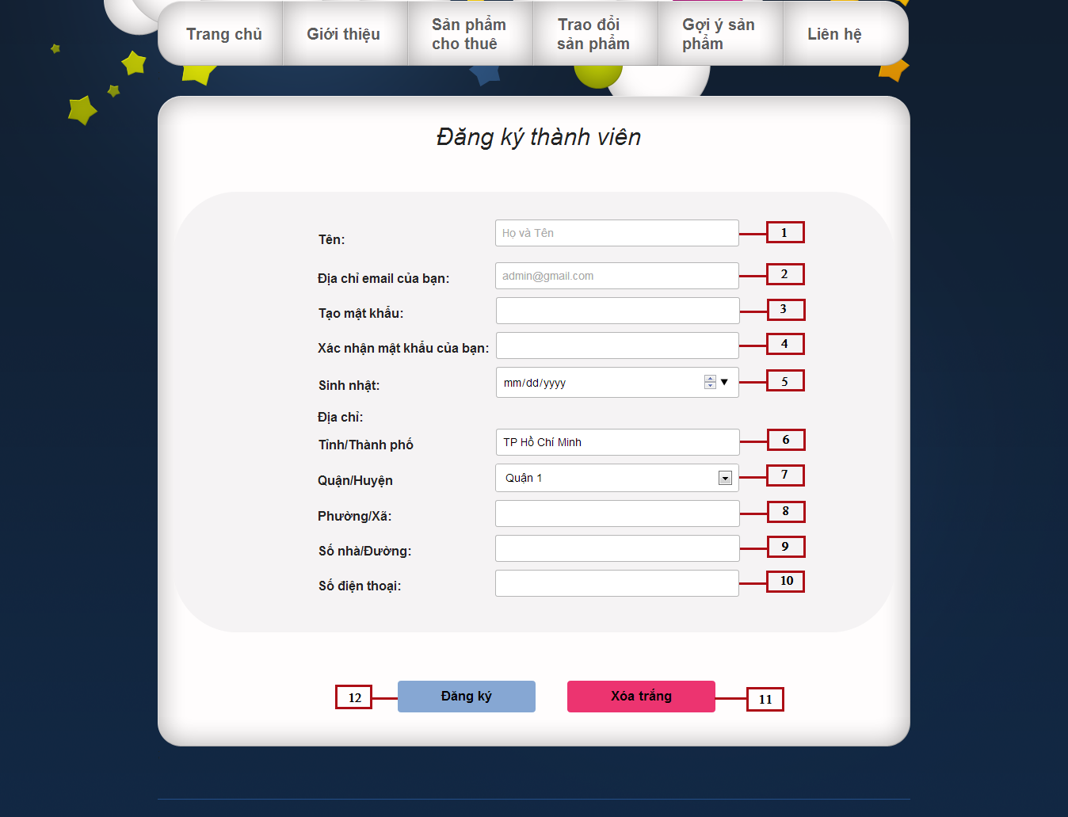

*Figure 145: Register*

**Fields**

|  |  |  |  |  |  |  |  |
| --- | --- | --- | --- | --- | --- | --- | --- |
| **No** | **Field Name** | **Description** | **Read only** | **Mandatory** | **Control Type** | **Data Type** | **Length** |
| 1 | Full Name | Fill user fullname | No | Yes | Textbox | String | N/A |
| 2 | Email | Fill user email | No | Yes | Email | String | N/A |
| 3 | Password | Fill password | No | Yes | Password | String | [8-32] |
| 4 | Re-Password | Fill re-password | No | Yes | Password | String | [8-32] |
| 5 | Birthday | Fill user birthday | No | Yes | Date time picker | String | N/A |
| 6 | City | Show city’s name | Yes | Yes | Textbox | String | N/A |
| 7 | District | Select user district | No | Yes | Drop down list | String | N/A |
| 8 | Ward | Fill user ward | No | Yes | Textbox | String | N/A |
| 9 | Adress | Fill user address | No | Yes | Textbox | String | N/A |
| 10 | Phone Number | Fill user phone number | No | Yes | Textbox | String | [10-11] |

**Buttons/Hyperlinks**

|  |  |  |  |  |
| --- | --- | --- | --- | --- |
| **No** | **Function** | **Description** | **Validation** | **Outcome** |
| 11 | Clear Text | Click to delete information in all field | N/A | All information in the data filed will be clear(Except : birthday, city, district fileds) |
| 12 | Register | Click to register a new account | N/A | Transfer to register page |

### View Category

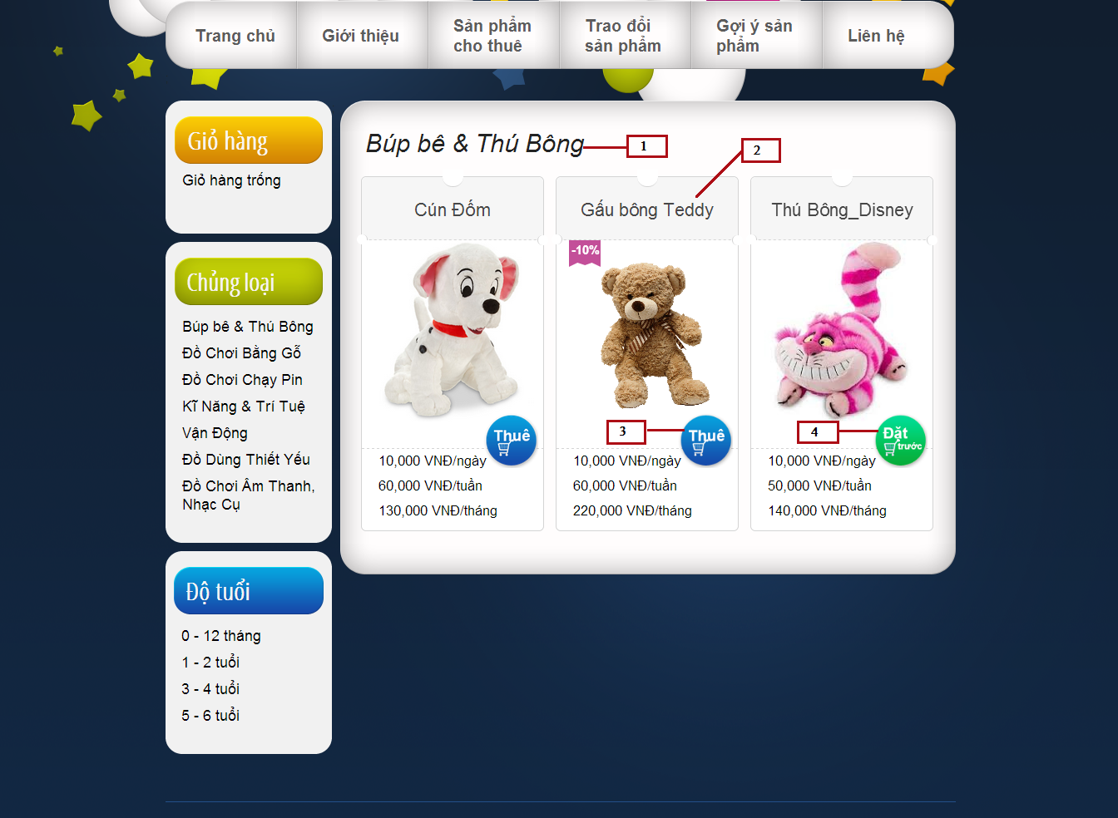

*Figure 146: View Category*

**Fields**

|  |  |  |  |  |  |  |  |
| --- | --- | --- | --- | --- | --- | --- | --- |
| **No** | **Field Name** | **Description** | **Read only** | **Mandatory** | **Control Type** | **Data Type** | **Length** |
| 1 | Category name lable | Show name of category | Yes | Yes | Label | String | N/A |
| 2 | Toy list | Show list toy | No | Yes | Gird list view | N/A | N/A |

**Buttons/Hyperlinks**

|  |  |  |  |  |
| --- | --- | --- | --- | --- |
| **No** | **Function** | **Description** | **Validation** | **Outcome** |
| 3 | Rent | Click to rent a toy | N/A | Show popup to choose the time and quantity to rent |
| 4 | Reserve | Click to reserve a toy | N/A | Show popup to confirm reserve toy |

**Toy List Includes**

|  |  |  |  |  |  |
| --- | --- | --- | --- | --- | --- |
| **Field Name** | **Description** | **Read only** | **Control Type** | **Data Type** | **Length** |
| Toy name | Show toy name | No | Textview | String | N/A |
| Promotion | Show percent promotion of toy | No | Textview | Integer | N/A |
| Toy image | Show toy image | No | Image | String | N/A |
| Price | Show toy price | Yes | Textview | Double | N/A |
| Action | Action of toy | No | Button | N/A | N/A |

### Advanced search

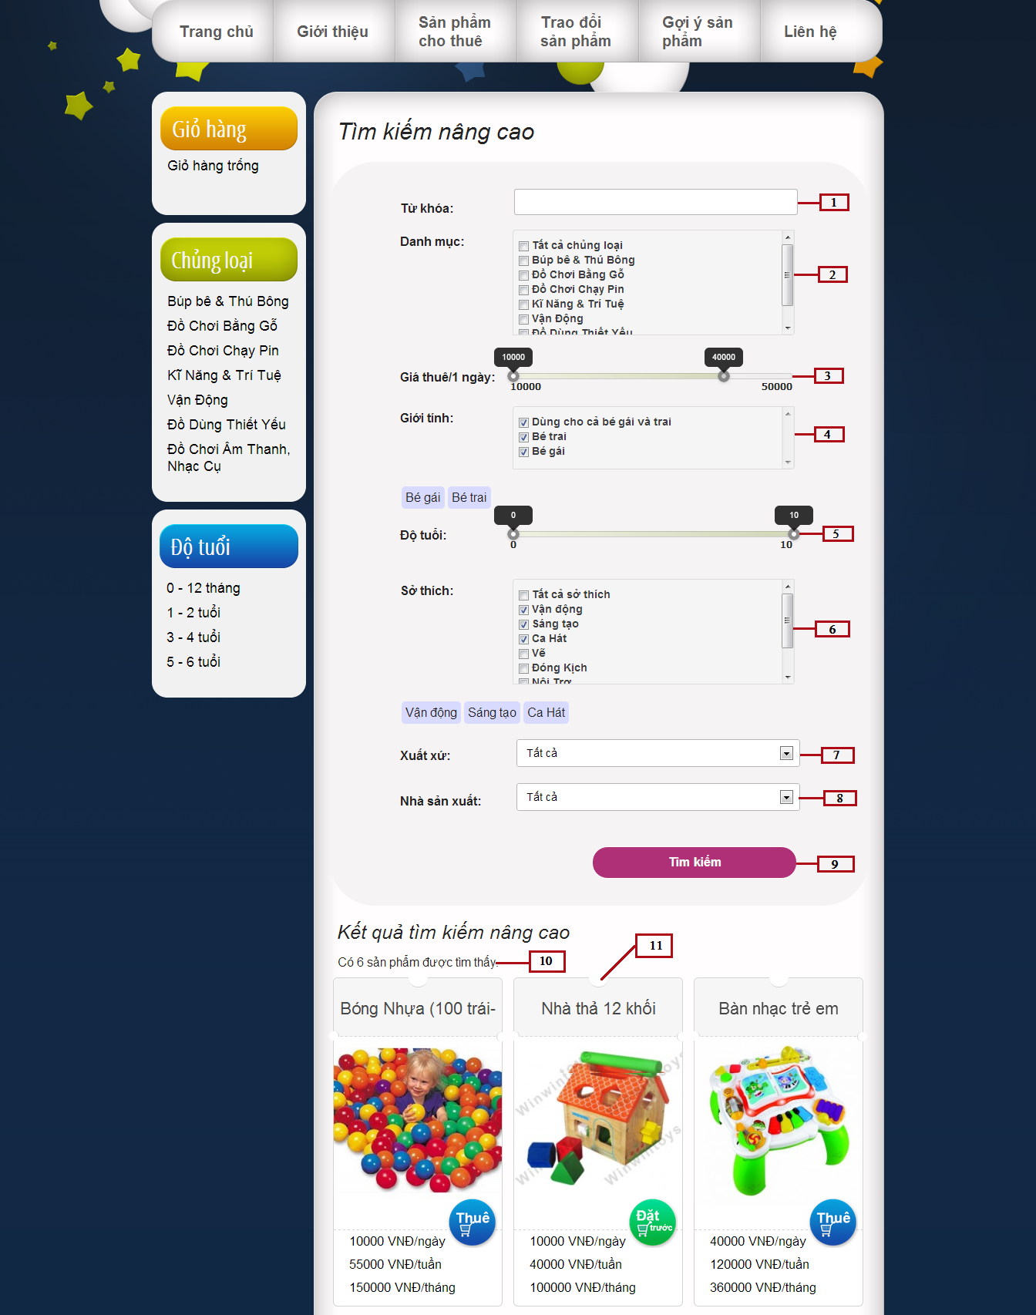

*Figure 147: Advanced Search*

**Fields**

|  |  |  |  |  |  |  |  |
| --- | --- | --- | --- | --- | --- | --- | --- |
| **No** | **Field Name** | **Description** | **Read only** | **Mandatory** | **Control Type** | **Data Type** | **Length** |
| 1 | Keyword | Fill keyword | No | Yes | Textbox | String | N/A |
| 2 | Category | Select category name | No | N/A | Checkbox | N/A | N/A |
| 3 | Price | Select price | No | N/A | Slider | N/A | N/A |
| 4 | Gender | Select gender | No | N/A | Checkbox | N/A | N/A |
| 5 | Age | Select age | No | N/A | Slider | N/A | N/A |
| 6 | Hobby | Select hobby | No | N/A | Checkbox | N/A | N/A |
| 7 | Origin | Select origin | No | N/A | Drop-down-list | N/A | N/A |
| 8 | Manufacture | Select manufacture | No | N/A | Drop-down-list | N/A | N/A |
| 10 | Result number | Show result number | Yes | N/A | Textview | N/A | N/A |
| 11 | Toy list | Show list toy result | No | N/A | Gird list view | N/A | N/A |

**Buttons/Hyperlinks**

|  |  |  |  |  |
| --- | --- | --- | --- | --- |
| **No** | **Function** | **Description** | **Validation** | **Outcome** |
| 9 | Search | Click to search toys | N/A | Show toys result below |

### Manage Members

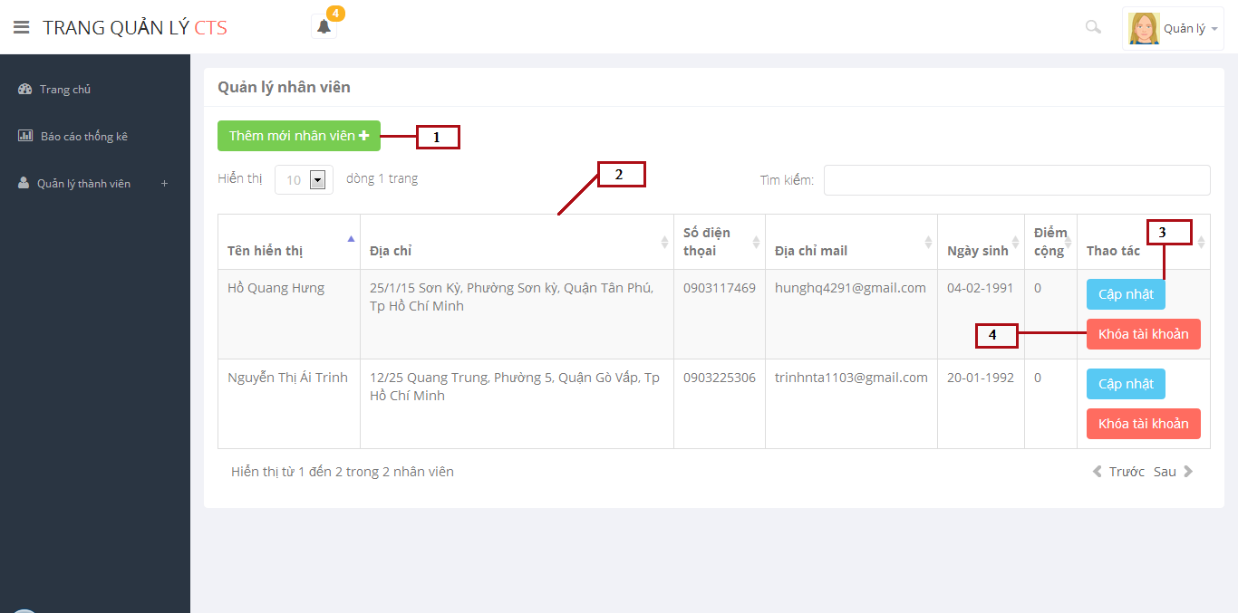

*Figure 148: Manage Members*

**Fields**

|  |  |  |  |  |  |  |  |
| --- | --- | --- | --- | --- | --- | --- | --- |
| **No** | **Field Name** | **Description** | **Read only** | **Mandatory** | **Control Type** | **Data Type** | **Length** |
| 2 | Members list | Show members list | Yes | N/A | Table list | N/A | N/A |

**Buttons/Hyperlinks**

|  |  |  |  |  |
| --- | --- | --- | --- | --- |
| **No** | **Function** | **Description** | **Validation** | **Outcome** |
| 1 | Create new member | Click to go to create new member page | No | Transfer to create new member page |
| 3 | Edit member | Click to edit information of member | No | Transfer to edit member page |
| 4 | Enable/Disable account | Click to enable/disable account | No | Message completed |

**Table Members List Includes**

|  |  |  |  |  |  |
| --- | --- | --- | --- | --- | --- |
| **Field Name** | **Description** | **Read only** | **Control Type** | **Data Type** | **Length** |
| Full name | Show full name | Yes | Textview | String | N/A |
| Address | Show address | Yes | Textview | String | N/A |
| Phone number | Show phone number | Yes | Textview | String | N/A |
| Email | Show email | Yes | Textview | String | N/A |
| Birthday | Show birthday | Yes | Textview | Datetime | N/A |
| Plus points | Show plus points | Yes | Textview | Integer | N/A |

### Add New Member

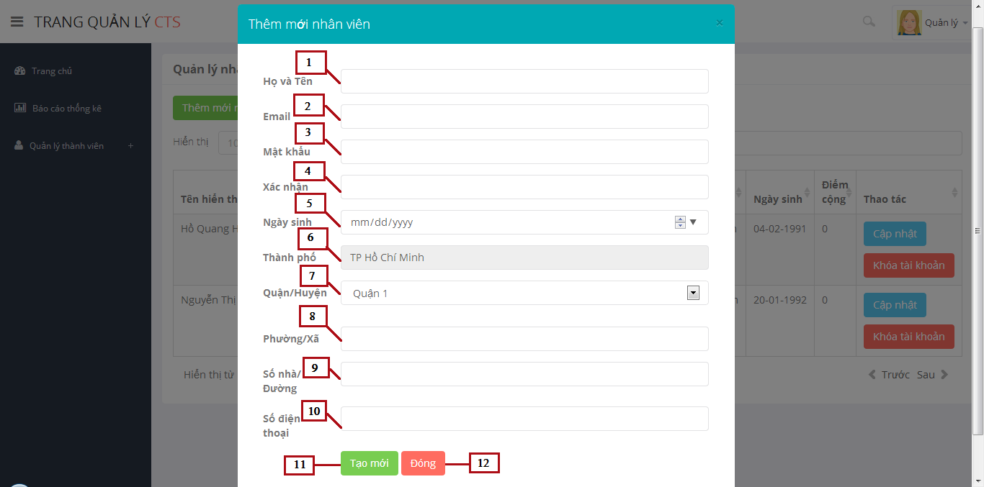

*Figure 149: Add New Member*

**Fields**

|  |  |  |  |  |  |  |  |
| --- | --- | --- | --- | --- | --- | --- | --- |
| **No** | **Field Name** | **Description** | **Read only** | **Mandatory** | **Control Type** | **Data Type** | **Length** |
| 1 | Full Name | Fill user fullname | No | Yes | Textbox | String | N/A |
| 2 | Email | Fill user email | No | Yes | Email | String | N/A |
| 3 | Password | Fill password | No | Yes | Password | String | [8-32] |
| 4 | Re-Password | Fill re-password | No | Yes | Password | String | [8-32] |
| 5 | Birthday | Fill user birthday | No | Yes | Date | String | N/A |
| 6 | City | Display city of user | Yes | Yes | Textbox | String | N/A |
| 7 | District | Click to choose district of user | No | Yes | Drop-down-list | String | N/A |
| 8 | Ward | Fill ward of user | No | Yes | Textbox | String | N/A |
| 9 | Adress | Fill address of user | No | Yes | Textbox | String | N/A |
| 10 | Phone Number | Fill phone number of user | No | Yes | Textbox | String | [10-11] |

**Buttons/Hyperlinks**

|  |  |  |  |  |
| --- | --- | --- | --- | --- |
| **No** | **Function** | **Description** | **Validation** | **Outcome** |
| 11 | Create new member | Create new member | Yes | Message completed |
| 12 | Close popup | Click to close popup | N/A | Popup add new member closed |

### Update Member

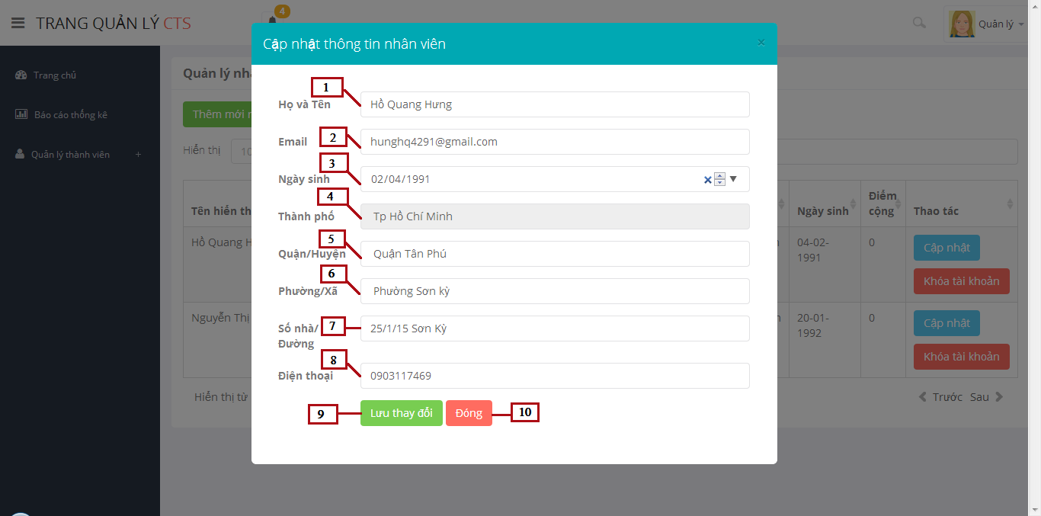

*Figure 150: Update Member*

**Fields**

|  |  |  |  |  |  |  |  |
| --- | --- | --- | --- | --- | --- | --- | --- |
| **No** | **Field Name** | **Description** | **Read only** | **Mandatory** | **Control Type** | **Data Type** | **Length** |
| 1 | Full Name | Fill user fullname | No | Yes | Textbox | String | N/A |
| 2 | Email | Fill user email | No | Yes | Email | String | N/A |
| 3 | Birthday | Fill user birthday | No | Yes | Date time picker | String | N/A |
| 4 | City | Display city of user | Yes | Yes | Textbox | String | N/A |
| 5 | District | Click to choose district of user | No | Yes | Drop down list | String | N/A |
| 6 | Ward | Fill ward of user | No | Yes | Textbox | String | N/A |
| 7 | Adress | Fill address of user | No | Yes | Textbox | String | N/A |
| 8 | Phone Number | Fill phone number of user | No | Yes | Textbox | String | [10-11] |

**Buttons/Hyperlinks**

|  |  |  |  |  |
| --- | --- | --- | --- | --- |
| **No** | **Function** | **Description** | **Validation** | **Outcome** |
| 9 | Create new member | Create new member | Yes | Message completed |
| 10 | Close popup | Click to close popup | N/A | Popup add new member closed |

### Manage Toys

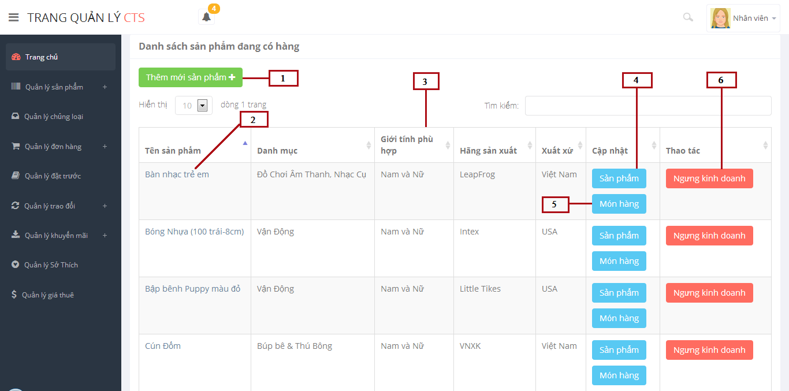

*Figure 151: Manage Toys*

**Fields**

|  |  |  |  |  |  |  |  |
| --- | --- | --- | --- | --- | --- | --- | --- |
| **No** | **Field Name** | **Description** | **Read only** | **Mandatory** | **Control Type** | **Data Type** | **Length** |
| 3 | Toys List | Show toy list | No | N/A | Table list | N/A | N/A |

**Buttons/Hyperlinks**

|  |  |  |  |  |
| --- | --- | --- | --- | --- |
| **No** | **Function** | **Description** | **Validation** | **Outcome** |
| 1 | Create new toy | Click to go to create new toy page | No | Transfer to create new toy page |
| 2 | Toy name | Click to view detail inforation of toy | No | Transfer to detail toy page |
| 4 | Edit toy | Click to edit information of toy | No | Transfer to edit toy page |
| 5 | Edit toy instance | Click to edit information of toy instance | No | Tranfer to edit toy instance page |
| 6 | Discontinue/Available toy | Click to discontinue/available toy | No | Message completed |

**Table Toys List Includes**

|  |  |  |  |  |  |
| --- | --- | --- | --- | --- | --- |
| **Field Name** | **Description** | **Read only** | **Control Type** | **Data Type** | **Length** |
| Toy name | Display name of toy | No | Link | String | N/A |
| Category name | Display category name of toy | Yes | Textview | String | N/A |
| Gender | Display suitable gender with toy | Yes | Textview | Integer | N/A |
| Manufacture | Display manufature of toy | Yes | Textview | String | N/A |
| Origin | Display origin of toy | Yes | Textview | String | N/A |
| Action | Edit toy, toy instance.  Discontinue/available toy | No | Button | N/A | N/A |

### Toy Instance List

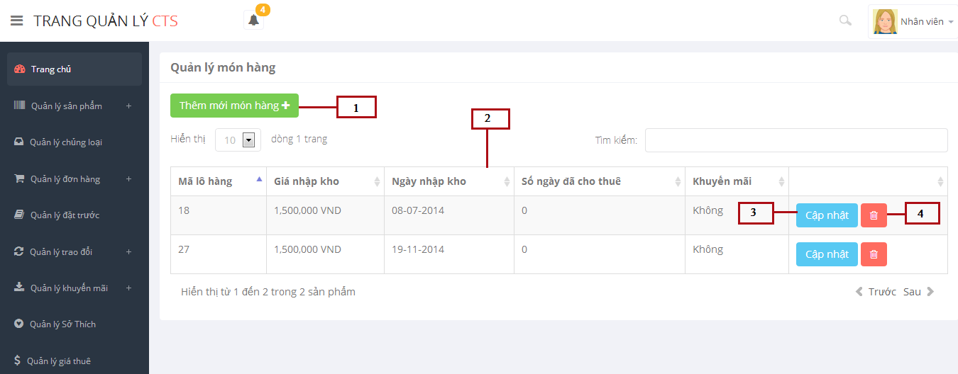

*Figure 152: Toy Instance List*

**Fields**

|  |  |  |  |  |  |  |  |
| --- | --- | --- | --- | --- | --- | --- | --- |
| **No** | **Field Name** | **Description** | **Read only** | **Mandatory** | **Control Type** | **Data Type** | **Length** |
| 2 | Toy Instance List | Show toy instance list | No | N/A | Table list | N/A | N/A |

**Buttons/Hyperlinks**

|  |  |  |  |  |
| --- | --- | --- | --- | --- |
| **No** | **Function** | **Description** | **Validation** | **Outcome** |
| 1 | Create new toy instance | Click to go to create new toy instance popup | No | Transfer to create new toy instance popup |
| 3 | Edit | Click to edit information of a toy instance | No | Transfer to edit toy instance popup |
| 4 | Delete toy instance | Click to delete a toy instance | N/A | Message completed |

**Table Toy Instance List Includes**

|  |  |  |  |  |  |
| --- | --- | --- | --- | --- | --- |
| **Field Name** | **Description** | **Read only** | **Control Type** | **Data Type** | **Length** |
| Code | Display code of toy instance | Yes | Textview | Integer | N/A |
| Capital Price | Display capital price | Yes | Textview | Double | N/A |
| Start rented day | Display start rented day | Yes | Textview | Datetime | N/A |
| Rented day number | Display rented day number | Yes | Textview | Integer | N/A |
| Promotion | Display promotion of toy instance | Yes | Textview | Integer | N/A |
| Action | Edit/delete toy instance | No | Button | N/A | N/A |

### Add New Toy Instance

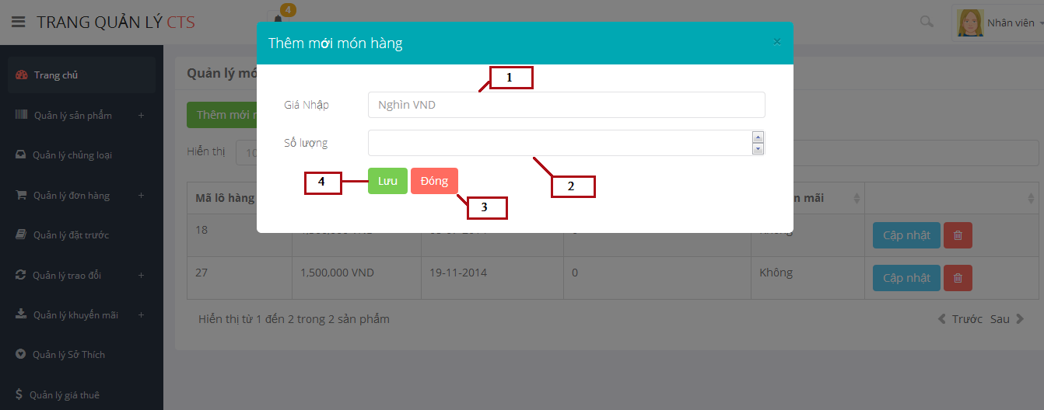

*Figure 153: Add New Toy Instance*

**Fields**

|  |  |  |  |  |  |  |  |
| --- | --- | --- | --- | --- | --- | --- | --- |
| **No** | **Field Name** | **Description** | **Read only** | **Mandatory** | **Control Type** | **Data Type** | **Length** |
| 1 | Capital Price | Fill capital price of toy instane | No | Yes | Textbox | Double | N/A |
| 2 | Quantity | Fill quantity of toy instance | No | Yes | Textbox | Integer | N/A |

**Buttons/Hyperlinks**

|  |  |  |  |  |
| --- | --- | --- | --- | --- |
| **No** | **Function** | **Description** | **Validation** | **Outcome** |
| 3 | Close | Click to close popup | No | Popup add new toy instance closed |
| 4 | Save | Click to save information of toy instance into database. | N/A | Message completed |

### Update Toy Instance

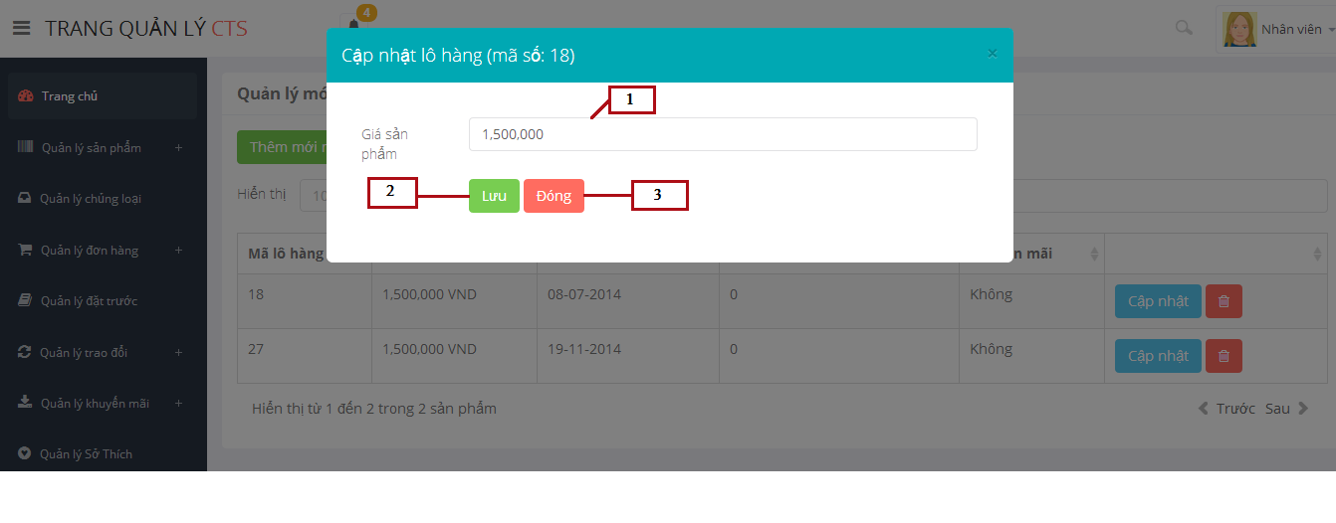

*Figure 154: Update Toy Instance*

**Fields**

|  |  |  |  |  |  |  |  |
| --- | --- | --- | --- | --- | --- | --- | --- |
| **No** | **Field Name** | **Description** | **Read only** | **Mandatory** | **Control Type** | **Data Type** | **Length** |
| 1 | Capital Price | Fill capital price of toy instane | No | Yes | Textbox | Double | N/A |

**Buttons/Hyperlinks**

|  |  |  |  |  |
| --- | --- | --- | --- | --- |
| **No** | **Function** | **Description** | **Validation** | **Outcome** |
| 2 | Close | Click to close popup | No | Popup add new toy instance closed |
| 3 | Save | Click to save information of toy instance into database. | N/A | Message completed |

### Add New Toy

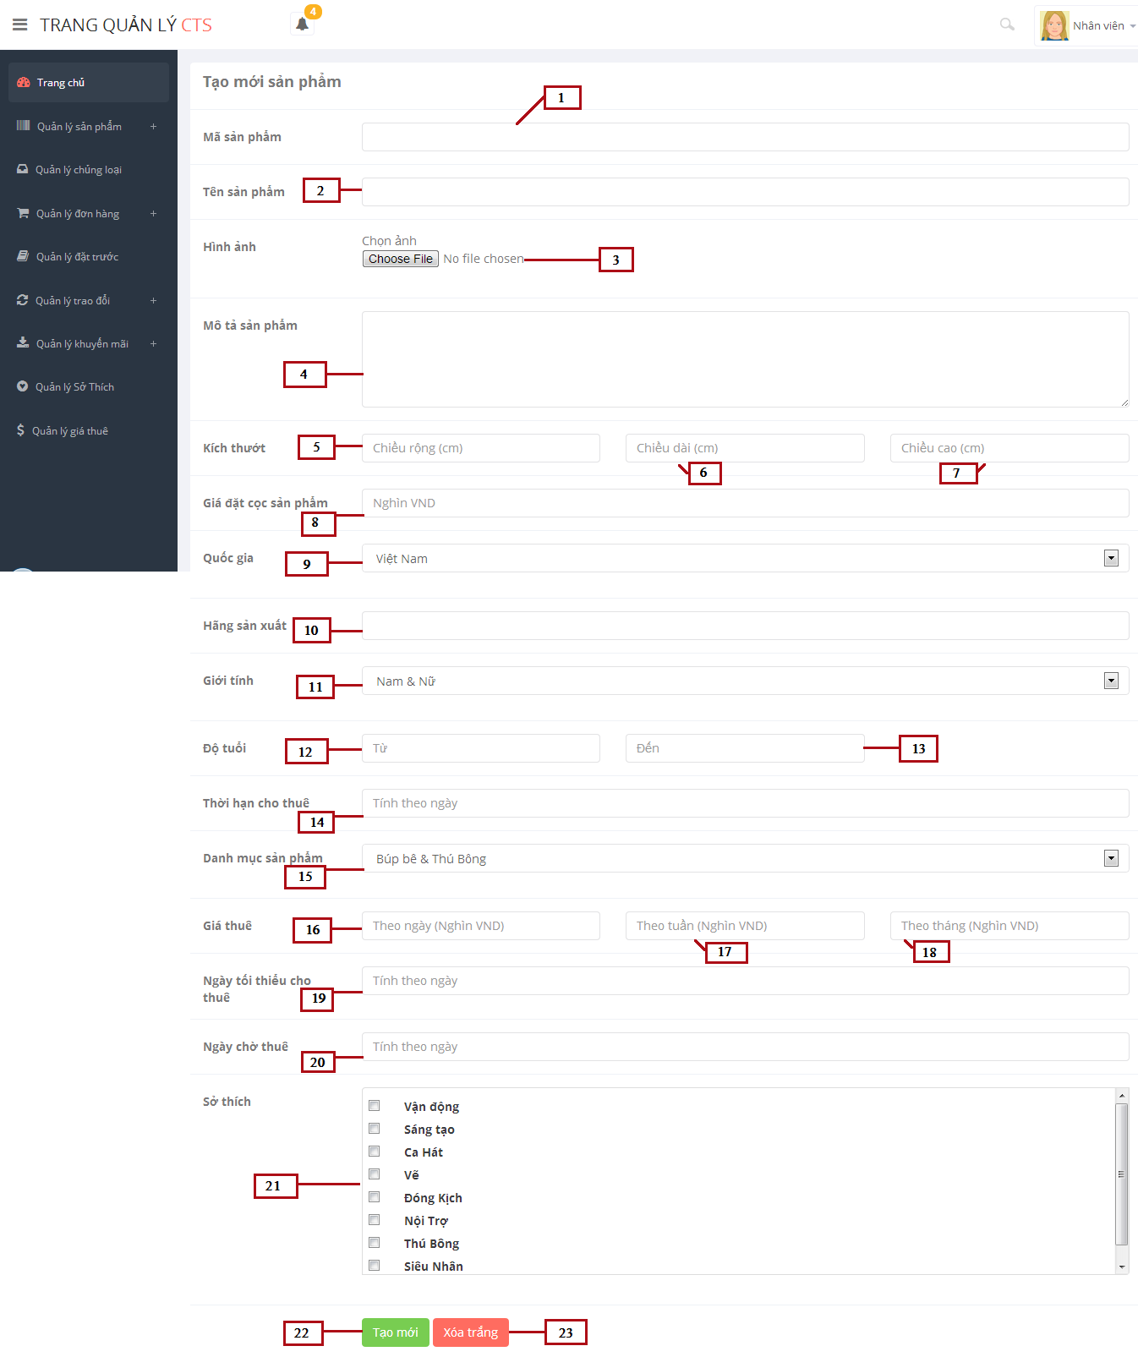

*Figure 155: Add New Toy*

**Fields**

|  |  |  |  |  |  |  |  |
| --- | --- | --- | --- | --- | --- | --- | --- |
| **No** | **Field Name** | **Description** | **Read only** | **Mandatory** | **Control Type** | **Data Type** | **Length** |
| 1 | Code | Fill code of toy | No | Yes | Textbox | String | [1-5] |
| 2 | Toy Name | Fill toy name | No | Yes | Textbox | String | N/A |
| 4 | Description | Fill description of toy | No | Yes | Textarea | String | N/A |
| 5 | Width | Fill width of toy | No | Yes | Textbox | Float | N/A |
| 6 | Length | Fill length of toy | No | Yes | Textbox | Float | N/A |
| 7 | Height | Fill height of toy | No | Yes | Textbox | Float | N/A |
| 8 | Deposit price | Fill deposit price of toy | No | Yes | Textbox | Double | N/A |
| 9 | Origin | Select origin of toy | No | Yes | Drop down list | N/A | N/A |
| 10 | Manufacture | Fill manufacture of toy | No | Yes | Textbox | String | N/A |
| 11 | Gender | Select suitable gender of toy | No | Yes | Drop down list | N/A | N/A |
| 12 | Age from | Fill age from | No | Yes | Textbox | Integer | N/A |
| 13 | Age to | Fill age to | No | Yes | Textbox | Integer | N/A |
| 14 | Max rented day | Fill max rented day | No | Yes | Textbox | Integer | N/A |
| 15 | Category name | Select category name | No | Yes | Drop down list | String | N/A |
| 16 | Day price | Fill day price | No | Yes | Textbox | Double | N/A |
| 17 | Week price | Fill week price | No | Yes | Textbox | Double | N/A |
| 18 | Month price | Fill month price | No | Yes | Textbox | Double | N/A |
| 19 | Min rent day | Fill min rent day | No | Yes | Textbox | Integer | N/A |
| 20 | Max pending day | Fill max pending day | No | Yes | Textbox | Integer | N/A |
| 21 | Hobby | Select hobby | No | Yes | Checkbox | N/A | N/A |

**Buttons/Hyperlinks**

|  |  |  |  |  |
| --- | --- | --- | --- | --- |
| **No** | **Function** | **Description** | **Validation** | **Outcome** |
| 3 | Upload image | Click to browse image | No | Upload image |
| 22 | Clear Text | Click to delete all information in the data field | N/A | All information in the data filed will be clear(Except : gender, category, hobby fileds) |
| 23 | Create new | Click to create new toy | Yes | Message completed |

### Update Toy

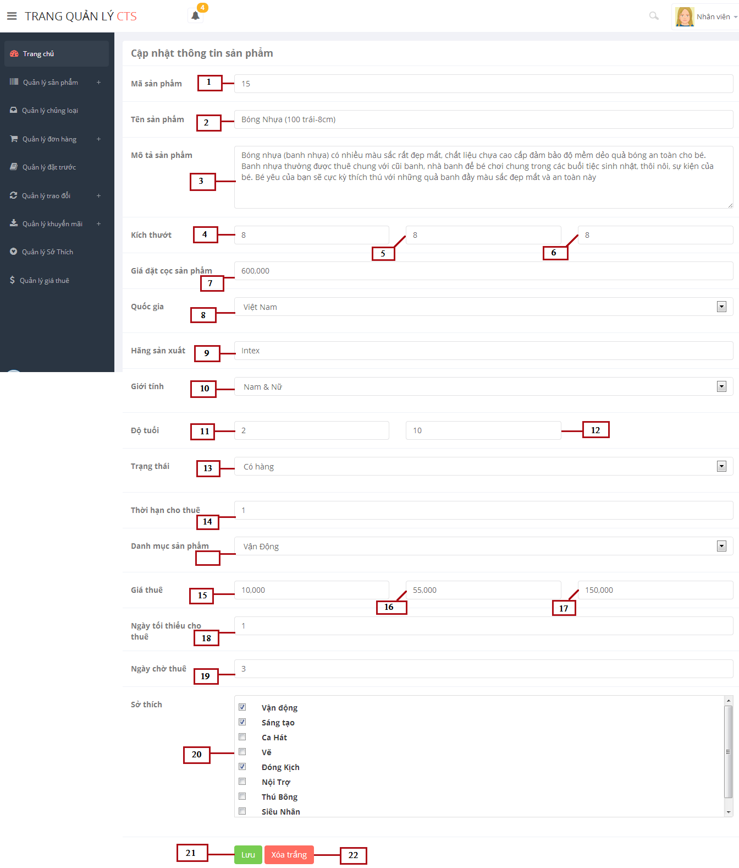

*Figure 156: Update Toy*

**Fields**

|  |  |  |  |  |  |  |  |
| --- | --- | --- | --- | --- | --- | --- | --- |
| **No** | **Field Name** | **Description** | **Read only** | **Mandatory** | **Control Type** | **Data Type** | **Length** |
| 1 | Code | Fill code of toy | No | Yes | Textbox | String | [1-5] |
| 2 | Toy Name | Fill toy name | No | Yes | Textbox | String | N/A |
| 4 | Description | Fill description of toy | No | Yes | Textarea | String | N/A |
| 5 | Width | Fill width of toy | No | Yes | Textbox | Float | N/A |
| 6 | Length | Fill length of toy | No | Yes | Textbox | Float | N/A |
| 7 | Height | Fill height of toy | No | Yes | Textbox | Float | N/A |
| 8 | Deposit price | Fill deposit price of toy | No | Yes | Textbox | Double | N/A |
| 9 | Origin | Select origin of toy | No | Yes | Drop down list | N/A | N/A |
| 10 | Manufacture | Fill manufacture of toy | No | Yes | Textbox | String | N/A |
| 11 | Gender | Select suitable gender of toy | No | Yes | Drop down list | N/A | N/A |
| 12 | Age from | Fill age from | No | Yes | Textbox | Integer | N/A |
| 13 | Age to | Fill age to | No | Yes | Textbox | Integer | N/A |
| 14 | Max rented day | Fill max rented day | No | Yes | Textbox | Integer | N/A |
| 15 | Category name | Select category name | No | Yes | Drop down list | String | N/A |
| 16 | Day price | Fill day price | No | Yes | Textbox | Double | N/A |
| 17 | Week price | Fill week price | No | Yes | Textbox | Double | N/A |
| 18 | Month price | Fill month price | No | Yes | Textbox | Double | N/A |
| 19 | Min rent day | Fill min rent day | No | Yes | Textbox | Integer | N/A |
| 20 | Max pending day | Fill max pending day | No | Yes | Textbox | Integer | N/A |
| 21 | Hobby | Select hobby | No | Yes | Checkbox | N/A | N/A |

**Buttons/Hyperlinks**

|  |  |  |  |  |
| --- | --- | --- | --- | --- |
| **No** | **Function** | **Description** | **Validation** | **Outcome** |
| 3 | Upload image | Click to browse image | No | Upload image |
| 22 | Clear Text | Click to delete all information in the data field | N/A | All information in the data filed will be clear(Except : gender, category, hobby fileds) |
| 23 | Create new | Click to create new toy | Yes | Message completed |

## Database Design

### Physical Database Diagram

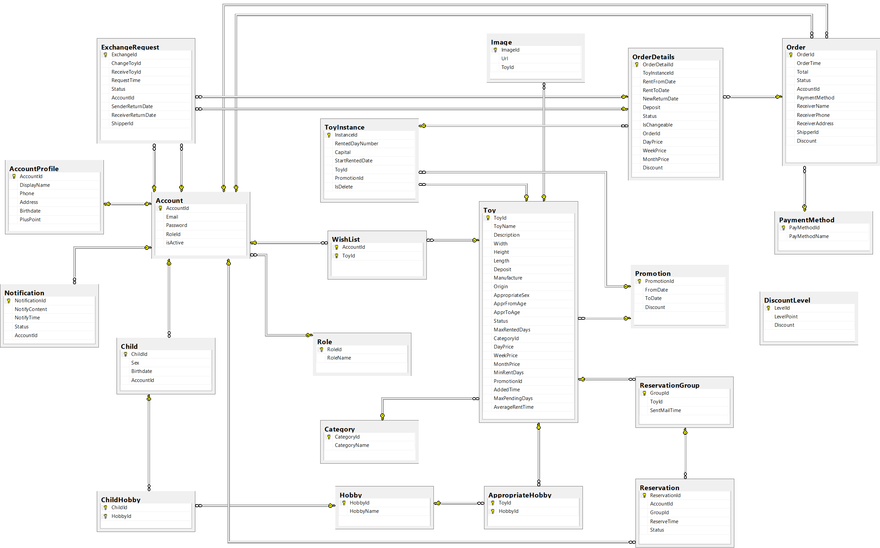

**Figure 157: Physical Database Diagram**

### Data Dictionary

|  |  |
| --- | --- |
| **Entity Data dictionary: describe content of all entities** | |
| **Entity Name** | **Description** |
| Account | Describe account of user of system. |
| Role | Describe role of user. One user has one role. |
| Child | Describe child of customers in system. |
| ChildHobby | Describe all hobbies of each child. |
| Hobby | Describe all normal hobbies of real child. |
| AccountProfile | Describe information of account in system. |
| Notification | Describe all of user’s notification of the system. |
| Toy | Describe all information of toys in system. |
| Image | Describe all image of toys in system. |
| ToyInstance | Describe all instances of a toy in system. |
| Category | Describe all kind of toys in system. |
| AppropriateHobby | Describe suitable hobbies of toys in system. |
| WishList | Describe favorite toys list of customer in system. |
| Promotion | Describe all information of promotion in system. |
| OrderDetails | Describe all details of an order in system. |
| Order | Describe all order of the renter in system. |
| PaymentMethod | Describe all payment of customer in system. |
| Reservation | Describe all toys booking of customer in system. |
| ReservationGroup | Describe all booking group of each toy in system. |
| DiscountLevel | Describe percent of discount based on plus point of customer |
| ExchangeRequest | Describe all toys exchange of customer in system. |

*Table 55: Entity Data Dictionary*

#### Table Role

|  |  |  |  |  |
| --- | --- | --- | --- | --- |
| **Entity name** | **Attributes** | **Description** | **Type** | **Null** |
| Role | RoleID {PK} | Unique identifier of a role, auto increment. | Integer | No |
| RoleName | Role name of each role | Varchar(10) | No |
| Unique Key: RoleName | | | | |

*Table 56: Data Dictionary of Role*

#### Table Account

|  |  |  |  |  |
| --- | --- | --- | --- | --- |
| **Entity name** | **Attributes** | **Description** | **Type** | **Null** |
| Account | AccountId{PK} | Unique identifier of an account, auto increment. | Integer | No |
| Email | Email to login system of customer | Nvarchar(50) | No |
| Password | Password to login system of customer | Nvarchar(32) | No |
| RoleId{FK} | Role of this account. Foreign key references to table Role (RoleId). | Integer | No |
| isActive | This description account isactive or active | Bit | No |
| Unique Key: Email | | | | |

*Table 57: Data Dictionary of Account*

#### Table Child

|  |  |  |  |  |
| --- | --- | --- | --- | --- |
| **Entity name** | **Attributes** | **Description** | **Type** | **Null** |
| Child | ChildId{PK} | Unique identifier of a child, auto increment. | Integer | No |
| Sex | Sex of child | Bit | No |
| Birthdate | Birthdate of child | Date | No |
| AccountId{FK} | ID of account that child belong to. Foreign key references to table Account (AccountId) | Integer | No |

*Table 58: Data Dictionary of Child*

#### Table ChildHobby

|  |  |  |  |  |
| --- | --- | --- | --- | --- |
| **Entity name** | **Attributes** | **Description** | **Type** | **Null** |
| ChildHobby | ChildId{PK, FK} | ID of child that has this hobby. Foreign key references to table Child (ChildId). | Integer | No |
| HobbyId{PK, FK} | ID of hobby of child. Foreign key references to table Hobby (HobbyId). | Integer | No |

*Table 59: Data Dictionary of ChildHobby*

#### Table Hobby

|  |  |  |  |  |
| --- | --- | --- | --- | --- |
| **Entity name** | **Attributes** | **Description** | **Type** | **Null** |
| Hobby | HobbyId{PK} | Unique identifier of a hobby, auto increment. | Integer | No |
| HobbyName | Name of hobby | Nvarchar(50) | No |
| Unique Key: HobbyName | | | | |

*Table 60: Data Dictionary of Hobby*

#### Table AccountProfile

|  |  |  |  |  |
| --- | --- | --- | --- | --- |
| **Entity name** | **Attributes** | **Description** | **Type** | **Null** |
| AccountProfile | AccountId{PK,FK} | Unique identifier of an account, auto increment. Foreign key references to table Account (AccountId). | Integer | No |
| DisplayName | Name of customer | Nvarchar(50) | No |
| Phone | Phone of a customer | Varchar(11) | No |
| Address | Address of a customer | Nvarchar(100) | No |
| Birthdate | Birthdate of a customer | Date | No |
| PlusPoint | Sum of point is plused | Integer | No |
| Unique Key: Phone | | | | |

*Table 61: Data Dictionary of AccountProfile*

#### Table Notification

|  |  |  |  |  |
| --- | --- | --- | --- | --- |
| **Entity name** | **Attributes** | **Description** | **Type** | **Null** |
| Notification | NotificationId{PK} | Unique identifier of a notification, auto increment. | Integer | No |
| NotifyContent | Content of a notification | Nvarchar(200) | No |
| NotifyTime | Time notification has been sent | DateTime | No |
| Status | Status shows state of a notification. | Varchar(6) | No |
| AccountId{FK} | ID of account receive this notification. Foreign key references to table Account (AccountId). | Integer | No |

*Table 62: Data Dictionary of Notification*

#### Table Toy

|  |  |  |  |  |
| --- | --- | --- | --- | --- |
| **Entity name** | **Attributes** | **Description** | **Type** | **Null** |
| Toy | ToyId{PK} | Unique identifier of each toy. | Varchar(5) | No |
| ToyName | Name of a toy | Nvarchar(100) | No |
| Description | Information about a toy | Nvarchar(500) | No |
| Width | Width of a toy | Float | No |
| Height | Height of a toy | Float | No |
| Length | Length of a toy | Float | No |
| Deposit | Deposit price customer has to pay when renting a toy | Bigint | No |
| Manufacture | Manufacture of a toy | Nvarchar(100) | No |
| Origin | Origin of a toy | Nvarchar(50) | No |
| AppropriateSex | Sex suitable with a toy | Integer | No |
| ApprFromAge | Suitable age for start to play a toy | Integer | No |
| ApprToAge | Suitable age for end to play a toy | Integer | No |
| Status | Status shows state of a toy | Varchar(15) | No |
| MaxRentedDays | Sum of days for rent a toy | Integer | No |
| CategoryId{FK} | ID of category that toy belong to. Foreign key references to table Category (CategoryID). | Integer | No |
| DayPrice | Rent price of toy for a day | BigInt | No |
| WeekPrice | Rent price of toy for a week | BigInt | No |
| MonthPrice | Rent price of toy for a month | BigInteger | No |
| MinRentDays | Minimum number of days customer has to rent this toy | Integer | No |
| AddedTime | Time that toy has been added to system | DateTime | No |
| MaxPendingDays | Maximum duration between order time and receive toy date | Integer | No |
| AverageRentTime | Average rent time of a toy | Float | Yes |
| PromotionId{FK} | ID of promotion that is applied for this toy. Foreign key references to table Promotion (PromotionId). | Integer | Yes |

*Table 63: Data Dictionary of Toy*

#### Table Image

|  |  |  |  |  |
| --- | --- | --- | --- | --- |
| **Entity name** | **Attributes** | **Description** | **Type** | **Null** |
| Image | ImageId{PK} | Unique identifier of an image, auto increment. | Integer | No |
| Url | Url to get image | Nvarchar(200) | No |
| ToyId{FK} | ID of toy that image belong to. Foreign key references to table Toy (ToyId). | Varchar(5) | No |
| Unique Key: Url | | | | |

*Table 64: Data Dictionary of Image*

#### Table ToyInstance

|  |  |  |  |  |
| --- | --- | --- | --- | --- |
| **Entity name** | **Attributes** | **Description** | **Type** | **Null** |
| ToyInstance | InstanceId{PK} | Code of each instance. | Integer | No |
| RentedDayNumber | Number of days that toy instance has been rented | Integer | No |
| Capital | Capital of that toy instance | BigInt | No |
| StartRentedDate | The date that toy intance is in stock | Date | No |
| ToyId{FK} | ID of toy that toy instance belong to. Foreign key references to table Toy (ToyId). | Varchar(5) | No |
| isDelete | Show instance is deleted or not | Bit | No |
| PromotionId{FK} | ID of promotion that toy instance is applied. Foreign key references to table Promotion (PromotionId). | Integer | Yes |

*Table 65: Data Dictionary of ToyInstance*

#### Table Category

|  |  |  |  |  |
| --- | --- | --- | --- | --- |
| **Entity name** | **Attributes** | **Description** | **Type** | **Null** |
| Category | CategoryId{PK} | Unique identifier of a category, auto increment. | Integer | No |
| CategoryName | Name of a category | Nvarchar(50) | No |
| Unique Key: CategoryName | | | | |

*Table 66: Data Dictionary of Category*

#### Table AppropriateHobby

|  |  |  |  |  |
| --- | --- | --- | --- | --- |
| **Entity name** | **Attributes** | **Description** | **Type** | **Null** |
| ApproriateHobby | ToyId{PK, FK} | ID of toy that have this hobby. Foreign key references to table Toy (ToyId). | Varchar(5) | No |
| HobbyId{PK, FK} | ID of hobby of toy. Foreign key references to table Hobby (HobbyId). | Integer | No |

*Table 67: Data Dictionary of AppropriateHobby*

#### Table WishList

|  |  |  |  |  |
| --- | --- | --- | --- | --- |
| **Entity name** | **Attributes** | **Description** | **Type** | **Null** |
| WishList | AccountId{PK, FK} | ID of customer that has saved this toy to wishlist. Foreign key references to table Account (AccountId). | Integer | No |
| ToyId{PK, FK} | ID of toy that has been saved to wishlist. Foreign key references to table Toy (ToyId). | Varchar(5) | No |

*Table 68: Data Dictionary of WishList*

#### Table Promotion

|  |  |  |  |  |
| --- | --- | --- | --- | --- |
| **Entity name** | **Attributes** | **Description** | **Type** | **Null** |
| Promotion | PromotionId{PK} | Unique identifier of a promotion, auto increment. | Integer | No |
| FromDate | Start date a promotion. | Date | No |
| ToDate | End date of a promotion | Date | No |
| Discount | Discount percent of this promotion | Integer | No |

*Table 69: Data Dictionary of Promotion*

#### Table DiscountLevel

|  |  |  |  |  |
| --- | --- | --- | --- | --- |
| **Entity name** | **Attributes** | **Description** | **Type** | **Null** |
| DiscountLevel | LevelId{PK} | Unique identifier of a discount level, auto increment. | Integer | No |
| LevelPoint | Plus point of customer that start apply discount in this level | Integer | No |
| Discount | Discount percent | Integer | No |
| Unique Key : LevelPoint | | | | |

*Table 70: Data Dictionary of DiscountLevel*

#### Table OrderDetail

|  |  |  |  |  |
| --- | --- | --- | --- | --- |
| **Entity name** | **Attributes** | **Description** | **Type** | **Null** |
| OrderDetails | OrderDetailId{PK} | Unique identifier of an order details, auto increment. | Integer | No |
| ToyInstanceId{FK} | ID of toy instance that has been rented. Foreign key references to table ToyInstance (ToyInstanceId). | Integer | No |
| RentFromDate | Start renting date | Date | No |
| RentToDate | Date to return toy | Date | No |
| NewReturnDate | Updated new date to return toy | Date | Yes |
| Status | Status shows renting state of order details. | Varchar(15) | No |
| OrderId{PK} | ID of order that order detail belong to. Foreign key references to table Order (OrderId). | Integer | No |
| IsChangeable | Show that rented product is exchangeable or not | Bit | No |
| Deposit | Deposit price of rented toy | BigInt | No |
| DayPrice | Rent price of toy for a day | BigInt | No |
| WeekPrice | Rent price of toy for a week | BigInt | No |
| MonthPrice | Rent pprice of toy for a month | BigInt | No |
| Discount | Discount percent of this order detail | Integer | No |

*Table 71: Data Dictionary of OrderDetail*

#### Table Order

|  |  |  |  |  |
| --- | --- | --- | --- | --- |
| **Entity name** | **Attributes** | **Description** | **Type** | **Null** |
| Order | OrderId{PK} | Unique identifier of an order, auto increment. | Integer | No |
| OrderTime | Time when order is made | DateTime | No |
| Total | Total payment amount af an order. | Bigint | No |
| Status | Status shows renting state of an order | Varchar(10) | No |
| AccountId{FK} | ID of account that rented this order. Foreign key references to table Account (AccountId). | Integer | No |
| PaymentMethod{FK} | ID of payment method customer has selected for this order. Foreign key references to table PaymentMethod (PayMethodId). | Integer | No |
| ReceiveName | Name of receiver | Nvarchar(50) | No |
| ReceivePhone | Phone of receiver | Varchar(11) | No |
| ReceiveAddress | Address of receiver | Nvarchar(200) | No |
| ShipperId | ID of staff who process this order. Foreign key references to table Account (AccountId) | Integer | Yes |
| Discount | Discount percent of entire order based on customer’s plus point | Integer | No |
| Unique Key: {AccountId, OrderTime} | | | | |

*Table 72: Data Dictionary of Order*

#### Table PaymentMethod

|  |  |  |  |  |
| --- | --- | --- | --- | --- |
| **Entity name** | **Attributes** | **Description** | **Type** | **Null** |
| PaymentMethod | PayMethodId{PK} | Unique identifier of a payment, auto increment. | Integer | No |
| PayMethodName | Name of payment method | Nvarchar(50) | No |
| Unique Key: {PayMethodName} | | | | |

*Table 73: Data Dictionary of PaymetMethod*

#### Table Reservation

|  |  |  |  |  |
| --- | --- | --- | --- | --- |
| **Entity name** | **Attributes** | **Description** | **Type** | **Null** |
| Reservation | ReservationId{PK} | Unique identifier of a reservation, auto increment. | Integer | No |
| AccountId{FK} | ID of customer who made reservation. Foreign key references to table Account (AccountId). | Integer | No |
| Status | Show that customer has received toy or not | Bit | No |
| GroupId{FK} | ID of reservation group of this toy. Foreign key references to table ReservationGroup (GroupId). | Integer | No |
| ReserveTime | Time when customer made reservation | Datetime | No |
| Unique Key: {AccountId, GroupId} | | | | |

*Table 74: Data Dictionary of Reservation*

#### Table ReservationGroup

|  |  |  |  |  |
| --- | --- | --- | --- | --- |
| **Entity name** | **Attributes** | **Description** | **Type** | **Null** |
| ReservationGroup | GroupId{PK} | Unique identifier of a reservation group, auto increment. | Integer | No |
| SentMailTime | Last time that system sent mail to customer in group to notify toy is available | Date | Yes |
| ToyId{FK} | ID of toy that is reserved by this group. Foreign key references to table Toy (ToyId). | Varchar(5) | No |
| Unique Key: {ToyId} | | | | |

*Table 75: Data Dictionary of ReservationGroup*

#### Table ExchangeRequest

|  |  |  |  |  |
| --- | --- | --- | --- | --- |
| **Entity name** | **Attributes** | **Description** | **Type** | **Null** |
| ExchangeRequest | ExchangeId{PK} | Unique identifier of an exchange request, auto increment. | Integer | No |
| ChangeToyId{FK} | ID of rented toy of request sender. Foreign key references to table OrderDetail (OrderDetailId). | Integer | No |
| ReceiveToyId{FK} | ID of rented toy of request receiver. Foreign key references to table OrderDetail (OrderDetailId). | Integer | No |
| RequestTime | Time when customer sent exchange request | DateTime | No |
| Status | Status of exchange | Varchar(15) | No |
| SenderReturnDate | Date sender want to return exchange toy | Date | No |
| ReceiverReturnDate | Date receiver want to return exchange toy | Date | No |
| ShipperId | ID of staff who process this exchange. Foreign key references to table Account (AccountId) | Integer | No |
| AccountId{FK} | ID of customer who sent this request. Foreign key references to table Account (AccountId). | Integer | No |

*Table 76: Data Dictionary of ExchangeRequest*

## Algorithms

### Suggest products which rented by customers who rented current product

#### Requirement:

Suggest related product for current viewed product by getting products most rent by customers who rented current product.

#### Solution:

1. Get all customers who rented current product
2. Get all products rented by these customers which is different from current product
3. Sort product list in order of most rented
4. Get top 5 products to suggest for customer

#### Example:

Current product: Gấu bông teddy

1. Customer who rented this product: Customer 1, Customer 2, Customer 3
2. Product these customers had rented:

|  |  |  |  |
| --- | --- | --- | --- |
|  | Customer 1 | Customer 2 | Customer 3 |
| Gấu bông teddy | X | X | X |
| Cún đốm | X | X |  |
| Nhà thả 12 khối | X |  |  |
| Bàn nhạc trẻ em |  | X | X |
| Bập bênh puppy | X | X | X |
| Xe tập đi |  | X |  |

1. Sorted list of most rented: Bập bênh puppy, Cún đốm, Bàn nhạc trẻ em, Nhà thả 12 khối, Xe tập đi
2. Top 5 products: Bập bênh puppy, Cún đốm, Bàn nhạc trẻ em, Nhà thả 12 khối, Xe tập đi

### Suggest products appropriate for child

#### Requirement:

Suggest products that appropriate for each child of customer.

#### Solution:

1. Get all children of customer
2. Get all products that appropriate to child’s age, gender and hobbies
3. Sort products list in order of most matched number of hobbies
4. Get top 20 products in products list

#### Example:

1. Child’s information:

* Age: 2 years
* Gender: female
* Hobbies: đóng kịch, thú bông, vận động

1. Product’s information:

|  |  |  |  |
| --- | --- | --- | --- |
|  | Age | Gender | Hobbies |
| Gấu bông teddy | 1 – 5 years | Both | Đóng kịch, thú bông |
| Cún đốm | 1 – 5 years | Both | Đóng kịch, thú bông |
| Nhà thả 12 khối | 1 – 3 years | Both | Sáng tạo |
| Bàn nhạc trẻ em | 3 – 6 years | Both | Ca hát |
| Bập bênh puppy | 3 – 5 years | Both | Vận động |
| Xe tập đi | 0 – 2 years | Both | Vận động |

Suggest products must be appropriate to age, gender and matched with hobbies.

* “Bàn nhạc trẻ em” and “Bập bênh puppy” are not appropriate for 2 age child
* “Nhà thả 12 khối” is not matched with child hobbies
  + Matched products: Gấu bông Teddy, Cún đốm, Xe tập đi

1. Sorted list of product by number of matched hobbies: Gấu bông Teddy, Cún đốm, Xe tập đi
2. Get top 20 products: Gấu bông Teddy, Cún đốm, Xe tập đi

### Suggest products by customer orders

#### Requirement:

Suggest products based on customer’s order. Compare orders history of all customers to find customers who have same renting trend of current customer.

#### Solution:

Using Pearson Correlation Coefficient Formula to calculate similarity between customers. And then select products most rented by these similar customer to suggest for current customer.

Pearson Correlation Coefficient is a way to determine the similarity between people’s interests. The correlation coefficient is a measure of how well two sets of data fit on a straight line.

To find the Pearson correlation score, first we have to find the items rented by both customers.

It then calculates the sums and the sum of the squares of the ratings for the two customer, and calculates the sum of the products of their ratings. Finally, it uses these results to calculate the Pearson correlation coefficient

##### **Create input dataset:**

* **Purpose**: Create customer’s point for each rented product as input dataset to compare renting trend of customers
* **Step**:
  + Get all products rented by each customer
  + Calculate customer’s point for each product by comparing with average rent time. Customer’s point will between 1 and 5, due to customer’s rent time.
* **Formula**: (let average rent time = average point = 2.5)

$$customer^{'}s point= \frac{customer^{'}s rent time*2.5}{average rent time}$$

If customer’s point > 5 🡪 set customer’s point = 5

##### **Calculate customer’s similarity:**

* **Purpose**: Calculate similarity of each other customer with current customer
* **Step**:
  + Get list of other customer
  + For each other customer, get all customer’s point for rented product of this customer and current customer
  + Calculate similarity point using **Pearson Correlation Coefficient Formula**.
* **Formula**:

***r = $\frac{N\sum{xy} -(\sum{x})(\sum{y})}{\sqrt{\left[N\sum{x^{2}} -{\left(\sum{x}\right)}^{2}\right][N\sum{y^{2}} -{\left(\sum{y}\right)}^{2}]}}$***

Where:

N: number of products rented by both customer

$\sum{xy}$: sum of the product of paired scores from 2 customer for each product

$\sum{x}$: sum of scores from current suggesting customer

$\sum{y}$: sum of scores from other customer

$\sum{x^{2}}$: sum of squared of scores from current suggesting customer

$\sum{y^{2}}$: sum of squared of scores from other customer

The formula will return result from -1 to 1.

r = -1 : 2 customers are opposite

r = 0 : 2 customers are not correlated

r = 1 : 2 customers are totally similar

##### **Suggest products for customer**

* **Purpose**: Suggest appropriate products for current customer
* **Step**:
  + Get all customer who has similarity point > 0 (who have same renting trend with current customer)
  + Get all rented products of each other customer in list
  + Exclude products that rented by current customer from products list
  + Calculate predict customer’s point of current customer for each product in list.
  + Sort products list in order of highest predict customer’s point
  + Get top products and suggest to current customer.
* **Formula**:

***Predict customer’s product point = $\sum{(similarity*customer's point)}/\sum{similarity}$***

Where:

similarity: similarity point of current customer and other customer

customer’s point: other customer’s point for each product

$\sum{similarity}$: sum of similarity point of current customer and other customers who rented this product

#### Example:

##### **Create input dataset:**

Customer 9 rented 3 product: product 1, product 2, product 3 with rent time showed in table.

* 1. Customer9’s point for each product is calculate in table

|  |  |  |  |
| --- | --- | --- | --- |
|  | Product 1 | Product 2 | Product 3 |
| Customer’s rent time | 7 days | 15 days | 26 days |
| Product’s average rent time | 5 days | 20 days | 12 days |
| Customer’s point | (7*2.5)/5 = 3.5 | (15*2.5)/20 = 1.875 | (26*2.5)/12 = 5.42 ~ 5 |

##### **Calculate customer’s similarity:**

Customer 1 rented 4 product: product 1, product 2, product 4, and product 5

Customer 2 rented 4 product: product 1, product 2, product 3, and product 5

Customer’s point for each rented product is shown in table

|  |  |  |  |  |  |
| --- | --- | --- | --- | --- | --- |
|  | **Product 1** | **Product 2** | **Product 3** | **Product 4** | **Product 5** |
| **Customer1’s point (x)** | 2.5 | 2 | - | 3 | 4 |
| **Customer2’s point (y)** | 2 | 3 | 3.5 | - | 4.5 |
| **xy** | 5 | 6 | - | - | 18 |
| $$x^{2}$$ | 6.25 | 4 | - | - | 16 |
| $$y^{2}$$ | 4 | 9 | - | - | 20.25 |

The Pearson Correlation Coefficient is only applied for products that is rented by both customer. So we exclude product 3 and product 4 from list when calculating.

We have:

; ;

;

;

*N* = 3

* 1. Apply Pearson formula:

r = $\frac{N\sum{xy} -(\sum{x})(\sum{y})}{\sqrt{\left[N\sum{x^{2}} -{\left(\sum{x}\right)}^{2}\right][N\sum{y^{2}} -{\left(\sum{y}\right)}^{2}]}}$ = $\frac{3*29 -8.5*9.5 }{\sqrt{\left[3*26.25 - 72.25\right][3*33.25 -90.25]}}$ = 0.7954

🡪 r > 0 🡪 customer 1 and customer 2 have same renting trend

##### **Suggest products for customer**

Pretend that system have 4 customers.

Current customer is Customer 1

Customer 2, Customer 3, Customer 4 have similarity point with Customer 1 as shown in below table.

Each customer has rented some products that Customer 1 hasn’t rented before. Customer’s point of each customer for each rented product is shown in below table.

|  |  |  |  |  |  |  |  |
| --- | --- | --- | --- | --- | --- | --- | --- |
|  | **Similarity** | **P3** | **Sim*P3** | **P6** | **Sim*P6** | **P7** | **Sim*P7** |
| **Customer 2** | 0.8 | 3.5 | 2.8 | 3 | 2.4 | 4 | 3.2 |
| **Customer 3** | 0.92 | - | - | 2.5 | 2.3 | 4.5 | 4.14 |
| **Customer 4** | 0.65 | 2.5 | 1.625 | - | - | 3 | 1.95 |
| **Total sim*point** |  |  | 2.8 + 1.625 = 4.425 |  | 2.4 + 2.3 = 4.7 |  | 3.2 + 4.14 = 9.29 |
| **Sim. Sum** |  |  | 0.8 + 0.65 = 1.45 |  | 0.8 + 0.92 = 1.72 |  | 0.8 + 0.92 + 0.65 = 2.37 |
| **Total/Sim. Sum (predict point)** |  |  | 4.424/1.45 = 3.05 |  | 4.7/1.72 = 2.73 |  | 9.29/2.37 = 3.92 |

* Recommend product for Customer 1 in order: Product 7, Product 3, Product 6

# System Implementation & Test (SIT)

## Introduction

### System Overview

This section provides in detail all necessary information about test plans, test cases, test result, test environments, pass/fail criteria and risks estimations as well as a checklist to cover all possible cases of CTS system.

### Test Approach

Goal: Check all the features in CTS system and record remain bug to fix.

Type: White box testing, Black-box Testing.

Size: System Component.

Technique: Check list.

## Test Plan

### Features to be tested

We will carry out test based on core workflow of system. All main functions will be tested carefully and clearly following phases.

* Guest: add to cart, view cart, update cart, view product detail, basic search, and advance search, register
* Admin: view statistic report
* Customer: check out online, check out delivering, view other exchange list, edit exchange list, send exchange request, respond exchange request, return toy soon, extend rent time, reserve toy, cancel order, cancel order detail
* System: auto send mail, auto select next renter, update status of order and exchange.
* Staff: confirm return toy, cancel order, cancel order detail, assign order’s shipper, done delivering order, cancel exchange, done exchange, assign exchange’s shipper, mobile process order, mobile process exchange, mobile process return toy

### Features not to be tested

* Login, Logout.
* Register
* Change password.
* Manage members.
* Manage toys.
* Manager promotions.
* Manage hobbies.
* Manage categories.
* View reservation list.
* View customer profile, edit profile, add/edit child
* View order history
* Edit discount level

## Test Cases

### Basic Search

|  |  |  |  |  |  |  |
| --- | --- | --- | --- | --- | --- | --- |
| **ID** | **Test Case Description** | **Pre-Condition** | **Test Case Procedure** | **Expected output** | **Result** | **Test Date** |
| BS01 | Basic Search with valid inputted key word | N/A | 1 – Input “bup be” into search fields.  2 – Press enter key | - After step 2, System redirected to search page and display 3 results:   1. Thú Bông_Disney Alice in Wonderland. 2. Cún đốm (Búp bê & Thú bông category). 3. Gấu bông teddy (Búp bê & Thú bông category) | Passed | 30/11/2014 |
| BS02 | Basic Search with wrong key word | N/A | 1 – Input “abc” into search fields.  2 – Press enter key | - After step 2, System redirected to search page and display message “Hiện tại không có sản phẩm mà bạn muốn tìm” | Passed | 30/11/2014 |
| BS03 | Default Search with empty search field | N/A | 1 – Click on search input field  2 – Press enter key | - After step 2, System do nothing. | Passed | 30/11/2014 |

*Table 77: Basic Search Test_Case*

### Advanced Search

|  |  |  |  |  |  |  |
| --- | --- | --- | --- | --- | --- | --- |
| **ID** | **Test Case Description** | **Pre-Condition** | **Test Case Procedure** | **Expected output** | **Result** | **Test Date** |
| AS01 | Advanced Search with valid inputted fields | Search page is displayed | 1 – Input “bup be” into search fields.  2 – Select categories “Búp bê & Thú bông” and “Vận động”  3 – Select rent price 10,000 – 30,000 VNĐ  4 – Select gender “female”  5 – Select age 0 to 7  6 – Select hobbies “Vận động”, “Sáng tạo”, “Đóng kịch”, “Thú bông”  7 – Select origin “USA”  8 – Select manufacturer “Tất cả”  9 – Click “Tìm kiếm” button | - After step 9, System display 2 results:   1. Thú Bông_Disney Alice in Wonderland. 2. Gấu bông teddy | Passed | 30/11/2014 |
| AS02 | Advanced Search with some field leave blank | Search page is displayed | 1 – Select rent price 10,000 – 30,000 VNĐ  2 – Select gender “female”  3 – Select age 0 to 7  4 – Select hobbies “Vận động”, “Sáng tạo”, “Đóng kịch”, “Thú bông”  5 – Select origin “Tất cả”  6 – Select manufacturer “Tất cả”  7 – Click “Tìm kiếm” button | - After step 7, System display 5 results:   1. Thú Bông_Disney Alice in Wonderland. 2. Bóng nhựa (100 trái – 8cm) 3. Gấu bông teddy 4. Cún đốm 5. Nhà thả 12 khối | Passed | 30/11/2014 |
| AS03 | Advanced Search with empty search field and min to min in price and age | Search page is displayed | 1 – Select rent price 10,000 – 10,000  2 – Select age 0 to 0  3 – Click “Tìm kiếm” button | - After step 3, System displays message “Hiện không có sản phẩm mà bạn muốn tìm” | Passed | 30/11/2014 |
| AS04 | Advanced Search with empty search field and min to max in price and age | Search page is displayed | 1 – Select rent price 10,000 to 50, 000  2 – Select age 0 to 10  3 – Click “Tìm kiếm” button | - After step 3, System displays all products. | Passed | 30/11/2014 |

*Table 78: Advanced Search Test_Case*

### View product details

|  |  |  |  |  |  |  |
| --- | --- | --- | --- | --- | --- | --- |
| **ID** | **Test Case Description** | **Pre-Condition** | **Test Case Procedure** | **Expected output** | **Result** | **Test Date** |
| PD01 | View product details of available product | N/A | 1 – Click on product title in products list | - After step 1, System redirected to product details page and display:   1. Product name. 2. Product images 3. Deposit price 4. Rent price each day, week and month 5. Date picker to select rent time 6. Input field to select rent amount 7. Rent button 8. Product details 9. Suggest product with same category 10. Suggest products often rented by customer rented this product | Passed | 30/11/2014 |

*Table 79: View Product Details Test_Case*

### View My Exchange List

|  |  |  |  |  |  |  |
| --- | --- | --- | --- | --- | --- | --- |
| **ID** | **Test Case Description** | **Pre-Condition** | **Test Case Procedure** | **Expected output** | **Result** | **Test Date** |
| VE01 | View list toy exchange of mine | - Log in successful with role customer | 1 – Choose “Trao đổi sản phẩm” in menu bar.  2 – Click “Sản phẩm trao đổi của tôi ” | - After step 2: show list of renting toys that current user added to list exchange. | Passed | 29/11/2014 |

*Table 80: View My Exchange List Test_Case*

### Add Toy to Exchange List

|  |  |  |  |  |  |  |
| --- | --- | --- | --- | --- | --- | --- |
| **ID** | **Test Case Description** | **Pre-Condition** | **Test Case Procedure** | **Expected output** | **Result** | **Test Date** |
| AT01 | Add toys that is renting to exchange list | - Log in successful with role customer | 1 – Choose “Trao đổi sản phẩm” in menu bar.  2 – Click “Sản phẩm trao đổi của tôi ”  3 - Click “Thêm sản phẩm” button  4 – Click to “Thêm sản phẩm trao đổi” button of toys wanting to exchange  5- Click “Có” button | -After step 4: show a popup have message “Bạn có chắc chắn muốn thêm sản phẩm vào danh sách trao đổi?” .Button “Có” và “Không”  -After step 5:  Show popup have message “Sản phẩm đã được thêm vào danh sách trao đổi”. Button “Đóng”. This toys is moved to exchange list | Passed | 30/11/2014 |
| AT02 | Add toy but then cancel | - Log in successful with role customer. | 1 – Choose “Trao đổi sản phẩm” in menu bar.  2 – Click “Sản phẩm trao đổi của tôi ”  3 - Click “Thêm sản phẩm” button  4 – Click to “Thêm sản phẩm trao đổi” button of toys that want to exchange  5- Click “Không” button | -After step 4: show a popup have message “Bạn có chắc chắn muốn thêm sản phẩm vào danh sách trao đổi?” .Button “Có” và “Không”  -After step 5: No toy is added to exchange list | Passed | 30/11/2014 |

*Table 81: Add Toy To Exchange List Test_Case*

### Remove Toy out of Exchange List

|  |  |  |  |  |  |  |
| --- | --- | --- | --- | --- | --- | --- |
| **ID** | **Test Case Description** | **Pre-Condition** | **Test Case Procedure** | **Expected output** | **Result** | **Test Date** |
| RT01 | Remove a toy out of exchange list | - Log in successful with role customer.  -Exchange list have at least one toy | 1 – Choose “Trao đổi sản phẩm” in menu bar.  2 – Click “Sản phẩm trao đổi của tôi ”.  3- Click “Hủy bỏ” button of toy that want to remove out of exchange list  4- Click “Có” button | - After step 3: show a popup have message “Bạn có chắc muốn xóa sản phẩm này khỏi danh sách trao đổi”. Button “Có”, “Không”.  - After step 4: show popup have message “Sản Phẩm đã được xóa khỏi danh sách trao đổi”. That toy is removed out of exchange list. If that toy is the last toy in exchange list, after remove that toy, show messgae “Không còn sản phẩm nào” | Passed | 30/11/2014 |
| RT02 | Remove a toy out of exchange list but then cancel | - Log in successful with role customer.  -Exchange list have at least one toy | 1 – Choose “Trao đổi sản phẩm” in menu bar.  2 – Click “Sản phẩm trao đổi của tôi ”  3- Click “Hủy bỏ” button of toy that want to remove out of exchange list  4- Click “Không” button | - After step 3: show a popup have message “Bạn có chắc muốn xóa sản phẩm này khỏi danh sách trao đổi”. Button “Có”, “Không”.  - After step 4: No toy is removed out of exchange list. | Passed | 30/11/2014 |

*Table 82: Remove Toy From Exchange List Test_Case*

### View Exchange List of Other Customer

|  |  |  |  |  |  |  |
| --- | --- | --- | --- | --- | --- | --- |
| **ID** | **Test Case Description** | **Pre-Condition** | **Test Case Procedure** | **Expected output** | **Result** | **Test Date** |
| VO01 | View exchange list of other customer | - Log in successful with role customer. | 1 – Choose “Trao đổi sản phẩm” in menu bar.  2 – Click “Sản phẩm trao đổi của mọi người ” | - After step 2: show list toys exhcnage of other customer | Passed | 30/11/2014 |

*Table 83: View Exchange List Of Other Customer Test_Case*

### Send Exchange Request

|  |  |  |  |  |  |  |
| --- | --- | --- | --- | --- | --- | --- |
| **ID** | **Test Case Description** | **Pre-Condition** | **Test Case Procedure** | **Expected output** | **Result** | **Test Date** |
| SR01 | Show process confirm exchange | - Log in successful with role customer | 1 – Choose “Trao đổi sản phẩm” in menu bar.  2 – Click “Sản phẩm trao đổi của mọi người ”  3- Click “Trao Đổi” button | -After step 3 : show popup include 3 step to confirm exchange | Passed | 30/11/2014 |
| SR02 | Send exchange but not add toy to exchange | - Log in successful with role customer | 1 – Choose “Trao đổi sản phẩm” in menu bar.  2 – Click “Sản phẩm trao đổi của mọi người ”  3- Click “Trao Đổi” button  4- Click “Kế Tiếp” | -After step 4: A error message show “Vui lòng chọn sản phẩm trao đổi để tiếp tục” | Passed | 30/11/2014 |
| SR03 | Check show list toys that are renting | - Log in successful with role customer | 1 – Choose “Trao đổi sản phẩm” in menu bar.  2 – Click “Sản phẩm trao đổi của mọi người ”  3- Click “Trao Đổi” button  4 – Click “Thêm sản phẩm” button | -After step 4: show list all toys that are renting | Passed | 30/11/2014 |
| SR04 | Add toy to list exchange | - Log in successful with role customer  - Staying ta “Sản phẩm trao đổi của mọi người” Page | 1- Click “Trao Đổi” button  2 – Click “Thêm sản phẩm” button  3-Click “Thêm vào trao đổi”  4-Click “Có” button | -After step 3: show popup have messgae “bạn có chắc chắn muốn thêm sản phẩm này vào danh sách trao đổi”. Button “Có”, “Không”  - After step 4 : show popup have message “Sản phẩm đã được thêm vào danh sách trao đổi”. That toy added to exchange list. | Passed | 30/11/2014 |
| SR05 | Choose toy to exchange | - Log in successful with role customer  - Staying ta “Sản phẩm trao đổi của mọi người” Page | 1- Click “Chọn” | -After step 1: toy that is choosed show status “đã chọn”. | Passed | 30/11/2014 |
| SR06 | Choose toy to exchange and choose toy to add to exchange list | - Log in successful with role customer  - Staying ta “Sản phẩm trao đổi của mọi người” Page | 1- Click “Chọn”  2- Click “Trao Đổi” button  3 – Click “Thêm sản phẩm” button  4-Click “Thêm vào trao đổi”  5-Click “Có” button | -After step 5: show exchange list with tos was chose and toys choose not yet | No Pass | 30/11/2014 |
| SR07 | View page choose time rent toy | - Log in successful with role customer  - Staying ta “Sản phẩm trao đổi của mọi người” Page | 1- Click “Chọn”  2-Click “Kế Tiếp” | -After step 2: show popup “Chọn thời gian thuê” with toy was chose. Checkbox choose return back before end date | Passed | 30/11/2014 |
| SR08 | System choose time rent toy | - Log in successful with role customer  - Staying ta “Sản phẩm trao đổi của mọi người” Page | 1- Click “Chọn”  2-Click “Kế Tiếp”  3- Click “Kế Tiếp” | -After step 3: show popup confirm exchange request with time is set default | Passed | 30/11/2014 |
| SR09 | Choose time rent toy | - Log in successful with role customer  - Staying ta “Sản phẩm trao đổi của mọi người” Page | 1- Click “Chọn”  2-Click “Kế Tiếp”  3- Click to check box choose return back before end date  4- Choose other date | -After step 3:  Date time picker choose date return back is open for choose. And show fee customer have to pay.  -After step 4: fee change follow date | Passed | 30/11/2014 |
| SR10 | Send exchange request | - Log in successful with role customer  - Staying ta “Sản phẩm trao đổi của mọi người” Page | 1- Click “Chọn”  2-Click “Kế Tiếp”  3- Click “Kế Tiếp”  4-Click “Kế Tiếp” | -After step 3: show popup confirm exchange request with default time or time is chose. And show information nessesary about exchange  -After step 4: show popup have messgae “Yêu cần trao đổi đã được gửi” | Passed | 30/11/2014 |

*Table 84: Send Exchange Request Test_Case*

### View Detail of Exchange Request

|  |  |  |  |  |  |  |
| --- | --- | --- | --- | --- | --- | --- |
| **ID** | **Test Case Description** | **Pre-Condition** | **Test Case Procedure** | **Expected output** | **Result** | **Test Date** |
| HR01 | View exchange request | - Log in successful with role customer | 1 – Choose “Trao đổi sản phẩm” in menu bar.  2 – Click “Yêu cầu trao đổi ” | -After step 2: show page with 2 tabs: “Yêu cầu trao đổi của tôi” and “Yêu cầu trao đổi gửi đến tôi” | Passed | 01/12/2014 |
| HR02 | View exchange request | - Log in successful with role customer | 1 – Choose “Trao đổi sản phẩm” in menu bar.  2 – Click “Yêu cầu trao đổi ”  3-Click tab “Yêu cầu trao đổi gửi đến tôi” | -After step 3: show list exchange request of other customer sent for current user | Passed | 01/12/2014 |
| HR03 | View detail exchange request | - Log in successful with role customer | 1 – Choose “Trao đổi sản phẩm” in menu bar.  2 – Click “Yêu cầu trao đổi ”  3-Click tab “Yêu cầu trao đổi gửi đến tôi”  4-Click “Chi Tiết” button of request | -After step 4: show popup detail of exchange request have all information of two toys exchange. Button “Đồng ý”, “Từ Chối” | Passed | 01/12/2014 |

*Table 85: View Details Of Exchange Request Test_Case*

### Respond Exchange Request

|  |  |  |  |  |  |  |
| --- | --- | --- | --- | --- | --- | --- |
| **ID** | **Test Case Description** | **Pre-Condition** | **Test Case Procedure** | **Expected output** | **Result** | **Test Date** |
| CE01 | Accept exchange request | - Log in successful with role customer  - Current page is popup detail of exchange request  - Show full detail of exchange request | 1- Click “Đồng ý” button.  2-Click “Có” button | -After step 1: show popup have message “Bạn có chắc chắn muốn xác nhận yêu cầu trao đổ này”. Button “Có”, “Không”  -After step 2: show popup confirm have message “Đã xác nhận đồng ý trao đổi”. Status of exchange request change to accepted | Passed | 01/12/2014 |
| CE02 | Decline exchange request | - Log in successful with role customer  - Current page is popup detail of exchange request  - Show full detail of exchange request | 1- Click “Từ Chối” button.  2-Click “Có” button | -After step 1: show popup have message “Bạn có chắc chắn muốn từ chối yêu cầu trao đổ này”. Button “Có”, “Không”  -After step 2: show popup confirm have message “Đã từ chối trao đổi”. Status of exchange request change to declined | Passed | 01/12/2014 |

*Table 86: Respond Exchange Request Test_Case*

### Cancel Exchange Request (customer)

|  |  |  |  |  |  |  |
| --- | --- | --- | --- | --- | --- | --- |
| **ID** | **Test Case Description** | **Pre-Condition** | **Test Case Procedure** | **Expected output** | **Result** | **Test Date** |
| CR01 | View list exchange request of current user | - Log in successful with role customer | 1 – Choose “Trao đổi sản phẩm” in menu bar.  2 – Click “Yêu cầu trao đổi ”  3-Click tab “Yêu cầu trao đổi của tôi” | -After step 2: show list exchange request of current user. Each request have difference status. | Passed | 01/12/2014 |
| CR02 | Cancel exchange request | - Log in successful with role customer | 1 – Choose “Trao đổi sản phẩm” in menu bar.  2 – Click “Yêu cầu trao đổi ”  3-Click tab “Yêu cầu trao đổi của tôi”  4-Click “Hủy” button  5-Click “Có” button | --After step 4: show popup have message “Bạn có chắc chắn muốn hủy yêu cầu trao đổ này”. Button “Có”, “Không”  -After step 5: show popup confirm have message “Yêu cầu trao đổi đã được hủy”. Status of exchange request change to canceled. Disable “Hủy” button | Passed | 01/12/2014 |

*Table 87: Cancel Exchange Request (Customer) Test_Case*

### Staff Assign Shipper For Exchange

|  |  |  |  |  |  |  |
| --- | --- | --- | --- | --- | --- | --- |
| **ID** | **Test Case Description** | **Pre-Condition** | **Test Case Procedure** | **Expected output** | **Result** | **Test Date** |
| AE01 | View Exchange confirmed | - Log in successful with role staff | 1 – Choose “Quản lý trao đổi” in menu bar.  2 – Click “Trao đổi đã xác nhận ”  3-Click icon plus beside request | -After step 2: show all exchange request confirmed  -After step 3: show all information detail of request | Passed | 01/12/2014 |
| AE01 | Staff assign Exchange confirmed | - Log in successful with role staff | 1 – Choose “Quản lý trao đổi” in menu bar.  2 – Click “Trao đổi đã xác nhận ”  3-Click icon plus beside request  4-Click “Giao hàng” button  5-Click “Chọn giao” button | -After step 4: show popup assign shipper.  -After step 5: show popup have message “Yêu cầu trao đổi đã được bàn giao vận chuyển”. Request is assigned shipper | Passed | 01/12/2014 |
| AE03 | View Exchange in process | - Log in successful with role staff | 1 – Choose “Quản lý trao đổi” in menu bar.  2 – Click “Trao đổi đang tiến hành”  3-Click icon plus beside request | -After step 2: show all exchange request in process  -After step 3: show all information detail of request | Passed | 01/12/2014 |
| AE01 | Staff assign Exchange in process | - Log in successful with role staff | 1 – Choose “Quản lý trao đổi” in menu bar.  2 – Click “Trao đổi đang tiến hành”  3-Click icon plus beside request  4-Click “Phân công” button  5-Click “Chọn giao” button | -After step 4: show popup assign shipper.  -After step 5: show popup have message “Yêu cầu trao đổi đã được bàn giao vận chuyển”. Request is assigned shipper | Passed | 01/12/2014 |

*Table 88: Staff Assign Shipper For Exchange Test_Case*

### Cancel Exchange Request (staff)

|  |  |  |  |  |  |  |
| --- | --- | --- | --- | --- | --- | --- |
| **ID** | **Test Case Description** | **Pre-Condition** | **Test Case Procedure** | **Expected output** | **Result** | **Test Date** |
| CR01 | Staff cancel exchange request in exchange confirmed | - Log in successful with role staff | 1 – Choose “Quản lý trao đổi” in menu bar.  2 – Click “Trao đổi đã xác nhận ”  3-Click icon plus beside request  4-Click “Hủy” button  5-Click “Chọn giao” button | -After step 4: show popup have message “Yêu cầu trao đổi đã bị hủy”. That exchange request is canceled | Passed | 01/12/2014 |
| CR02 | Staff cancel exchange request in exchange in process | - Log in successful with role staff | 1 – Choose “Quản lý trao đổi” in menu bar.  2 – Click “Trao đổi đang tiến hành ”  3-Click icon plus beside request  4-Click “Hủy” button  5-Click “Chọn giao” button | -After step 4: show popup have message “Yêu cầu trao đổi đã bị hủy”. That exchange request is canceled | Passed | 01/12/2014 |

*Table 89: Cancel Exchange Request (Staff) Test_Case*

### Finish Exchange

|  |  |  |  |  |  |  |
| --- | --- | --- | --- | --- | --- | --- |
| **ID** | **Test Case Description** | **Pre-Condition** | **Test Case Procedure** | **Expected output** | **Result** | **Test Date** |
| DR01 | Finish exchange | - Log in successful with role customer | 1 – Choose “Quản lý trao đổi” in menu bar.  2 – Click “Trao đổi đang tiến hành ”  3-Click icon plus beside request  4-Click “Hoàn Tất” button  5-Click “Có” button | -After step 4: show popup have message “Bạn có chắc chắn muốn hoàn tất yêu cầu trao đổi này không”. “Không”, “Có” button  -After step 5:  Show popup have message “Yêu cầu trao đổi đã được hoàn tất” | Passed | 01/12/2014 |

*Table 90: Finish Exchange Test_Case*

### View Statistic Report

|  |  |  |  |  |  |  |
| --- | --- | --- | --- | --- | --- | --- |
| **ID** | **Test Case Description** | **Pre-Condition** | **Test Case Procedure** | **Expected output** | **Result** | **Test Date** |
| SR01 | View statistic report | - Log in successful with role admin | 1 – Choose “Báo cáo thống kê” in menu bar. | -After step 1: show page with 3 tab “Thống kê theo ngày”, “Thống kê theo tháng”, “Thống kê theo 2 năm”. | Passed | 01/12/2014 |
| SR02 | View statistic report follow day.  Test from 19/11/2014 to 30/11/2014 | - Log in successful with role admin | 1 – Choose “Báo cáo thống kê” in menu bar.  2- Choose from date and to date  3-Click “Xem” button | -After step 3: show error message “Khoảng thời gian bạn chọn quá dài để hiển thị. Vui lòng chọn xem tối đa 10 ngày” | Passed | 01/12/2014 |
| SR03 | View statistic report follow day.  Test from 19/11/2014 to 28/11/2014 | - Log in successful with role admin | 1 – Choose “Báo cáo thống kê” in menu bar.  2- Choose from date and to date  3- Click “Xem” button | -After step 3: show chart display statistic report from 19/11/2014 to 28/11/2014 | Passed | 01/12/2014 |
| SR04 | View statistic report follow month.  Test from 5/2014 to 12/2014 | - Log in successful with role admin | 1 – Choose “Báo cáo thống kê” in menu bar.  2- Choose from month, to month  3- Click “Xem” button | -After step 3: show chart display statistic report from 5/2014 to 12/2014 | Passed | 02/12/2014 |
| SR05 | View statistic report follow month.  Test from 12/2014 to 12/2014 | - Log in successful with role admin | 1 – Choose “Báo cáo thống kê” in menu bar.  2- Choose from month, to month  3- Click “Xem” button | -After step 3: show chart display statistic report in December | Passed | 02/12/2014 |
| SR06 | View statistic report follow month.  Test from 10/2015 to 12/2014 | - Log in successful with role admin | 1 – Choose “Báo cáo thống kê” in menu bar.  2- Choose from month, to month  3- Click “Xem” button | -After step 3: show error message | Passed | 02/12/2014 |
| SR05 | View statistic report follow year.  Test from 2013 to 2014 | - Log in successful with role admin | 1 – Choose “Báo cáo thống kê” in menu bar.  2- Choose from year to year  3- Click “Xem” button | -After step 3: show chart compare statistic between 2013 and 2014 | Passed | 02/12/2014 |

*Table 91: View Statistic Report Test_Case*

### Add To Cart

|  |  |  |  |  |  |  |
| --- | --- | --- | --- | --- | --- | --- |
| **ID** | **Test Case Description** | **Pre-Condition** | **Test Case Procedure** | **Expected output** | **Result** | **Test Date** |
| AT01 | Guest adds toy to cart | Home page loaded successful | 1 - On current page click “Thuê” button  2 - Choose from rent day, to rent day and quantity for rent toy | After step 2: Show popup successful “Thêm vào giỏ hàng thành công”. Added toy to card | Passed | 29/11/2014 |
| AT02 | Guest adds toy to cart when toy has existed in cart | Home page loaded successful | 1 - On cuurent page guest clicks “Giỏ hàng” tab.  2 - On “ShowCart” page, guest change from rent day, to rent day and quantity for rent toy | After step 2: updated from rent day, to rent day and quantity of toy in cart. | Passed | 29/11/2014 |
| AT03 | Customer add toy to cart. | Login successful with role customer. | 1 - On current page customer clicks “Thuê” button  2 - Choose from rent day, to rent day and quantity for rent | After step 2: Show popup successful “Thêm vào giỏ hàng thành công”. Added toy to card | Passed | 01/12/2014 |
| AT04 | Customer adds toy to cart when toy has existed in cart | Login successful with role customer. | 1 - On cuurent page customer clicks “Giỏ hàng” tab.  2 - On “ShowCart” page, guest edit from rent day, to rent day and quantity for rent | After step 2: updated from rent day, to rent day and quantity of toy in cart. | Passed | 01/12/2014 |

*Table 92: Add To Cart Test_Case*

### Edit Cart

|  |  |  |  |  |  |  |
| --- | --- | --- | --- | --- | --- | --- |
| **ID** | **Test Case Description** | **Pre-Condition** | **Test Case Procedure** | **Expected output** | **Result** | **Test Date** |
| ED01 | Guest update order when toy has existed in cart | Toy has existed in cart | 1 - On cuurent page guest clicks “Giỏ hàng” tab.  2 - On “ShowCart” page, guest edit from rent day, to rent day and quantity to rent  3 - Guest clicks “Cập nhật” button on “ShowCart” page. | After step 3: Rental was updated and display dialog message “Cập nhật thành công” | Passed | 01/12/2014 |
| ED02 | Customer update order when toy has existed in cart | Toy has existed in cart | 1 - On cuurent page guest clicks “Giỏ hàng” tab.  2 - On “ShowCart” page, guest edit from rent day, to rent day and quantity to rent  3 - Guest clicks “Cập nhật” button on “ShowCart” page. | After step 3: Rental was updated and display dialog message “Cập nhật thành công” | Passed | 01/12/2014 |
| ED03 | Guest/Customer edit order when toy out of stock | Toy has existed in cart | 1 - On cuurent page guest clicks “Giỏ hàng” tab.  2 - On “ShowCart” page, guest/customer increase quantity for rent | After step 2: Display dialog message “Sản phẩm này đã hết hàng để đặt thêm” | Passed | 01/12/2014 |

*Table 93: Edit Cart Test_Case*

### Remove Cart

|  |  |  |  |  |  |  |
| --- | --- | --- | --- | --- | --- | --- |
| **ID** | **Test Case Description** | **Pre-Condition** | **Test Case Procedure** | **Expected output** | **Result** | **Test Date** |
| RM01 | User want to remove order when toy has existed in cart | Home page loaded successful | 1 - On current page guest clicks “Giỏ hàng” tab.  2 - On “ShowCart” page, guest choose from rent day, to rent day and quantity to rent | After step 2: toy removed from cart | Passed | 01/12/2014 |

*Table 94: Remove Cart Test_Case*

### Add Promotion Item

|  |  |  |  |  |  |  |
| --- | --- | --- | --- | --- | --- | --- |
| **ID** | **Test Case Description** | **Pre-Condition** | **Test Case Procedure** | **Expected output** | **Result** | **Test Date** |
| AP01 | Guest adds promotion toy in cart | Home page loaded successful | 1 - Guest clicks “Thuê” button with promotion toy  Step 2 : Choose from rent day, to rent day and quantity for rent toy  3 - Clicks “Thuê” button on “ToyDetail” popup | - After step 3:  Show popup successful “Thêm vào giỏ hàng thành công”. Added toy to card and show rental deducted promotion | Passed | 01/12/2014 |

*Table 95: Add Promotion Item Test_Case*

### Checkout And Online Payment

|  |  |  |  |  |  |  |
| --- | --- | --- | --- | --- | --- | --- |
| **ID** | **Test Case Description** | **Pre-Condition** | **Test Case Procedure** | **Expected output** | **Result** | **Test Date** |
| PO01 | Customer check out order after add to cart and payment online | Toy has existed in cart  - Log in successful with role customer | 1 - On “ShowCart” page clicks “Thanh toán” button.  2 - Choose payment onlinemethods  3 - Clicks “Tiếp tục” to edit personal information  4 - Clicks “Tiếp tục” to view information of order  5 - Clicks “Check Out With PayPal” on dialog confirm to show.  6 - Customer login into  “PayPal” page and clicks “Pay” button. | -After step 6 : Display dialog message “Đã thanh toán online thành công” | Passed | 01/12/2014 |
| PO02 | Customer check out order after add to cart and payment for staff | - Toy has existed in cart  - Log in successful with role customer | 1 - On “ShowCart” page clicks “Thanh toán” button.  2 - Choose payment onlinemethods  3 - Clicks “Tiếp tục” to edit personal information  4 - Clicks “Tiếp tục” to view information of order  5 - Clicks “Thuê” on “order confirm” popup | -After step 5: Display dialog message “Đã xác nhận đơn hàng” | Passed | 01/12/2014 |

*Table 96: Checkout And Online Payment Test_Case*

### View Oder History

|  |  |  |  |  |  |  |
| --- | --- | --- | --- | --- | --- | --- |
| **ID** | **Test Case Description** | **Pre-Condition** | **Test Case Procedure** | **Expected output** | **Result** | **Test Date** |
| VO01 | View order history | Log in successful with role customer | 1 - On current page clicks “Lịch sử đơn hàng”  2 - On “CustomerOrder” page, customer clicks order to choosed | After step 2: Show detail information of order | Passed | 01/12/2014 |

*Table 97: View Order History Test_Case*

### Cancel Order/Order Detail

|  |  |  |  |  |  |  |
| --- | --- | --- | --- | --- | --- | --- |
| **ID** | **Test Case Description** | **Pre-Condition** | **Test Case Procedure** | **Expected output** | **Result** | **Test Date** |
| CO01 | Cancel order when toy has existed in cart | - Toy has existed in cart  - Log in successful with role customer | 1 - On “Customer Order” page, customer clicks detail order choosed.  2 - Customer clicks “Hủy đơn hàng” button. | After step 2: Display dialog message “Đơn hàng đã được hủy” | Passed | 01/12/2014 |
| CO02 | Cancel order detail when toy has existed in cart | - Toy has existed in cart  - Log in successful with role customer | 1 - On “Customer Order” page, customer clicks detail order choosed.  2 - Customer clicks “Hủy” button. | After step 2: Display dialog message “Đơn hàng đã được hủy” | Passed | 01/12/2014 |

*Table 98: Cancel Order Test_Case*

### Extend Rent Time

|  |  |  |  |  |  |  |
| --- | --- | --- | --- | --- | --- | --- |
| **ID** | **Test Case Description** | **Pre-Condition** | **Test Case Procedure** | **Expected output** | **Result** | **Test Date** |
| ER01 | Extend rent time of toy | - Toy has existed in cart  - Log in successful with role customer  - Toy shipped | 1 - On “Customer Order” page, customer clicks detail order want to extend rent time  2- Customer clicks “Thuê thêm” button on detail order.  3 - Customer choose new time to rent and clicks “Xác nhận” button on popup | -After step 3: Display dialog message “Đã gia hạn thành công” | Passed | 01/12/2014 |

*Table 99: Extend Rent Time Test_Case*

## Checklists

### Checklist of Validation

N/A

### Submission Checklist

N/A

## Other material

N/A

# System User’s Manual

## Installation Guide

### Setting up environment at server side

The following software must be installed into the server machine:

#### Hardware requirements

Server computer for deploying with the minimum configuration:

* CPU Intel® Core 2 Duo
* 2GB RAM.
* 30GB of hard disk.
* Internet

#### Software requirements

* Web Server: Internet Information System – IIS 7.
* Operating system: Windows Server 2008, or above
* SQL Server 2012 Express, or above: used to create and manage database of web application.

### Deployment at server side

#### Prepare deployment package

* Extract the deployment package to a folder on the server.
* For example: D:\ChildrenToyService

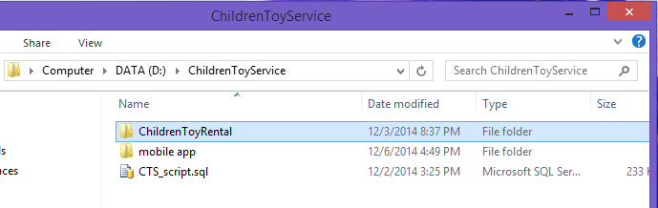

**Figure 158: Extract Deployment Package**

#### Database Deployment

* Open Microsoft SQL Server Management Studio 2012 and login with administration account.

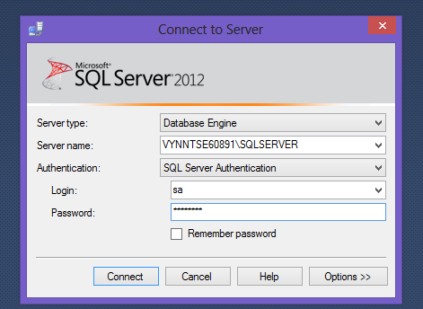

**Figure 159: Connect to server**

* Open “CTS_script.sql” in Microsoft SQL Server Management
* Change FILENAME in line 7 and 9 to the directory of SQL Server Instance in your server.

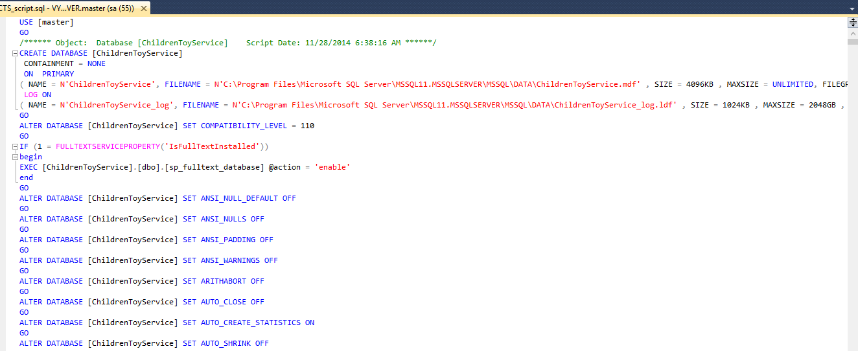

**Figure 160: Open database script**

* Execute the script

#### Server configuration

* Open the Internet Information System Manager
* Change the .NET Framework version to 4.0

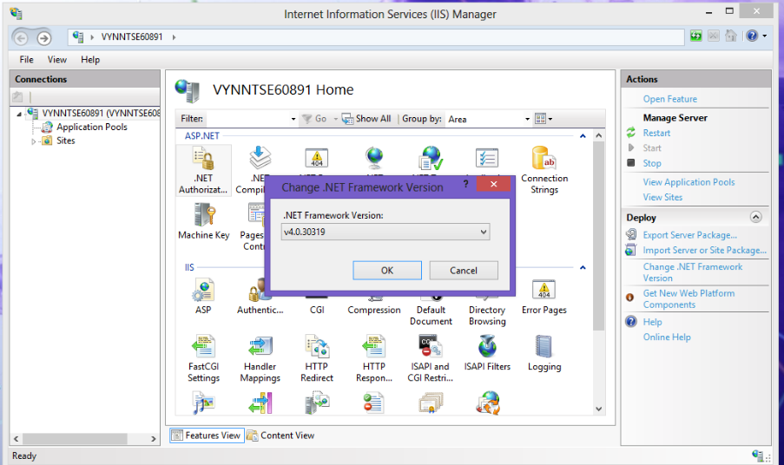

**Figure 161: Configure Server**

#### Deploy

* Change the user ID, password and data source parts of connection string in Web.config (in ChildrenToyRental folder) with your data
* Change the user ID, password and data source parts of connection string in App.config (in ChildrenToyRentalDAL folder) with your data

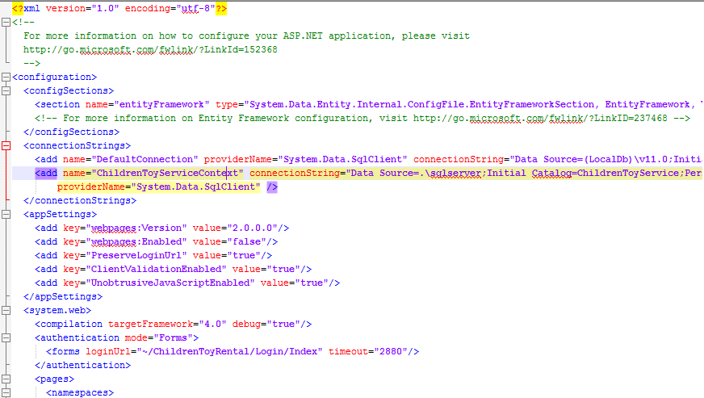

**Figure 162: Change Web.config connection string**

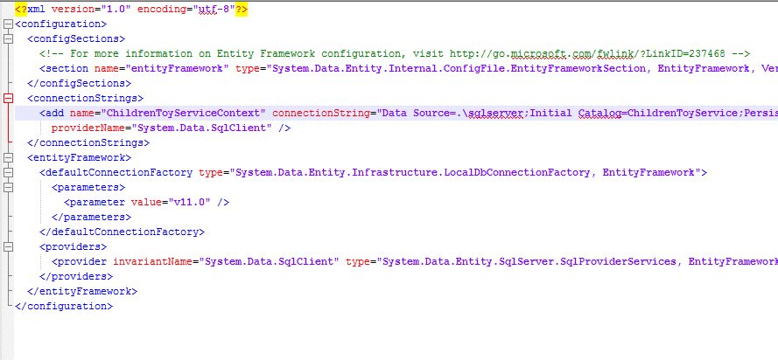

**Figure 163: Change App.config connection string**

* On IIS Manager, right click as Sites. Choose “Add Web Site”.

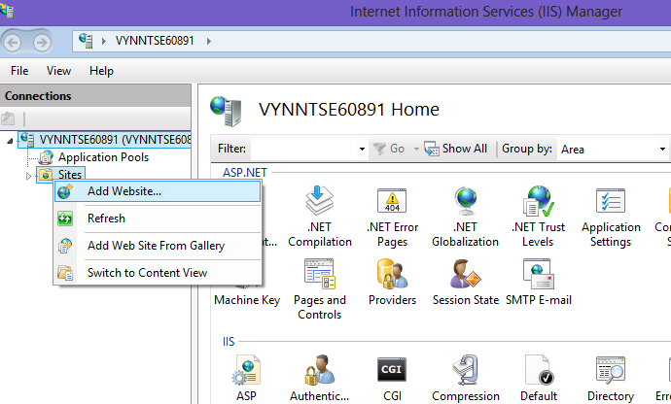

**Figure 164: Deploy web application on server**

* Enter site name. Choose ASP.NET 4.0 as Application Pool
* Select the path to the folder in step 1. Enter random port which different from port 80.

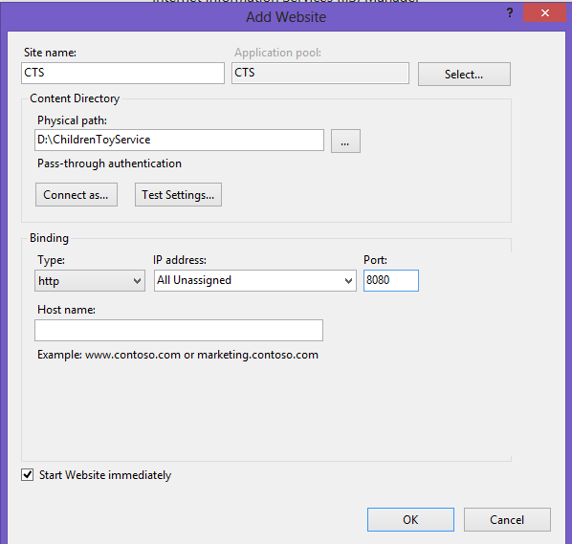

**Figure 165: Deploy web application on server**

* Press ok to finish the process

### Client side environment setting

Client side should have one of these following browser:

* Google Chrome
* Firefox
* Internet Explorer

## User’s Guide

This user guide describes how to use the application based on the process of children toy rental service website

### Admin –Staff Login

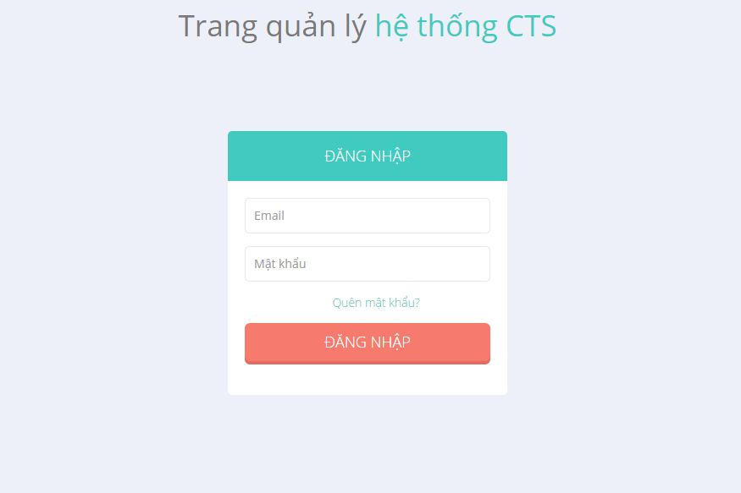

**Figure 166: Admin - Staff Login Page**

|  |  |
| --- | --- |
| **Step** | **Description** |
| 1 | Enter “Email” và “Mật khẩu”  (E.g: Email: admin@gmail.com. Mật khẩu: 12345678) |
| 2 | Click “Đăng nhập” |

**Table 100: Login Step**

### Staff

#### View List Of Orders

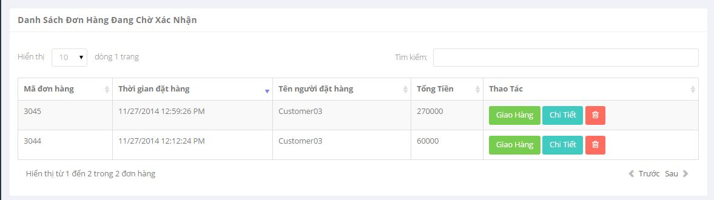

**Figure 167 : View List Of Orders**

|  |  |
| --- | --- |
| **Step** | **Description** |
| 1 | Click “Quản Lý dơn hàng” on menu => Click “Đang chờ xác nhận” |
| 2 | Show list order |

**Table 101: View List Of Orders**

#### View Order Detail (Staff)

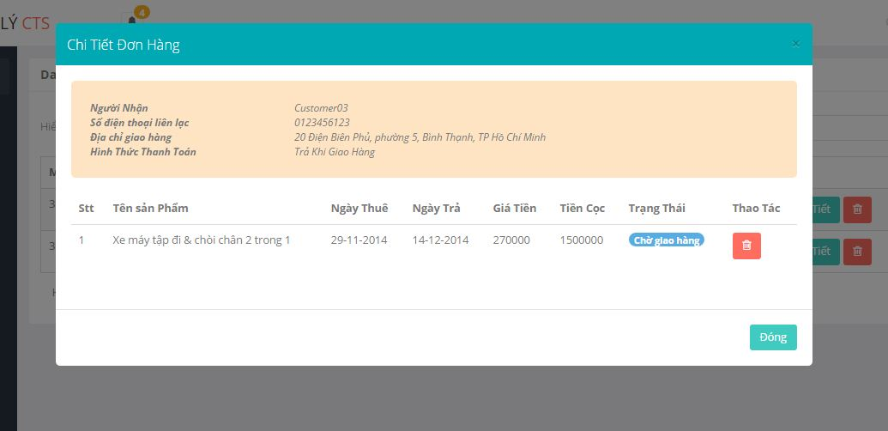

**Figure 168 : View Order Detail (Staff)**

|  |  |
| --- | --- |
| **Step** | **Description** |
| 1 | Click “Quản Lý đơn hàng” on menu => Click “Đang chờ xác nhận” |
| 2 | Click “Chi Tiết” button |

**Table 102: View Order Detail (Staff)**

#### Assign Shipper

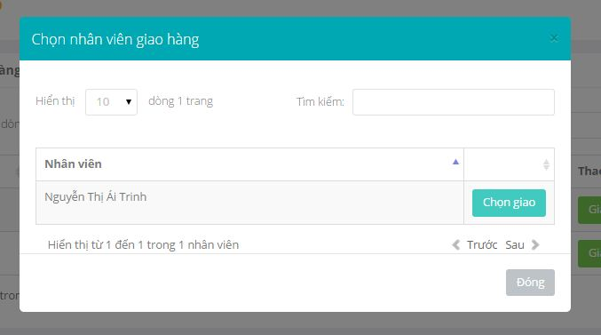

**Figure 169 : Assign Shipper**

|  |  |
| --- | --- |
| **Step** | **Description** |
| 1 | Click “Quản Lý Đơn hàng” on menu => Click “Đang chờ xác nhận” |
| 2 | Click “Giao Hàng” button |
| 3 | Click “Chọn giao” button |

**Table 103: Assign Shipper**

#### View Exchange Request List

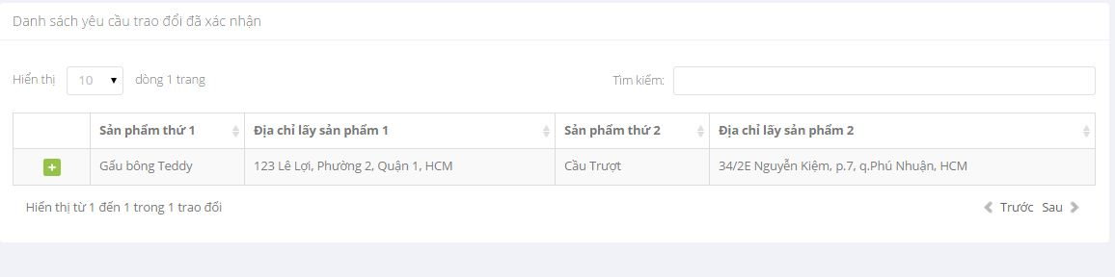

**Figure 170 : View Exchange Request List**

|  |  |
| --- | --- |
| **Step** | **Description** |
| 1 | Click “Quản Lý trao đổi” on menu => Click “Trao Đổi Đã Xác Nhận” |

**Table 104: View Exchange Request List**

#### View Detail Of Exchange Request

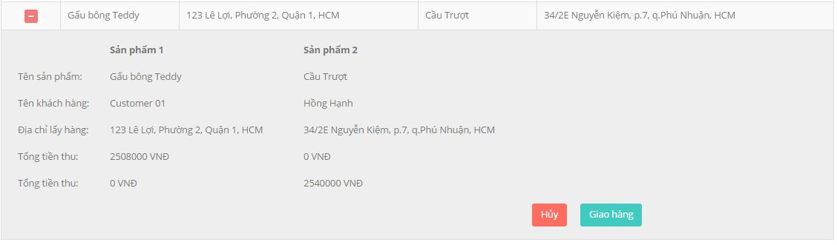

**Figure 171 : View Detail Of Exchange Request**

|  |  |
| --- | --- |
| **Step** | **Description** |
| 1 | Click “Quản Lý Trao đổi” on menu => Click “Trao đổi đã xác nhận” |
| 2 | Click icon plus |

**Table 105: View Detail Of Exchange Request**

#### Cancel Exchange Request



**Figure 172 : Cancel Exchange Request**

|  |  |
| --- | --- |
| **Step** | **Description** |
| 1 | Click “Quản Lý Trao đổi” on menu => Click “Trao đổi đã xác nhận” |
| 2 | Click icon plus |
| 3 | Click “Hủy” button |

**Table 106: Cancel Exchange Request**

### Customer

#### Add To Cart

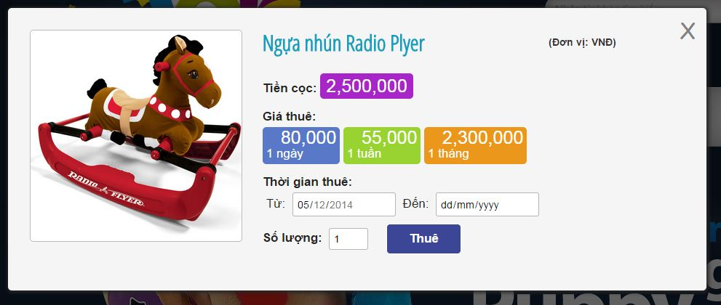

**Figure 173 : Add To Cart**

|  |  |
| --- | --- |
| **Step** | **Description** |
| 1 | Click “Thuê” of each toy |
| 2 | Full fill rent time and amount |
| 3 | Click “Thuê” button |

**Table 107: Add To Cart**

#### View Cart

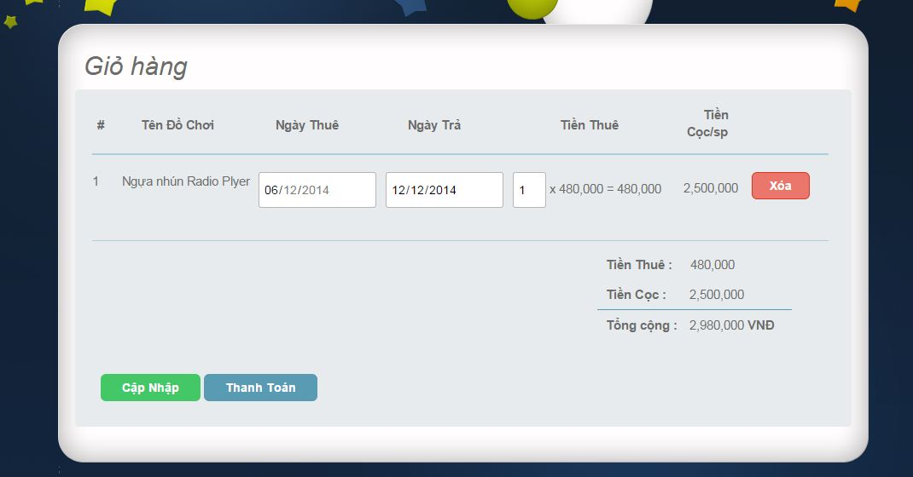

**Figure 174 : View Cart**

|  |  |
| --- | --- |
| **Step** | **Description** |
| 1 | Click “Giỏ hàng” in Home Page |

**Table 108: View Cart**

#### Edit Cart

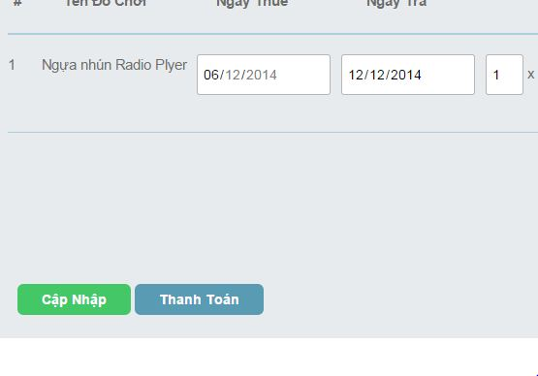

**Figure 175 : Edit Cart**

|  |  |
| --- | --- |
| **Step** | **Description** |
| 1 | Update information about rent time , amount |
| 2 | Click “Cập Nhập” button |

**Table 109: Edit Cart**

#### CheckOut_step 1

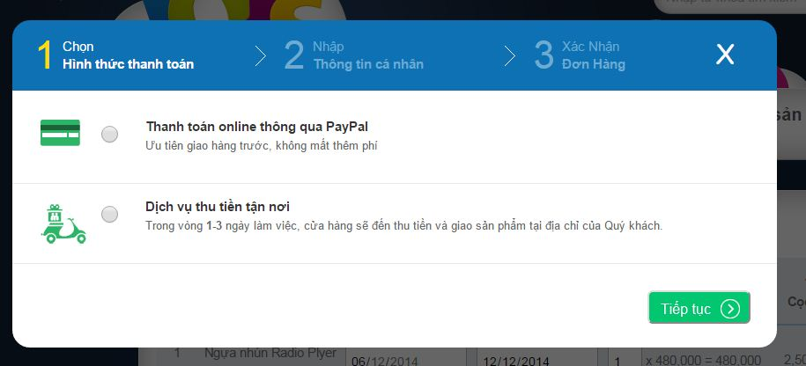

**Figure 176 : Check out_ step 1**

|  |  |
| --- | --- |
| **Step** | **Description** |
| 1 | Click “Thanh Toán” in cart |
| 2 | Click to choose way to payment |

**Table 110: Check out_ step 1**

#### CheckOut_step 2

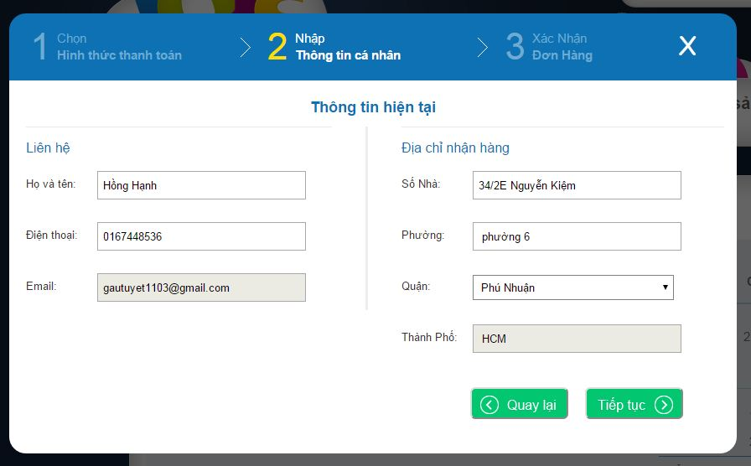

**Figure 177 : CheckOut_step 2**

|  |  |
| --- | --- |
| **Step** | **Description** |
| 1 | Click “Thanh Toán” in cart |
| 2 | Click to choose way to payment |
| 3 | Click “Tiếp Tục” button |
| 4 | Edit information profile |

**Table 111: CheckOut_step 2**

#### CheckOut_step 3

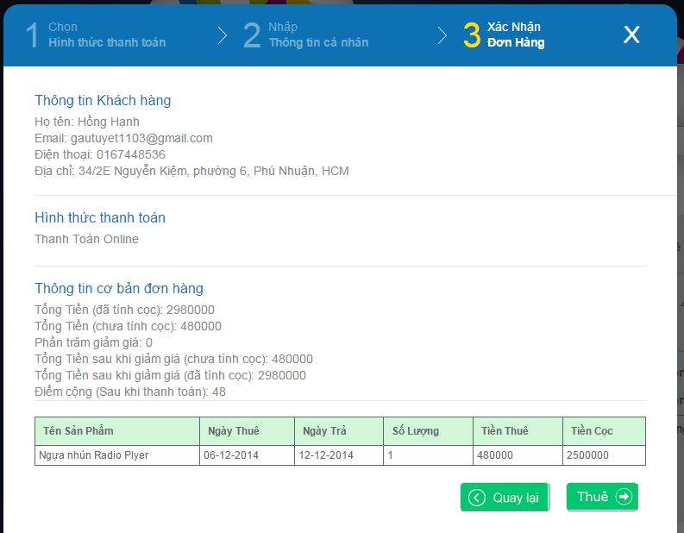

**Figure 178 : CheckOut_step 3**

|  |  |
| --- | --- |
| **Step** | **Description** |
| 1 | Click “Thanh Toán” in cart |
| 2 | Click to choose way to payment |
| 3 | Click “Tiếp Tục” button |
| 4 | Edit information profile |
| 5 | Click “Tiếp Tục” button |

**Table 112: CheckOut_step 3**

#### View Order History

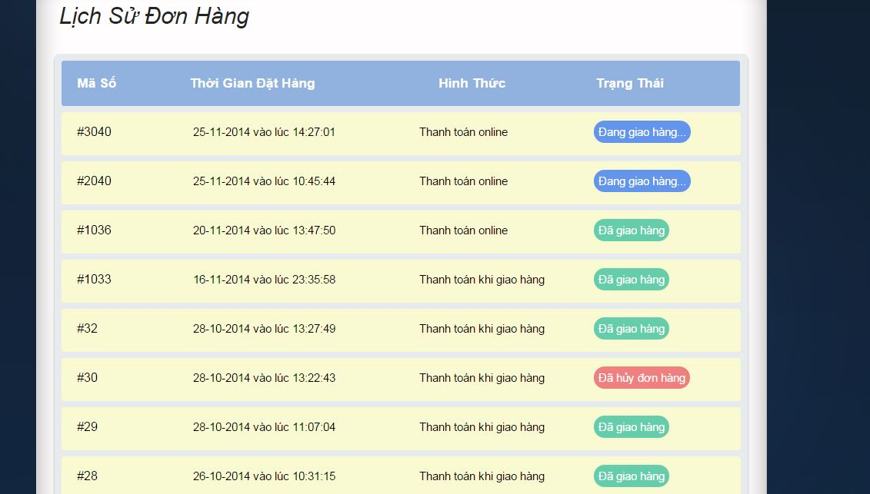

**Figure 179 : View Order History**

|  |  |
| --- | --- |
| **Step** | **Description** |
| 1 | Click “Lịch Sử Đơn Hàng” |

**Table 113: View Order History**

#### View Order Detail (Customer)

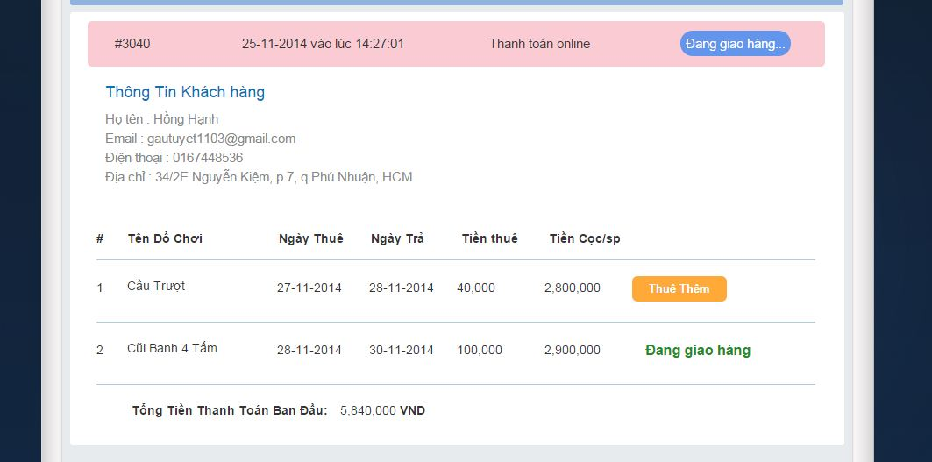

**Figure 180 : View Order Detail (Customer)**

|  |  |
| --- | --- |
| **Step** | **Description** |
| 1 | Click “Lịch Sử Đơn Hàng” |
| 2 | Click order that want to view detail |

**Table 114: View Order Detail (Customer)**

#### Extend Rent Time

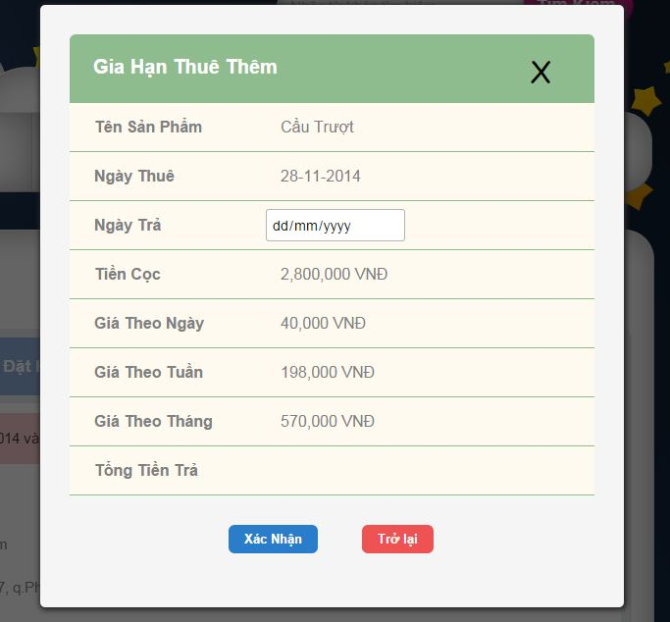

**Figure 181 : Extend Rent Time**

|  |  |
| --- | --- |
| **Step** | **Description** |
| 1 | Click “Lịch Sử Đơn Hàng” |
| 2 | Click order |
| 3 | Click “Thuê Thêm” button |

**Table 115: Extend Rent Time**

#### Product Detail

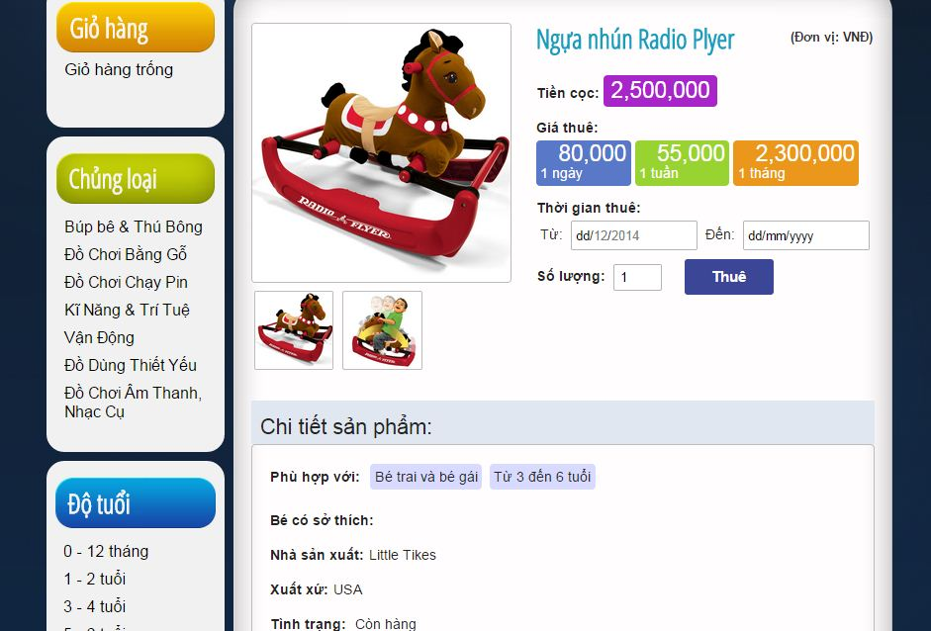

**Figure 182 : Product Detail**

|  |  |
| --- | --- |
| **Step** | **Description** |
| 1 | Click product to view detail |

**Table 116: Product Detail**

#### View Suggest Toy

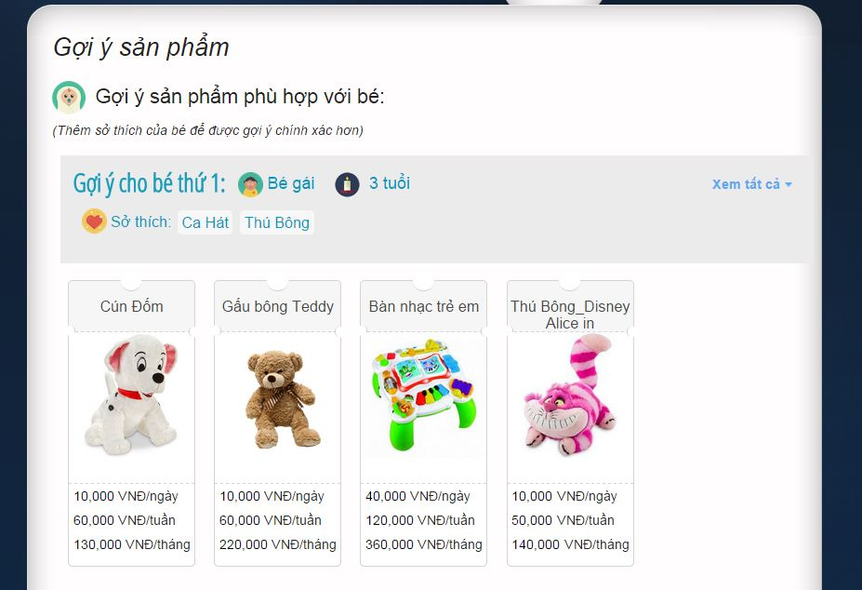

**Figure 183 : View Suggest Toy**

|  |  |
| --- | --- |
| **Step** | **Description** |
| 1 | Click “Gợi ý sản phẩm” in menu bar |

**Table 117: View Suggest Toy**

#### View Other Exchangeable Toys List

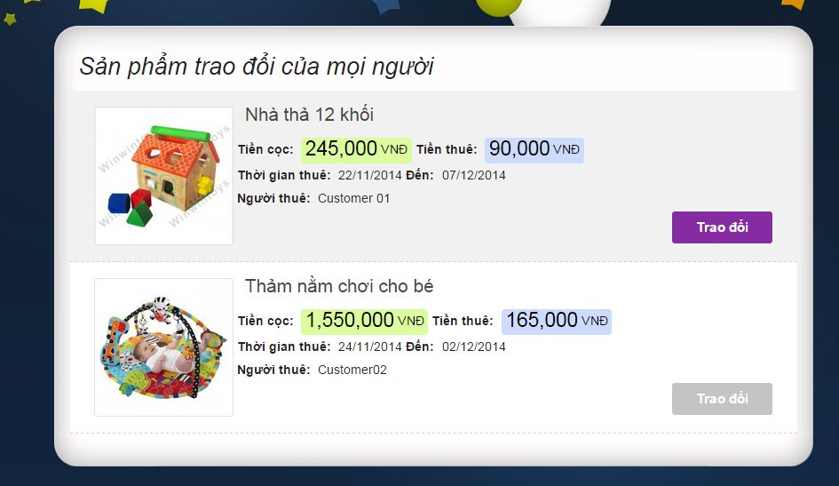

**Figure 184 : View Other Exchangeable Toy List**

|  |  |
| --- | --- |
| **Step** | **Description** |
| 1 | Click “Trao Đổi Sản Phẩm” in menu bar |
| 2 | Click “Sản Phẩm Trao Đổi Của mọi người” |

**Table 118: View Other Exchangeable Toy List**

#### Exchange Request _step 1

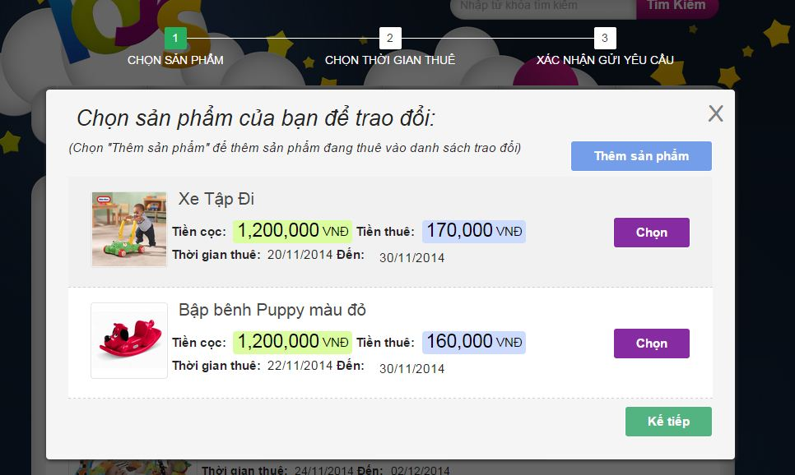

**Figure 185 : Exchange Request _ Step 1**

|  |  |
| --- | --- |
| **Step** | **Description** |
| 1 | Click “Trao Đổi Sản Phẩm” in menu bar |
| 2 | Click “Sản Phẩm Trao Đổi Của mọi người” |
| 3 | Click “Trao đổi” button |

**Table 119: Exchange Request _ Step 1**

#### Exchange Request _ step 2

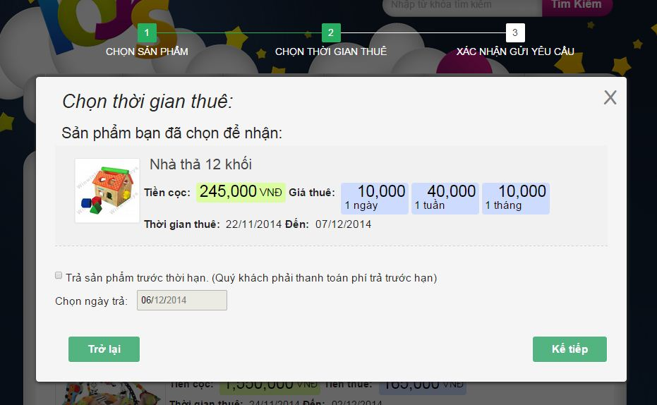

**Figure 186 : Exchange Request_ step 2**

|  |  |
| --- | --- |
| **Step** | **Description** |
| 1 | Click “Trao Đổi Sản Phẩm” in menu bar |
| 2 | Click “Sản Phẩm Trao Đổi Của mọi người” |
| 3 | Click “Trao đổi” button |
| 4 | Click “Kế tiếp” button |

**Table 120: Exchange request _ step 2**

#### Exchange Request – step 3

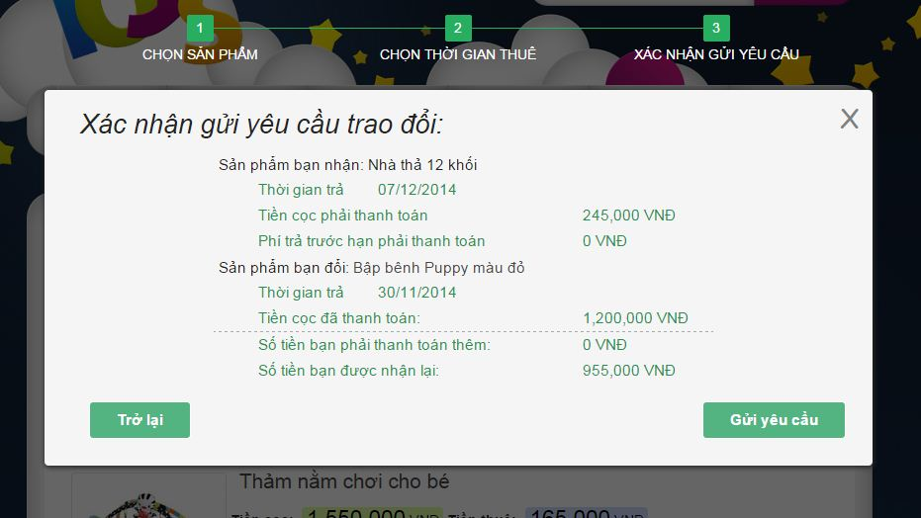

**Figure 187 : Exchange Request – step 3**

|  |  |
| --- | --- |
| **Step** | **Description** |
| 1 | Click “Trao Đổi Sản Phẩm” in menu bar |
| 2 | Click “Sản Phẩm Trao Đổi Của mọi người” |
| 3 | Click “Trao đổi” button |
| 4 | Click “Kế tiếp” button |
| 5 | Click “Kế tiếp” button |

**Table 121: Exchange Request – step 3**

#### View Sent Exchange Request of Customer

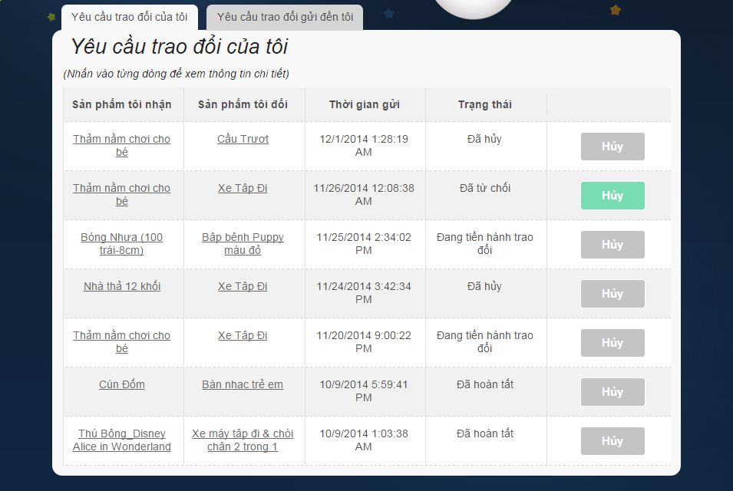

**Figure 188 : View Sent Exchange Request Of Customer**

|  |  |
| --- | --- |
| **Step** | **Description** |
| 1 | Click “Trao Đổi Sản Phẩm” in menu bar |
| 2 | Click “Yêu Cầu Trao Đổi” |

**Table 122: View Sent Exchange Request Of Customer**

#### View Receive Exchange Request Of Customer

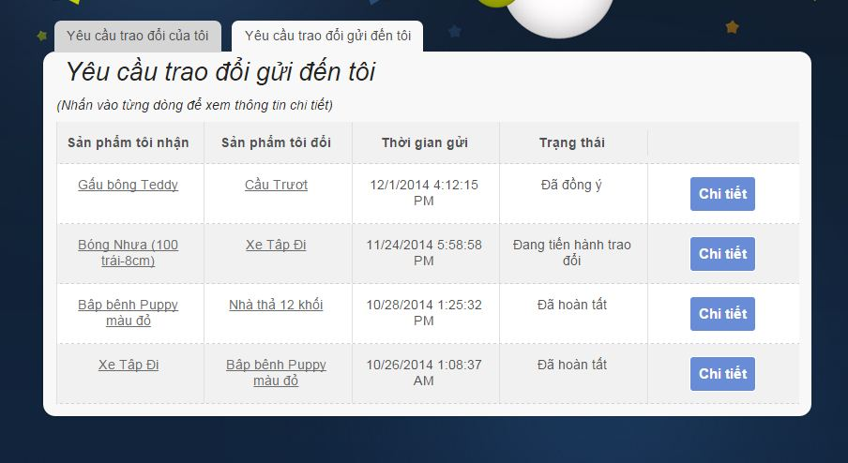

**Figure 189 : View Receive Exchange Request Of Customer**

|  |  |
| --- | --- |
| **Step** | **Description** |
| 1 | Click “Trao Đổi Sản Phẩm” in menu bar |
| 2 | Click “Yêu Cầu trao đổi” |
| 3 | Click tab “Yêu cầu trao đổi gửi đến tôi” |

**Table 123: View Receive Exchange Request Of Customer**

#### View Detail Request

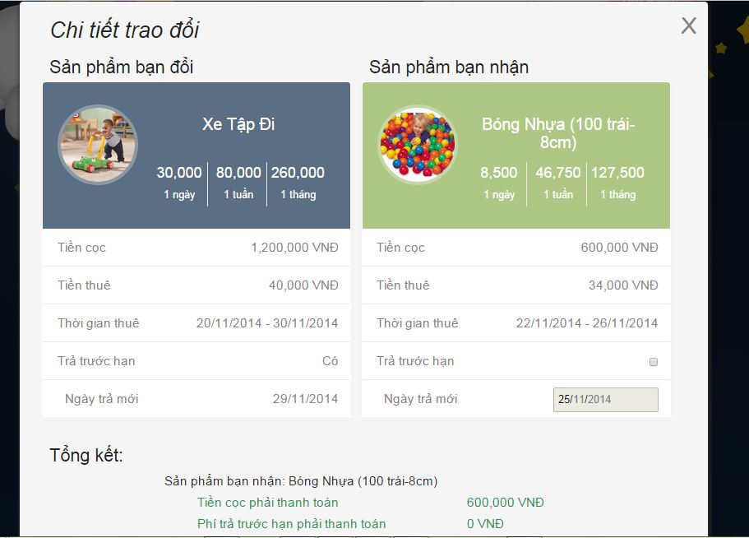

**Figure 190: View Exchange Request Details**

|  |  |
| --- | --- |
| **Step** | **Description** |
| 1 | Click “Trao Đổi Sản Phẩm” in menu bar |
| 2 | Click “Yêu Cầu trao đổi” |
| 3 | Click tab “Yêu cầu trao đổi gửi đến tôi” |
| 4 | Click “Chi Tiết” button |

**Table 124: View Exchange Request Details**